

|  |  |  |  |  |
| --- | --- | --- | --- | --- |
| 72 Central Campus Dr Salt Lake City, UT 84112 |  |  |  | yong.wan@utah.edu  www.fluorender.com |

FluoRender User’s Guide

Version 2.33/July 2025

|  |  |
| --- | --- |
|  | **Please make sure that you have the latest graphics driver installed on your computer before start using FluoRender. Your graphics card needs to at least support:**  **OpenGL 4.0**  **OpenCL 1.2**  **Look up your graphics card’s capability on Wikipedia.org**  **For AMD graphics processing units:**  [**https://en.wikipedia.org/wiki/List\_of\_AMD\_graphics\_processing\_units**](https://en.wikipedia.org/wiki/List_of_AMD_graphics_processing_units)  **For Intel graphics processing units:**  [**https://en.wikipedia.org/wiki/List\_of\_Intel\_graphics\_processing\_units**](https://en.wikipedia.org/wiki/List_of_Intel_graphics_processing_units)  **For Nvidia graphics processing units:**  [**https://en.wikipedia.org/wiki/List\_of\_Nvidia\_graphics\_processing\_units**](https://en.wikipedia.org/wiki/List_of_Nvidia_graphics_processing_units) |

|  |  |
| --- | --- |
|  | **You can find FluoRender tutorial videos on YouTube.** |

Table of Contents

[List of Figures 6](#_Toc205389366)

[Chapter 1 What’s New in Version 2.33 8](#_Toc205389367)

[Chapter 2 Installation 12](#_Toc205389368)

[Install FluoRender on Microsoft Windows](#_Toc205389369)

[Install FluoRender on Mac OS](#_Toc205389370)

[Build FluoRender on Linux Systems](#_Toc205389371)

[Chapter 3 FluoRender User Interface 20](#_Toc205389372)

[FluoRender Main User Interface](#_Toc205389373)

[Reorganizing FluoRender’s User Interface](#_Toc205389374)

[FluoRender Main Menu](#_Toc205389375)

[FluoRender Main Toolbar](#_Toc205389376)

[Chapter 4 Load Data Sets Error! Bookmark not defined.](#_Toc205389377)

[Volume Data](#_Toc205389378)

[ImageJ & Bioformats Plugin](#_Toc205389379)

[Mesh Data](#_Toc205389380)

[Chapter 5 Manage Data Sets 30](#_Toc205389381)

[Chapter 6 Workspace 33](#_Toc205389382)

[Toolbar Icons](#_Toc205389383)

[Context Menu Commands](#_Toc205389384)

[Chapter 7 Render View 37](#_Toc205389385)

[Multi-view Management](#_Toc205389386)

[Channel Intermixing Methods](#_Toc205389387)

[Render View Settings](#_Toc205389388)

[Interactions](#_Toc205389389)

[Capturing Render View](#_Toc205389390)

[Full-Screen Mode (Microsoft Windows Only)](#_Toc205389391)

[Chapter 8 Volume Properties 46](#_Toc205389392)

[Transfer Function Settings](#_Toc205389393)

[Effect Settings](#_Toc205389394)

[Color Settings](#_Toc205389395)

[Voxel Size](#_Toc205389396)

[Other Settings](#_Toc205389397)

[Synchronize Settings](#_Toc205389398)

[Mode Combinations](#_Toc205389399)

[Chapter 9 Output Adjustments 56](#_Toc205389400)

[Chapter 10 Clipping Planes 58](#_Toc205389401)

[Clipping Plane Display Controls](#_Toc205389402)

[Clipping Plane Translations](#_Toc205389403)

[Clipping Plane Rotations](#_Toc205389404)

[Chapter 11 Mesh Properties 60](#_Toc205389405)

[Basic Mesh Properties](#_Toc205389406)

[Mesh Manipulations](#_Toc205389407)

[Chapter 12 Making Movies 62](#_Toc205389408)

[Movie Clip Playback Controls](#_Toc205389409)

[Basic Movie Making](#_Toc205389410)

[Keyframes](#_Toc205389411)

[Keyframe Presets](#_Toc205389412)

[Crop the Movie Frames](#_Toc205389413)

[Chapter 13 Automated Data Analysis with Scripts 72](#_Toc205389414)

[FluoRender Script](#_Toc205389415)

[Script File Format](#_Toc205389416)

[Script Tasks](#_Toc205389417)

[Chapter 14 Managing Projects 97](#_Toc205389418)

[Chapter 15 Volume Filters 99](#_Toc205389419)

[Open and save filter files](#_Toc205389420)

[Built-in filter files](#_Toc205389421)

[Code panel](#_Toc205389422)

[Execute a kernel](#_Toc205389423)

[Output panel](#_Toc205389424)

[Chapter 16 Paint Brush 102](#_Toc205389425)

[Brush History](#_Toc205389426)

[Brush Types](#_Toc205389427)

[Creating New Channels from Selection](#_Toc205389428)

[Copying and Pasting Masks](#_Toc205389429)

[Selection Settings](#_Toc205389430)

[Brush Properties](#_Toc205389431)

[Wacom Tablet and Display Tablet Support](#_Toc205389432)

[Information](#_Toc205389433)

[Align Render View to Selection Mask](#_Toc205389434)

[Chapter 17 Measurement 109](#_Toc205389435)

[Measurement Tools](#_Toc205389436)

[Editing Measurement Tools](#_Toc205389437)

[Settings for Measurement Tools](#_Toc205389438)

[Ruler List](#_Toc205389439)

[Align Render View to Rulers](#_Toc205389440)

[Chapter 18 Component Analysis 117](#_Toc205389441)

[Settings for Component Generation](#_Toc205389442)

[Cluster](#_Toc205389443)

[Component Analysis](#_Toc205389444)

[Information Panel](#_Toc205389445)

[Chapter 19 Processing and Analyzing Volumes 129](#_Toc205389446)

[Volume Size](#_Toc205389447)

[Noise Reduction](#_Toc205389448)

[Volume Channel Calculations](#_Toc205389449)

[Colocalization Analysis](#_Toc205389450)

[Chapter 20 Tracking 135](#_Toc205389451)

[Track Map Generation and Management](#_Toc205389452)

[Semi-Automatic Tracking](#_Toc205389453)

[Component Selection Settings](#_Toc205389454)

[Visualizing Tracking Results](#_Toc205389455)

[Assign/Modify IDs](#_Toc205389456)

[Manually Linking Components](#_Toc205389457)

[Making Analysis](#_Toc205389458)

[Chapter 21 Volume-Mesh Conversion 143](#_Toc205389459)

[Chapter 22 Machine Learning Manager 145](#_Toc205389460)

[Start Machine Learning Automatically](#_Toc205389461)

[Choose A Category for Machine Learning Management](#_Toc205389462)

[Volume Properties](#_Toc205389463)

[Tables](#_Toc205389464)

[Records](#_Toc205389465)

[Chapter 23 Configurations 148](#_Toc205389466)

[Project](#_Toc205389467)

[Rendering](#_Toc205389468)

[Performance](#_Toc205389469)

[Automation](#_Toc205389470)

[Display](#_Toc205389471)

[File Format](#_Toc205389472)

[ImageJ Link](#_Toc205389473)

[Settings through the configuration File](#_Toc205389474)

[Chapter 24 Contributing to FluoRender 163](#_Toc205389475)

[Developing and Contributing with Source Code via GitHub](#_Toc205389476)

[Appendices 164](#_Toc205389477)

[A. Functions of FluoRender](#_Toc205389478)

[B. File Formats](#_Toc205389479)

[C. Keyboard Shortcuts](#_Toc205389480)

[D. Command Line Options](#_Toc205389481)

[E. Frequently Asked Questions](#_Toc205389482)

[Index 183](#_Toc205389483)

# List of Figures

[Figure 2‑1. Installation language. 12](#_Toc205389484)

[Figure 2‑2. License agreement. 13](#_Toc205389485)

[Figure 2‑3. Destination location. 13](#_Toc205389486)

[Figure 2‑4. Main user interface of FluoRender on Windows. 14](#_Toc205389487)

[Figure 2‑5. Additional tasks. 14](#_Toc205389488)

[Figure 2‑6. Ready to install. 15](#_Toc205389489)

[Figure 2‑7. FluoRender installation on Mac OS. 16](#_Toc205389490)

[Figure 2‑8. FluoRender software license. 16](#_Toc205389491)

[Figure 2‑9. FluoRender software license. 17](#_Toc205389492)

[Figure 2‑10. FluoRender installation information. 17](#_Toc205389493)

[Figure 2‑11. FluoRender installation is successful. 18](#_Toc205389494)

[Figure 3‑1. Main user interface of FluoRender. 20](#_Toc205389495)

[Figure 3‑2. Tabs in the output adjustment panel are reorganized. 21](#_Toc205389496)

[Figure 4‑1. Load a Z-stack sequence. 26](#_Toc205389497)

[Figure 4‑2. Load a time sequence. 27](#_Toc205389498)

[Figure 4‑3. Load a series from LIF. 28](#_Toc205389499)

[Figure 5‑1. Dataset panel. 30](#_Toc205389500)

[Figure 5‑2. Save volume dialog. 31](#_Toc205389501)

[Figure 6‑1. Workspace panel. 33](#_Toc205389502)

[Figure 7‑1. Multiple render views in FluoRender. 37](#_Toc205389503)

[Figure 7‑2. Channel intermixing modes. 38](#_Toc205389504)

[Figure 7‑3. Save the captured image. 44](#_Toc205389505)

[Figure 8‑1. Volume properties. 46](#_Toc205389506)

[Figure 9‑1. Output adjustment panel. 56](#_Toc205389507)

[Figure 10‑1. Clipping plane translations. 58](#_Toc205389508)

[Figure 10‑2. Clipping plane rotations. 59](#_Toc205389509)

[Figure 11‑1. Mesh properties. 60](#_Toc205389510)

[Figure 11‑2. Mesh manipulations. 61](#_Toc205389511)

[Figure 12‑1. Movie playback controls. 62](#_Toc205389512)

[Figure 12‑2. Save or export a movie or time sequence. 64](#_Toc205389513)

[Figure 12‑3. Basic movie-making settings. 65](#_Toc205389514)

[Figure 12‑4. Advanced movie playback controls. 67](#_Toc205389515)

[Figure 12‑5. Keyframe presets. 69](#_Toc205389516)

[Figure 12‑6. Frame cropping controls. 71](#_Toc205389517)

[Figure 13‑1. Script settings. 72](#_Toc205389518)

[Figure 14‑1. Save project dialog. 97](#_Toc205389519)

[Figure 15‑1. Volume Filter window. 99](#_Toc205389520)

[Figure 16‑1. The Paint Brush window. 102](#_Toc205389521)

[Figure 16‑2. Align settings. 108](#_Toc205389522)

[Figure 17‑1. Launch the Measurement window from the main toolbar. 109](#_Toc205389523)

[Figure 17‑2. Measurement window. 109](#_Toc205389524)

[Figure 17‑2. Align panel in Measurement window. 116](#_Toc205389525)

[Figure 18‑1. The basic settings in the component analyzer dialog. 117](#_Toc205389526)

[Figure 18‑2. Clustering tools. 120](#_Toc205389527)

[Figure 18‑3. Component analysis tools. 122](#_Toc205389528)

[Figure 18‑4. Component information. 126](#_Toc205389529)

[Figure 18‑5. Select components from the output list or in the render view. 126](#_Toc205389530)

[Figure 19‑1. Access the additional processing and analyzing functions from the drop-down menu of the main toolbar. 129](#_Toc205389531)

[Figure 19‑2. Volume size dialog. 129](#_Toc205389532)

[Figure 19‑3. Noise reduction dialog. 130](#_Toc205389533)

[Figure 19‑4. Calculation functions in the Analyze window. 131](#_Toc205389534)

[Figure 19‑5. Colocalization analysis dialog. 133](#_Toc205389535)

[Figure 20‑1. Components and Tracking window. 135](#_Toc205389536)

[Figure 20‑2. The Selection tab of the Component and Tracking window. 137](#_Toc205389537)

[Figure 20‑3. Tracks of a tracked cell. 139](#_Toc205389538)

[Figure 20‑4. The Modify tab of the Component and Tracking Window. 140](#_Toc205389539)

[Figure 20‑5. The Linkage tab of the Component and Tracking window. 141](#_Toc205389540)

[Figure 20‑6. The Analysis tab of the Component and Tracking window. 142](#_Toc205389541)

[Figure 21‑1. Convert dialog. 143](#_Toc205389542)

[Figure 22‑1. Machine Learning Manager. 145](#_Toc205389543)

[Figure 23‑1. Project settings. 148](#_Toc205389544)

[Figure 23‑2. Rendering settings. 151](#_Toc205389545)

[Figure 23‑3. Performance settings. 152](#_Toc205389546)

[Figure 23‑4. Automation settings. 154](#_Toc205389547)

[Figure 23‑4. Display settings. 155](#_Toc205389548)

[Figure 23‑5. File-format settings. 157](#_Toc205389549)

[Figure 23‑6. Settings, ImageJ Link panel. 159](#_Toc205389550)

# What’s New in Version 2.33

Thank you for using FluoRender and reading the operation manual. You can also download a document containing several tutorials from FluoRender’s website.

FluoRender 2.33 marks a major leap forward in both functionality and usability. With a focus on clarity, speed, and intuitive interaction, FluoRender now offers a richer toolkit for analyzing volume data from fluorescence microscopy. Users can dive into tasks like painting, filtering, and color mapping with minimal setup — or no manual fine-tuning at all — and still achieve precise, insightful results. Key updates streamline workflows, reduce the learning curve, and make advanced features more accessible. Whether you're visualizing time-dependent properties, customizing your color map, or leveraging smart automation, FluoRender adapts to your data and goals with surprising agility. The goal remains constant: to empower researchers with interactive tools that feel natural to use, yet remain powerful under the hood.

|  |  |
| --- | --- |
|  | **Looking Glass Support** |

FluoRender now seamlessly supports the latest [Looking Glass holographic displays](https://lookingglassfactory.com/displays-overview), expanding your visualization toolkit with intuitive controls and immersive clarity. See Chapter 7 and Chapter 23 for more information.

The 16" Looking Glass displays can be purchased here: <https://lookingglassfactory.com/looking-glass-16-lightfield>

The 27" Looking Glass dispalys can be purchased here: <https://lookingglassfactory.com/looking-glass-27>

And a portable holographic display, the Looking Glass Go can be purchased here: <https://lookingglassfactory.com/lkg-go>

* **Hologram Modes:** Choose from three distinct modes to configure camera and lens shifts—whether for depth emphasis, parallax refinement, or artistic rotation.
* **Projection Flexibility:** Easily toggle between orthographic and perspective projections to match your analytical or illustrative needs.
* **Camera Control Options:** Navigate with precision using either Globe Mode for orbital rotation or Flight Mode for dynamic pathing.
* **Auto Focusing:** Automatically focus on the scene’s center or snap to a user-specified point with a simple click.
* **Hologram Snapshot:** Capture and share high-resolution holographic snapshots—perfect for documentation, collaboration, or presentation.

|  |  |
| --- | --- |
|  | **Visualization & Volume Properties** |

Overhauled **volume property settings**, with reordered layout. See Chapter 8 for more information.

* New UI displays:
  + **Intensity distribution**
  + **Color map range**
* Updated **multi-function buttons** and introduced **min–max/boundary high controls**
* Filter updates: **Lanczos-bicubic** scaling with zoom-aware window sizing
* Added **4D color maps** featuring time, intensity delta, and speed options
* Keyframe animation:
  + Now supports **volume property changes**
  + Enabled only when keyframes are present

|  |  |
| --- | --- |
|  | **Interactive Tools & Painting** |

Improved the ease-of-use for all interactive tools and UI displays. See Chapter 6, Chapter 15, and Chapter 17 for more information.

* New brush tools: **Segment** and **Isolate**
* Brushes support **fine-grained grow rate**
* Automatic **threshold estimation** for paint and component generation
* Isolate brush works with ruler tools to locate **center points**

|  |  |
| --- | --- |
|  | **Automation & Scripting** |

* OpenCL filter script now runs **last-used parameters** from UI when left empty
* Added script stop command for one-time scripts
* Introduced **automation options** in configuration dialog, supporting:
  + Histogram generation
  + Paint selected size computing
  + Component generation
  + Colocalization
  + Ruler relaxation

|  |  |
| --- | --- |
|  | **Volume Filtering** |

Enhanced volume filtering functions and ease of use. See Chapter 15 for more information.

* OpenCL editor renamed to **Volume Filter**
* Added **deconvolution filters**, including Richardson-Lucy and Wiener filters
* Updated **Gaussian** filters for smoother results
* Added other commonly used filters

|  |  |
| --- | --- |
|  | **UI & Usability Enhancements** |

* Refreshed **icons and text** throughout UI
* Adopted **notebook-style tabs** for improved dialog navigation
* **Dialog layouts** can now be saved and restored
* Added **dark mode** support on Windows
* Reordered settings to prioritize frequent tasks
* Frequently used interactive tools now available in the **workspace panel**
* Added dialog buttons to the **project panel**
* Interactive tool states now **sync across dialogs**

|  |  |
| --- | --- |
|  | **File & Data Management** |

* Added support for **INI**, **XML**, and **JSON** config file formats
* Refactored memory handling using **smart pointers**
* Updated **volume cache** system for time-sequenced data
* Introduced **movie playback caching** for smoother experience
* Enhanced capture capabilities: Support for **JPEG** and **PNG**
* Ability to read **JPEG/PNG sequences**

|  |  |
| --- | --- |
|  | **Core System & Build Improvements** |

* Reorganized **CMake** structure and third-party libraries
* Switched from wxString and legacy path utilities to **std::string** and **std::filesystem**
* Resolved **type cast warnings**
* Updated **FFmpeg** integration to use current API
* Forward-declared third-party types for cleaner compilation

# Installation

## Install FluoRender on Microsoft Windows

|  |  |
| --- | --- |
|  | We have discontinued the support of 32-bit Windows since Version 2.14. Please make sure that your hardware is 64-bit compatible, and a 64-bit Windows is installed. If you have any questions about the Windows version, please contact us. Continued support will only be available for the latest Release of FluoRender. |

1. Download *FluoRender2.33\_win64.exe* from the website (https://github.com/SCIInstitute/fluorender/releases).
2. Double-click the installer icon to initiate the installation.

|  |  |
| --- | --- |
|  | You may be asked by “User Account Control” to provide permission to allow the installer from an unknown publisher to make changes to your computer. Click “Yes” to allow FluoRender to install. |

1. The first dialog you will see will ask you to select your language for installation. Click OK.



Figure ‑. Installation language.

1. At this point, the installer checks to see if you have FluoRender already on your machine. If FluoRender is not yet on your machine, continue to step 5. If the version you are installing already exists, the setup will terminate.

|  |  |
| --- | --- |
|  | If you wish to re-install the same version of FluoRender, first uninstall using Add/Remove programs in the Control Panel. |

If you are trying to install an older version of FluoRender, you will be asked to confirm an installation overwrite of the newer version. If the installed FluoRender is older than what is being installed, you will be asked if you wish to upgrade to the installer’s version.

1. License Agreement. FluoRender is under the MIT license agreement. Please read and accept the license. Click Next to continue.

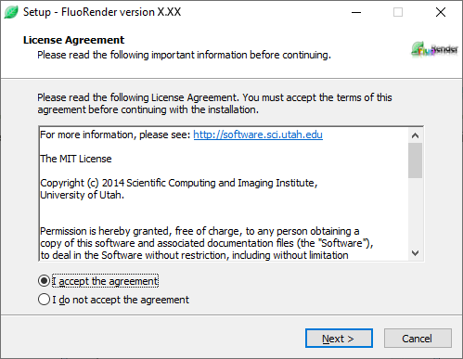

Figure ‑. License agreement.

1. Choose your installation path. Default is recommended. Click Next to continue.

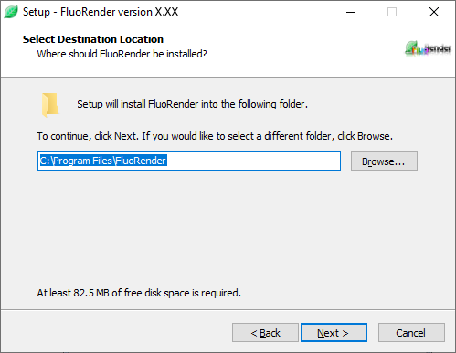

Figure ‑. Destination location.

1. Select shortcut options. Click Next to continue.

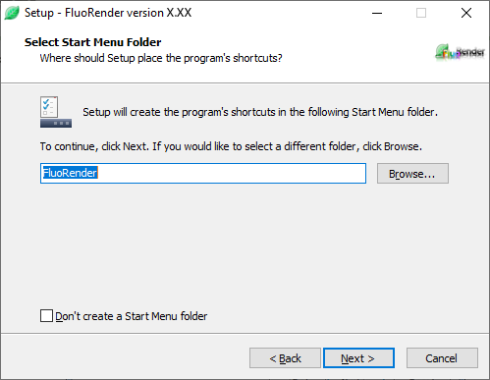

Figure ‑. Main user interface of FluoRender on Windows.

1. Select Additional Tasks. Check the box if you wish to have a desktop shortcut to FluoRender. Click Next to continue.

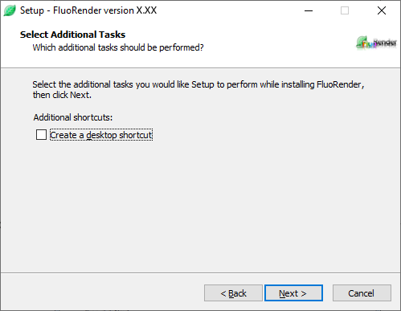

Figure ‑. Additional tasks.

1. Ready to Install. Here is a review of what will be installed on your machine. Click Install to continue.

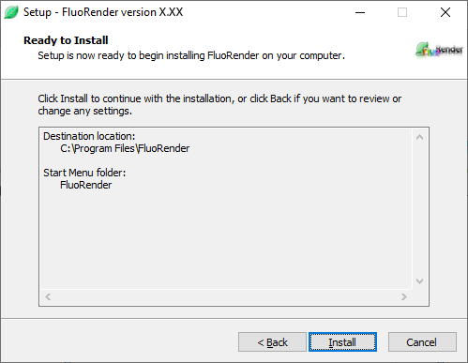

Figure ‑. Ready to install.

|  |  |
| --- | --- |
|  | You may also be asked to install “Microsoft Visual Studio Runtime Redistributable for x64”. You will need an internet connection for the installer to download and install this requirement for FluoRender. |

1. After clicking “Install”, setup will copy files onto your computer. When completed, setup will tell you that install is complete and to click “OK” to run FluoRender.

## Install FluoRender on Mac OS

|  |  |
| --- | --- |
|  | We have discontinued the support of old Mac OS versions. Currently supported versions include: 13.3 (Ventura) and later. Please make sure your hardware is compatible with this version of Mac OS. If you are unable to use the latest Mac OS, you will need to use an earlier version of FluoRender (also on FluoRender’s download website). FluoRender 2.14 is compatible with Mac OS 10.6 and above. There are many new features and bug fixes that are not included in 2.14. Continued support will only be available for the latest Release of FluoRender. |

1. Download *FluoRender2.33\_mac64\_x86\_64.pkg* from the website (https://github.com/SCIInstitute/fluorender/releases).
2. Double-click the package file icon to start the installation process. Recent Mac OS versions check the signature of an installer and may prevent the installation of FluoRender. Copy the installer file to the desktop and right-click the file icon. From the pop-up menu, choose **Running the Installer** by the Installer app.



Figure ‑. FluoRender installation on Mac OS.

1. Click the button “Continue” to view the license.



Figure ‑. FluoRender software license.

1. Click the button “Continue”.



Figure ‑. FluoRender software license.

1. Click the button “Agree” to accept the license.



Figure ‑. FluoRender installation information.

6. Click the button “Install” to install FluoRender on your computer. You need to type the root password in order to continue installation.



Figure ‑. FluoRender installation is successful.

7. If the installation finishes, click the button “Close” to quit the installation program. You can run FluoRender from the “Application” directory.

## Build FluoRender on Linux Systems

1. The choice of Linux distribution as well as hardware configuration may influence the running of FluoRender. Make sure that OpenGL and OpenCL are supported with GPU acceleration. Vendor-specific drivers for GPUs may need installation before using FluoRender.

2. Install these dependencies:

gcc, g++, git, CMake, JDK, gtk-dev, libOpenCL1, glu-dev, opencl-headers, hdf5, python, and ffmpeg development libraries.

Compilers with C++20 support are needed.

3. Download and build boost:

|  |
| --- |
| git clone --recursive https://github.com/boostorg/boost.git  cd boost  ./bootstrap.sh  ./b2 |

List ‑. Build boost.

4. Download and build wxWidgets:

|  |
| --- |
| git clone --recursive https://github.com/wxWidgets/wxWidgets.git  cd wxWidgets  mkdir mybuild  cd mybuild  ../configure --disable-shared --enable-cxx11 --with-cxx=11 --enable-stl --enable-std\_containers --enable-std\_iostreams --enable-std\_string\_conv\_in\_wxstring --with-libpng=builtin --with-libtiff=builtin --with-libjpeg=builtin --with-zlib=builtin --with-opengl  make |

List ‑. Build wxWidgets.

5. Use CMake to generate FluoRender make files. Select directories for dependencies that are not installed or automatically found by CMake. If an IDE is desired, use CMake to generate the project file for the IDE.

6. Build FluoRender.

# FluoRender User Interface

## FluoRender Main User Interface

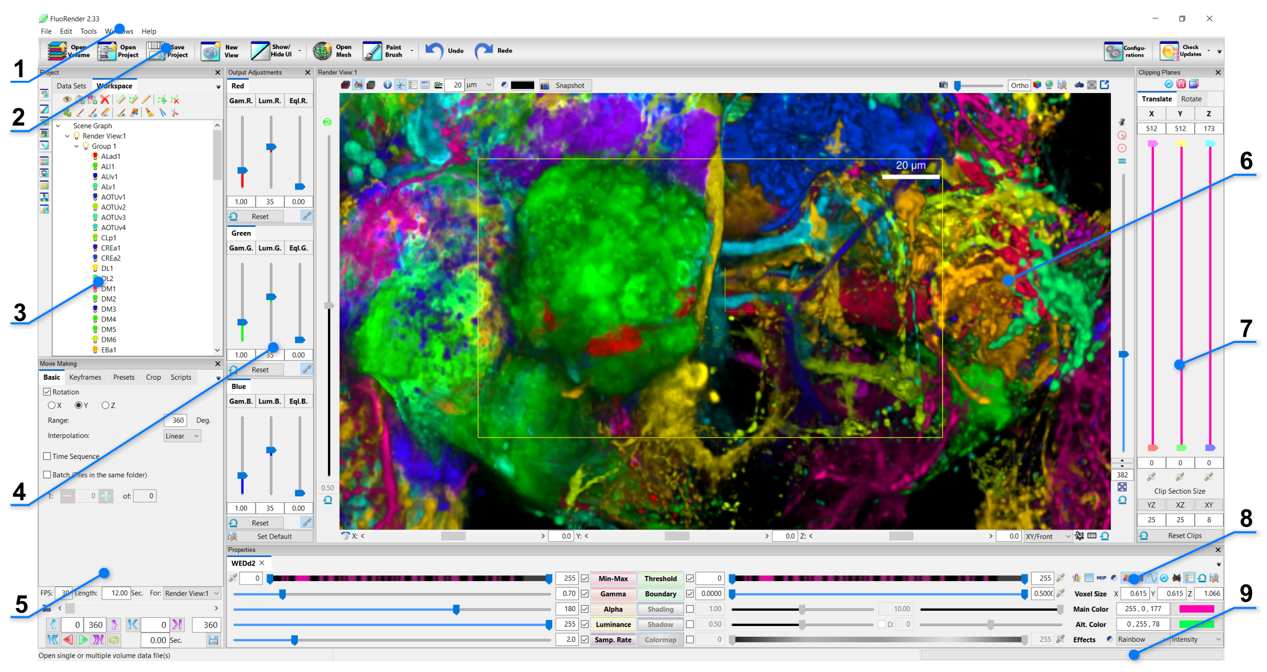

Figure ‑. Main user interface of FluoRender.

The default layout of FluoRender’s main user interface includes panels as follows.

1. **Main menu.** Functions in the main menu can be accessed from the main toolbar as well.
2. **Main Toolbar.** The most used functions are listed on the left side of the main toolbar, including loading volumes and projects. Analysis tools of FluoRender are stacked under one button on the main toolbar. You can use the drop-down menu to choose a tool that is not currently shown. The most recently used tool is shown for quick access.
3. **Project panel.** The project panel contains two sub-panels. The loaded data sets are listed in the dataset panel. They can be added to a render view. Multiple instances of the same data set can be added to render views as well. The visualized data sets are listed in the workspace panel. For volume data, each item is called a “channel”. There is no limit to the number of channels that can be visualized. When a channel is selected in the workspace panel, most subsequent operations are applied to the selection.
4. **Output adjustment panel.** Use this panel to adjust the visual settings of render view output, as individual RGB color channels. When a volume is selected in the workspace, its adjustments are for the entire group that the selection belongs to; when a render view is selected, its adjustments are for the entire render view.
5. **Movie-Making panel.** Record and export a rotation movie, a time sequence, or a keyframe animation using this panel. The selected viewport can also be cropped for export.
6. **Render-View panel.** The main panel for visualization and analysis. Multiple render view panels are supported.
7. **Clipping plane panel.** Use clipping planes to isolate a portion of the selected volume. Clipping planes belonging to different channels can also be synchronized.
8. **Property panel.** All adjustable visual settings of the current selection. Adjustments are applied in real time.
9. **Status bar.** The status bar is divided horizontally into three sections: tooltips displaying information on toolbar buttons, status information showing current work in progress, and a progress bar indicating the work progress.

|  |  |
| --- | --- |
|  | Try the example project, which can be found in the “Data” folder in the FluoRender installation directory. |

## Reorganizing FluoRender’s User Interface

Most panels, dialogs, and windows of FluoRender can be closed by clicking the close button on the top right corner. To reopen a panel, use the Windows menu. You can also hide or show all panels except render views using the “Show/Hide UI” button in the main toolbar. Most panels can be repositioned by dragging the title bar. Additionally, panels can be resized by dragging the dividers between two panels.

The controls of the panels of the main user interface are also organized into tabs. For example, the settings for each channel of the output adjustment panel are shown side-by-side by default (Chapter 9). You can drag the tab of each channel and reorganize them so that only the top tab is visible.

The layout of FluoRender’s user interface is saved in the settings each time FluoRender is closed. The saved layout will be applied when FluoRender is launched next time. However, the saved layout will be cleared, and the layout will revert to the default if the display scaling changes. To reset the layout, use the reset function in the “Windows” main menu.

Figure ‑. Tabs in the output adjustment panel are reorganized.

## FluoRender Main Menu

### File

The file menu contains operations for loading data sets and managing projects.

**New Project.** Clear the current workspace for a new project (Chapter 14).

**Open Volume.** Load a volume data set into FluoRender (**Error! Reference source not found.**).

**Open Mesh.** Load a polygonal mesh object into FluoRender (**Error! Reference source not found.**).

**Open Project.** Load a saved project file into FluoRender (Chapter 14).

**Save Project.** Save the current workspace in a project file (Chapter 14). If the current workspace is already saved as a project, it will either save the project in a new file with an incremental serial number or overwrite the existing project file based on the settings of FluoRender (Chapter 23).

**Save As Project.** For an already saved project, it will ask for the name of a new project file. If no project file is saved previously, it is the same as the save project operation (Chapter 14).

**Exit.** Close FluoRender.

### Edit

**Undo.** Undo a previous operation.

**Redo.** Redo an undone operation.

### Tools

The tools menu contains operations to open dialog windows for the data processing and analysis tools in FluoRender.

**Volume Filter.** Enhance features in volume data using volume filters. It provides a list of built-in filters that can be applied to an entire volume or every XY plane in a volume. The code of each filter can be edited in the editor. Users can also write custom filters using the OpenCL C language (Chapter 15).

**Paint Brush.** Use the paintbrush to select structures three-dimensionally. The selected structures can be extracted, erased, aligned to viewport orientation, and measured for size (Chapter 16).

**Measurement.** Draw rulers three-dimensionally or over time to measure length, angle, and branches (Chapter 17).

**Component Analyzer.** Segment structures into components and make an analysis of the components (Chapter 18).

**Tracking.** Track the movement of segmented components over time. Both automated tracking and manual tracking are supported (Chapter 20).

**Calculation.** Compute the union, difference, division, and colocalization of two volume channels (Chapter 19).

**Noise Reduction.** Remove small-size structures via the component analysis functions (Chapter 19).

**Volume Size.** Compute the voxel size of a volume channel or a paint-brush selected structure (Chapter 19).

**Colocalization.** Compute the colocalization of three or more channels and show the results in a table (Chapter 19).

**Convert.** Convert a volume channel or paint-brush selected structure into a polygonal mesh object (Chapter 21).

**Machine Learning Manager.** Manage the records for generating machine-learning models for predicting the parameters of data analysis and visualization tools in FluoRender (Chapter 22).

**Configurations.** The main settings of FluoRender (Chapter 23).

### Windows

The windows menu contains operations to adjust the layout of FluoRender’s main user interface.

**Show/Hide Toolbar.** Show or hide the main toolbar of FluoRender.

**Show/Hide UI.** Show or hide the panels other than the render view panel of FluoRender’s main user interface.

**Project.** Show or hide the project panel.

**Movie Making.** Show or hide the movie-making panel.

**Output Adjustments.** Show or hide the output adjustment panel.

**Clipping Planes.** Show or hide the clipping plane panel.

**Properties.** Show or hide the property panel.

**Layout.** Adjust the sizes of multiple render-view panels to be evenly sized.

**Reset.** Revert the user interface layout to default.

**New View.** Open a new render-view panel.

**Full Screen.** Make the FluoRender window expand to cover the entire screen space.

### Help

The help menu contains extra information about FluoRender.

**Check for Updates.** Check if the currently running version of FluoRender is the latest official release.

**Video Tutorials.** Open a web link to tutorial videos for using FluoRender.

**Twitter.** Open a web link to the Twitter page of FluoRender.

**Facebook.** Open a web link to the Facebook page of FluoRender.

**Manual PDF.** Open a web link to the manual (this document) of FluoRender.

**Tutorial PDF.** Open a web link to the written tutorials of FluoRender.

**About FluoRender.** Information about the developing team.

## FluoRender Main Toolbar

The main toolbar contains frequently used operations of FluoRender.

**Open Volume.** Load a volume data set into FluoRender (**Error! Reference source not found.**).

**Open Project.** Load a saved project file into FluoRender (Chapter 14).

**Save Project.** Save the current workspace in a project file (Chapter 14). If the current workspace is already saved as a project, it will either save the project in a new file with an incremental serial number or overwrite the existing project file based on the settings of FluoRender (Chapter 23).

**New View.** Open a new render-view panel.

**Show/Hide UI.** Show or hide the panels other than the render view panel of FluoRender’s main user interface.

**Open Mesh.** Load a polygonal mesh object into FluoRender (**Error! Reference source not found.**).

**Tools.** The same operations as the tool’s menu. The last used tool is shown.

**Undo.** Revert one step of previous operations.

**Redo.** Reapply one step of operations reverted by the previous undo operation.

**Configurations.** The main settings of FluoRender (Chapter 23).

**Extra Information.** The same operations as the help menu. A randomly selected option is shown at startup.

# Loading Data

Volume and mesh objects are the two major data types to be visualized and analyzed in FluoRender. A volume is a 3D image comprised of sample points on a regular 3D grid, each sample point called a voxel. A volume can be saved on disk as a single file or as a series of 2D images. A time sequence of volumes is generated from continuously scanning a living sample. A time sequence can be saved as individual time points, or as a single file with a supported format. See Appendices for more details on file formats.

## Volume Data

### Single channel

To open a single channel of a volume, click “Open Volume”  in the main toolbar. In the file browser dialog, choose a supported volume data file. Then, click “Open”. The selected file is loaded into FluoRender and visualized in the render view with default settings.

### Multiple channels

To open more than one channel of volumes, click “Open Volume”  in the main toolbar. In the file browser dialog, select multiple files within the same file folder. Then, click “Open”. The selected files are loaded into FluoRender and visualized in the render view with default settings. The first three channels loaded are assigned with red, green, and blue colors respectively. Then, a subsequently loaded channel is assigned with a randomly generated color.

|  |  |
| --- | --- |
|  | Alternatively, the “Open Volume” command can be found in the main menu. Users can also drag and drop file(s) to the FluoRender main user interface to open them. If FluoRender is not currently running, Users can drag and drop file(s) to the desktop icon of FluoRender. FluoRender also supports file names as command inputs. For example, to launch FluoRender with opened files, type the following command in the console window: FluoRender.exe “file1” “file2”. |
|  | If excitation wavelength information is read from metadata, colors can be automatically assigned. See Chapter 22 and the appendix on file format for more details. |

### Z-stack sequence

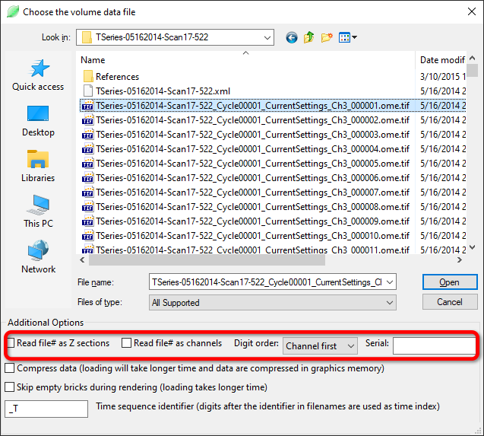

Figure ‑. Load a Z-stack sequence.

|  |  |  |
| --- | --- | --- |
| Z-stack type | Option setting | Example |
| Multiple Z sections, single channel | 🗹Read file# as Z sections | Name\_Z###.tif |
| Single Z section, multiple channels | 🗹Read file# as channels | Name\_C###.tif |
| Multiple Z sections, multiple channels;  Channel number goes first | 🗹Read file# as Z sections;  🗹Read file# as channels;  Channel first | Name\_C###\_Z###.tif |
| Multiple Z sections, multiple channels;  Z section number goes first | 🗹Read file# as Z sections;  🗹Read file# as channels;  Z section first | Name\_Z###\_C###.tif |

A volume channel stored in the form of a series of 2D images (Z-stacks) can be loaded with FluoRender, on condition that the stack files are named properly with numbers to index the sequence. A multichannel data set can store RGB channels in one Z slice. Or the channels may be stored as individual files. When channels are stored as separate files, a number representing the channel index needs to be in the names as well. To open a Z-stack sequence, click “Open Volume”  in the main toolbar. In the file browser dialog, check the options to match the naming style (Figure 4‑1). Then, select **just one** file from the sequence and open it. FluoRender will match the file names within the folder to the selected file and load the entire sequence as a volume channel. Use the table below as a guide for setting the options.

### Time sequence



Figure ‑. Load a time sequence.

FluoRender can also load a time sequence. Like a Z-stack sequence, a time sequence needs to be named correctly for loading. However, there is a configurable identifier for a time sequence. To open a time sequence, click “Open Volume”  in the main toolbar. In the file browser dialog, make sure the “Time sequence identifier” matches that within the sequence. Then, select **just one** file in the sequence to open it. The selected file is visualized. To view the time sequence, use the playback functions in the “Movie Making” panel (Chapter 12).

|  |  |
| --- | --- |
|  | Make sure the time sequence identifier only appears once in the file name. For example, when using the identifier “\_T”, a file name pattern like “My\_Time\_Sequence\_T\*\*.tif” can confuse FluoRender, because “\_T” appears twice. In this case, you can simply change the identifier in the file browser dialog to “e\_T”, which appears only once in the file name. |

### Loading data with masks

Mask files to a channel are saved along with the original data files. They are automatically loaded into FluoRender when the data files are loaded. It is possible to generate masks on reduced resolution data and apply them to original resolution data. Simply copy the mask files into the same directory and make sure the file names are the same (except the suffixes). FluoRender automatically resamples the mask files if their resolution does not match with the original files.

### Load mask and label directly

You can also load mask and label files directly into FluoRender. Their file extensions are .msk and .lbl respectively.

### ImageJ Hyperstack

ImageJ can save a 5D (XYCZT) data set as a hyperstack in a single TIFF file. Information about the hyperstack is saved in the image description of the TIFF file. You can open a hyperstack TIFF using the same method as a normal TIFF file. FluoRender will read the image description and separate channels and time points accordingly. FluoRender supports ImageJ Hyperstack files larger than 4 GB. Convert a large time sequence data set into the Hyperstack to open in FluoRender.

### Large Data Streaming

If a data set is large in terms of spatial resolution or channel number, rendering can become less interactive, or even impossible. Enable large data streaming when data size exceeds graphics memory size. Details of large data streaming can be found in Chapter 22. When data sets are being loaded, the progress dialog displays current large data streaming settings.

|  |  |
| --- | --- |
|  | Since FluoRender version 2.33, the large data size setting determines if a data set is divided into bricks and if large data streaming is enabled. |
|  | Skip empty bricks during rendering can be enabled when volumes are loaded for large data streaming. When enabled, each brick is checked, and empty bricks are ignored during rendering to allow faster speed. |

### File Formats

To achieve great performance, we code our own readers for different formats, instead of using third-party format converters. See Appendices for supported file formats.

### Series Selection

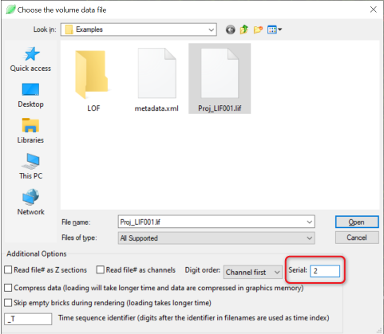

Figure ‑. Load a series from LIF.

**Serial.** A LIF file may contain multiple independent scans. Set the serial number to load a specific scan in the file. When the serial number is left blank, the first scan in a LIF is loaded. Different scans in an LIF file can also be browsed using the batch process function.

### Automatic Channel Separation

When loading Prairie/Bruker XML format, if the data set contains tiles scanned at different stage locations, FluoRender will check if the tiles overlap with each other. If no overlapping tiles are found, FluoRender separates each tile into a channel. This is useful when an experiment scans several samples mounted on the same stage. Make sure you set the stage to leave some space between any two samples.

### Multiresolution Data

FluoRender supports the VVD format, which contains a series of resolution levels. A resolution level is selected for display based on the zoom ratio. An extremely large data set can therefore be visualized.

### Video Files

Commonly used video formats are supported. They are loaded as time-dependent volumes of single Z slices.

### Floating-Point TIFF

Floating-point TIFF files are converted to 16-bit integer volume data. The files are scanned for their value range for conversion. A dialog is shown to allow modification of the value range.

## ImageJ & Bioformats Plugin

You can use ImageJ and Bioformats to load a format originally unsupported by FluoRender. You need to have ImageJ and Bioformats installed and configured correctly. See Chapter 22 for the settings to link FluoRender with ImageJ. When ImageJ and Bioformats are correctly configured, click “ImageJ Import”  in the main toolbar. In the file browser dialog, choose one or multiple files and let ImageJ load them into FluoRender.

|  |  |
| --- | --- |
|  | You can also link FluoRender with Fiji, which includes Bioformats. Therefore, no additional plugins and configurations are needed. |

## Mesh Data

To load mesh data, click “Open Mesh”  in the main toolbar. In the file browser dialog, choose one or multiple mesh files to load them.

|  |  |
| --- | --- |
|  | Only Wavefront OBJ format is currently supported. A mesh object can have associated materials and textures. |

# Managing Data

Loaded data sets are listed in the “Datasets” panel (Figure 5‑1). The data-set panel is a tab of the project panel, which can be shown on top by clicking the title tab or dragged to show side-by-side with the workspace panel.

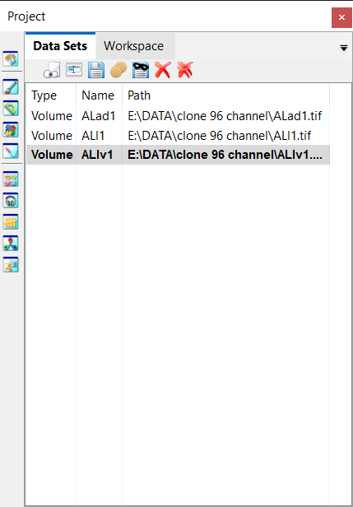

Figure ‑. Dataset panel.

Each loaded data set has a type identifier (volume, mesh, etc.), a name (initialized to its file name), and a path. For a data set created within FluoRender, the path entry is empty initially. When a created data set is saved, the path entry is updated. Only one data set can be selected from the list at one time. The following operations are applied to the selected data set.

 **Add.** It adds the selected data set to the render view. If multiple render views are opened, the data set is added to the first render view in the “Workspace” panel.

|  |  |
| --- | --- |
|  | Alternatively, the user can right-click a data set. In the context menu, under “Add”, there is a list of currently opened render views. A different render view than the first one can be selected through the context menu. The same data set can be added to a render view repeatedly. Each instance of the data set has its own volume settings. However, if the intensity values of any one of the instances are changed, all will be updated. |

** Rename.** It allows renaming selected data sets. Names are used to uniquely identify data sets within FluoRender. They are initialized to their file names after loading, which can be changed for easy data organization. FluoRender will automatically resolve name conflicts, for example, when data sets are duplicated.

** Save.** It saves the selected data set to a hard drive. FluoRender will always ask for a directory and file name for saving a data set. Make sure that important original data sets are not over-written.

|  |  |
| --- | --- |
|  | The file formats that a selected volume can be saved are less than that can be read. For example, for volumes, TIFF is the preferred format. |

When saving a volume channel, these additional options are available:

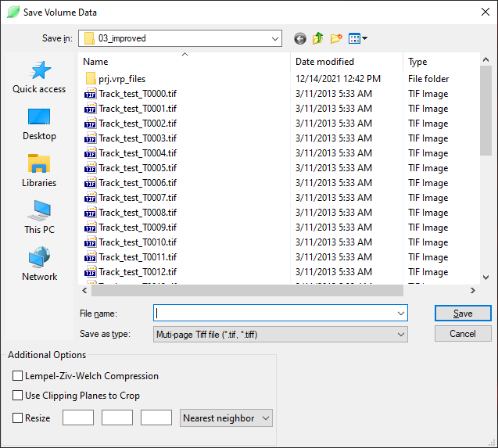

Figure ‑. Save volume dialog.

**Lempel-Ziv-Welch compression.** It saves the image content in the TIFF file using the compression method.

**Use Clipping Planes to Crop.** Enable this option to crop the volume to a smaller size defined by the clipping planes. You need to set the clipping planes before using this option. Clipping planes can be moved to only include a smaller size. Or, they can be rotated, which will reorient the saved volume. If mask and label volumes are present, they are cropped to the same size.

**Resize.** Once checked, the original resolution of the volume channel is displayed. New resolution values can be entered. FluoRender will resample the data to the new resolutions.

**Interpolation/filtering.** Choose an interpolation or filtering method when a volume channel is resized or rotated to smooth the aliasing from resampling. The nearest neighbor method does not apply any smoothing; the bilinear method applies smoothing only within Z sections; the trilinear method applies smoothing in 3D; the box method applies equal weights to all neighbors.

** Bake.** It saves a selected volume data set with its properties applied. For example, you can set a threshold value for a volume data set to cut off noise signals. When you “bake” the volume data set, you save it with the threshold applied, therefore removing the noise signals. Volume properties that are saved with the baking function include:

* Gamma
* Saturation
* Alpha
* Boundary
* Threshold (Soft threshold, see Chapter 23)
* Clipping planes

The same settings for saving a volume channel (Figure 5‑2) are used for baking.

|  |  |
| --- | --- |
|  | Data values outside of the clipping planes are set to 0 when baked. You may use this feature to create a sub-volume from the original data. However, the actual data size is unchanged. Clipped space is padded with zero values. |

 **Save Masks**. It saves the selection mask and label mask of a selected volume channel. The name of the mask files is automatically chosen based on the file name of the selected volume channel. Therefore, make sure the volume channel is saved before saving its masks.

** Delete.** It deletes the selected data set from FluoRender. It does not delete data from a hard drive.

In addition, the “delete all” **** command is used to delete all data sets in the list.

# Workspace

Only data sets in the “Workspace” panel can be visualized and analyzed (Figure 6‑1). Most operations in FluoRender are applied to currently selected items in the “Workspace” panel. Only one item can be selected at one time. If a volume or mesh is selected, its properties are loaded into the “Property” panel. Items are organized into a “Render View”-“Group”-“Data Set” hierarchy. Items can be reorganized by dragging and dropping them on the list.

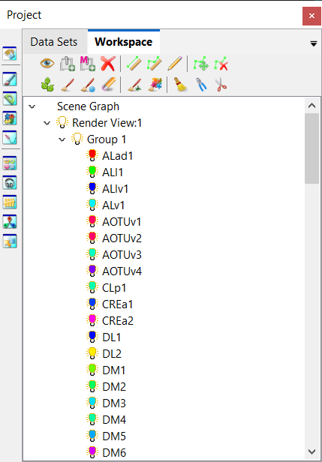

Figure ‑. Workspace panel.

## Toolbar Icons

 **Toggle visibility.** Click to enable and disable the visibility of a selected data set. The same effect can be achieved by double-clicking the icon of a data set. The visibility of a group or a render view can be toggled similarly. When the visibility of a group is disabled, every item within the group becomes invisible.

 **Add a volume group.** Volume data sets are organized under groups. Some operations are applied on groups, instead of individual volume channels, including output adjustments, and synchronized operations.

|  |  |
| --- | --- |
|  | Alternatively, a volume data set can be dragged to the bottom empty space within the “Workspace” list. A new volume group is automatically created. |

** Add a mesh group.** Mesh groups are for organizing mesh data sets.

** Delete selection.** It removes a selected data set from the workspace. Removed data sets are not deleted from FluoRender and can still be accessed from the “Dataset” panel.

The rest of the workspace toolbar icons are for paint selection. Please refer to Chapter 15 for details.

## Context Menu Commands

|  |  |
| --- | --- |
|  | Context menu commands can vary when different items are selected. |

### Common context menu commands

**Toggle Visibility.** It changes the visibility of a selected item.

**Randomize Colors.** It randomly chooses a color for the current selection.

**Add Volume Group.** It adds a volume group to the current render view.

**Add Mesh Group.** It adds a mesh group to the current render view.

**Delete.** It deletes the current selection from the workspace. “Close” is shown instead for a render view.

|  |  |
| --- | --- |
|  | Alternatively, you can hold down the “Ctrl” key and double-click the icon of an item to randomize its color. |

### Context menu commands for render views

**Collapse/Expand.** It collapses or expands a list of child items.

### Context menu commands for groups

**Isolate.** It disables the visibility of all other data sets except those in the group.

**Show All.** It enables the visibility of all data sets.

### Context menu commands for volumes

**Isolate.** It disables the visibility of all other data sets except the current selection.

**Show All.** It enables the visibility of all data sets.

**Copy Mask.** It copies the mask of the selected channel to be pasted into another channel.

**Paste Mask.** It pastes the copied mask into the selected channel.

**Merge Mask.** It merges a copied mask into the selected channel with its existing mask.

**Exclude Mask.** It pastes a copied mask into the selected channel and subtracts it from the existing mask.

**Intersect Mask.** It pastes a copied mask into the selected channel and computes the intersection between the two masks.

**Volume Filter.** It shows the “Volume Filter” (see Chapter 22).

**Paint Brush.** It shows the “Paint Brush” window (see Chapter 15).

**Measurement.** It shows the “Measurement” window (see Chapter 17).

**Component Analyzer.** It shows the “Component Analyzer” window (see Chapter 18).

**Tracking.** It shows the “Tracking” window (see Chapter 20).

**Noise Reduction.** It shows the “Noise Reduction” window (see Chapter 18).

**Volume Size.** It shows the “Volume Size” window (see Chapter 18).

**Colocalization.** It shows the “Colocalization” window (see Chapter 18).

**Convert.** It shows the “Convert” window (see Chapter 21).

|  |  |
| --- | --- |
|  | Details on volume processing and analysis functions are discussed in the respective chapters. |

### Context menu commands for mesh objects

**Manipulate.** It shows mesh transformation controls in the “Property” panel. Selected mesh object can be rotated, translated, and scaled (see Chapter 11).

### Interactive Tools

Interactive tools include various paint brushes, grow selection, and rulers for measurements. They can be accessed quickly from the toolbar of the Workspace panel. Some of the interactive tools have settings automatically determined based on the intensity distribution of the volume, such as paint brushes and grow selection tools. If detailed settings are needed, icons on the vertical toolbar can be used to quickly open a tool dialog window. Detailed information for the measurement tools can be found in Chapter 17 and information for brush tools can be found in Chapter 16.

 Two-point ruler

 Polyline ruler

 Pencil ruler

 Edit ruler by moving points

 Delete ruler point

 Grow selection

 Brush selection

 Diffuse selection

Erase selection



Create a locator by brush selection



Brush selection and then segment



Reset all selection



 Extract selected region

 Delete selected region

# Render View

Render views are the most important panel/window in FluoRender. Data are visualized and analyzed within render views. Multiple render views can be created and managed. Figure 7‑1 shows FluoRender’s capability to mimic a classical “four-view” configuration. However, each render view provides powerful visualization functions, so it is adequate to use a single render view for most visualization and analysis requirements.

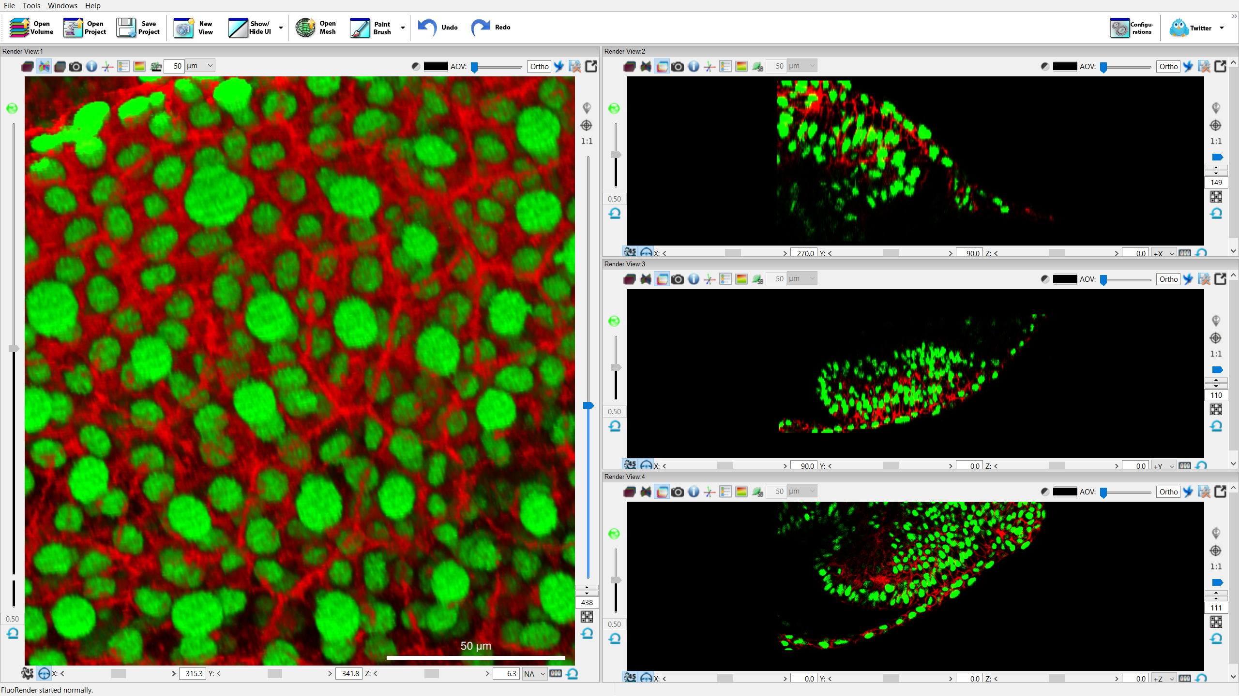

Figure ‑. Multiple render views in FluoRender.

## Multi-view Management

Render views are sequentially numbered in a session. FluoRender requires at least one render view available at the center of the main user interface. To create a new render view panel, click “New View”  in the main toolbar. The newly created render view is placed side-by-side with the initially created one. To adjust the sizes of render views, drag the divider between two render views. Like most panels in FluoRender, additional render views can be detached from the main user interface and become a standalone window. This can be useful when multiple monitors are available. Additional render views can be closed from the “Workspace” panel. However, the initial render view cannot be closed or detached from the main user interface. To close an additional render view, right-click its icon in the “Workspace” panel. In the context menu, choose “Close”.

Opened data sets are automatically added to the initial render view. To add a data set to an additional render view, right-click the data set in the “Dataset” panel. In the context menu, choose “Add to”, and then choose the desired render view. Data sets are duplicated by instance, which means that they share original data values, but can receive different settings. For example, there are four instances of the opened data set in Figure 7‑1.

## Channel Intermixing Methods

For multi-channel data, FluoRender provides three intermixing modes (Figure 7‑2). Use different intermixing modes to best visualize features from different channels.



Figure ‑. Channel intermixing modes.

 **Layered.** Channels are rendered individually and then layered one on top of another. Top channels in the workspace are also rendered on top. Changing the order of channels in the workspace will affect the visualization result. Layered mode is good for visualizing un-occluded features from top channels.

 **Depth.** Channels are intermixed with correct spatial occlusion. Depth mode is good for inspecting spatial relationships between channels.

 **Composite.** Channels are rendered individually and then their colors are summed up. Composite mode is good for occluding features between colocalized structures.

|  |  |
| --- | --- |
|  | A different render mode can be set for a group. Refer to Chapter 8 for more details. |
|  | Use output adjustments of a render view to reduce brightness if outputs of composite mode become oversaturated. See Chapter 9 for more details. |

## Render View Settings

The following render view settings are available through control widgets surrounding the render view.

 **Information.** It toggles the information display. Information includes render speed (in frames per second), and current cursor location in 3D.

** Center view axis.** It toggles the display of the center view axis. The center of render view is indicated by a widget of color-coded lines, perpendicular to each other. It rotates with current rotations settings.

 **Legend.** It displays a legend or list of names of currently visualized data. You can turn on or off the display of each channel of volume data by checking the legend button in the volume properties.

 **Color map legend.** It displays a legend for the currently selected volume channel if a color map is applied.

** Scalebar.** It displays a scalebar at the bottom margin of the render view. The length that the scalebar measures can be set using the numeric input next to the scalebar button. This button can be clicked twice to enable the scalebar text. A unit can be chosen from the dropdown list next to the numeric input. Click thrice to disable the scale bar. When frame cropping is enabled in the movie-making panel, the scalebar can be placed at the four corners of the frame.

|  |  |
| --- | --- |
|  | If correct metadata are read from data, the unit of the scalebar is chosen automatically. If no metadata can be obtained, the unit defaults to µm. |

 **Invert the background color.** It reverses the background color. For example, you can click the reverse background color button to set a white background from black quickly.

**Background color.** It changes the background color of the render view. To view data of low intensities, a background with a bright color can be helpful.

 **Camera operation mode.** When another interactive tool is enabled, such as a paint brush or ruler, click this button to set the mouse interaction within the render view to camera operations.

**AOV (Perspective Angle).** Projection determines how 3D structures are projected. A strong foreshortening effect is achieved with large angle values. Use the slider on the top border of the render view to set a perspective angle. When the slider handle is placed to the left end, orthographic projection is used. When the mouse cursor is moved into the slider region, a bounding box of the currently selected volume channel is displayed.

/ **Projection toggle.** Click this button to toggle between orthographic and perspective projections.

/ **Globe-Flight mode toggle.** Click this button to toggle between globe and flight mode for camera operations. In the flight mode, the camera is rotated around its own center, mimicking the motion of looking around. In the globe mode, the camera is rotated around a center usually on the data, mimicking the motion of rotating a globe. When the flight mode is enabled, the keyboard keys WSAD can be used to translate the position of the camera.

|  |  |
| --- | --- |
|  | A gradient background can be enabled in the FluoRender settings. When a gradient background is enabled, a faded color of the chosen background color is used at the “horizon” of the render view. |

** Save settings.** It saves all render view settings into a file. The settings are restored to the saved values the next time FluoRender is launched.

 **Stereography.** Click this button to enable stereography. If a VR/AR headset is connected to the computer, the render view is also mirrored to the VR/AR headset. FluoRender may need restart after connecting the holographic display. Settings for a VR/AR device can be found in the Configuration window (Chapter 23). Render view interactions can be operated by the controllers or hand gestures when a VR/AR device is used.

 **Holography.** Click this button to enable holography. To view the render view as a hologram, connect a Looking Glass display to the computer and install Looking Glass Bridge. FluoRender may need restart after connecting the holographic display.

 **Fullscreen.** Project the render view in full screen to a display. The full screen display can be selected from FluoRender configurations. Use keyboard key Esc to exit the full screen mode.

## Interactions

Basic render view interactions can be achieved using a mouse or compatible pointing device. In addition, standard control widgets can be found surrounding a render view panel.

### Rotations

To rotate the view, click and hold down the left mouse button (or primary button), and drag the mouse to the intended direction. Additional controls for rotation are located at the bottom of the render view panel. Use the sliders to restrict rotations around a single axis. Alternatively, you can input the exact rotation values. Note that the camera is rotated around different centers in the globe and flight modes. In the globe mode, the camera is rotated around a distant point usually on the data. In the flight mode, the camera is rotated around a point on its own body.

There are three buttons for rotation control.

/ **Rotation slider style.** There are two styles for the sliders controlling render view rotations. The first mode is the jog mode. In its resting state, the slider control is at the center. A rotation angle around an axis starts to change when the user drags the handle in one direction. The change rate depends on the offset of the handle to its center. The view keeps rotating at the specified speed as long as the handle is held at an offset position. This allows users to continuously rotate the view without resorting to the movie export functions. The second mode is the direct mode. The control of the slider sets the angle directly.

 **Geared rotation.** When enabled, all rotation angles are restricted to multipliers of 45. This allows users to quickly rotate to axis-aligned angles. For example, the axis-aligned views in Figure 7‑1 use this function to visualize image sections.

 **Zero rotation.** After rotating the render view to an arbitrary orientation. Click the zero-rotation button to set the current orientation as the zero rotation. Use this function for a tilted or flipped scan. To reset the zero rotation, reset the rotation angles first. Then, click the zero-rotation button again. Also, use the alignment functions to compute the leveled rotation for a scan (see Chapter 15, Chapter 17, and Chapter 18).

 **Reset rotation.** It sets all rotation angles of the X, Y, and Z axes to 0.

|  |  |
| --- | --- |
|  | Rotations of different render views can be synchronized by enabling “Link all render views’ rotations” in the “Rendering” panel of the setting dialog. |

On a computer equipped with a multitouch display, use one finger to rotate the view.

 When an Xbox controller is connected, use the right thumb stick to rotate the view.

### Standard Orthographic Views

Six standard orthographic views can be selected from the drop-down list for each render view: XY/Front, XY/Back, XZ/Top, XZ/Bottom, YZ/Left, and YZ/Right. Each view sets the viewing angle of data from an orthographic axis. When an orthographic view is selected, the 45-degree rotation lock is also enabled, so that the rotation of the view snaps to 45 increments. To quit a standard orthographic view, select “NA” from the list, or disable the 45-degree rotation lock and then rotate the view. When the view is rotated from one of the standard orthographic views, the orthographic view selection list is updated if a new standard orthographic view is achieved.

### Depth Attenuation

 **Depth attenuation.** It attenuates the renderings of data into a dark color based on their distance from the viewer. The strength of depth attenuation can be adjusted using the slider on the left border of the render view.

|  |  |
| --- | --- |
|  | The range of depth attenuation can be controlled by the rotation center. |

### Zooming

To zoom the view, click and hold down the right mouse button (or secondary button), and drag the mouse in straight up-down or left-right directions.

**Zooming in:** Up or right.

**Zooming out:** Down or left.

Additional controls for zooming are located on the right border of the render view. Use the slider to change the zoom level. Or, input an exact zoom level value. Value input also allows zoom levels greater than the slider’s range.

These buttons are for zooming control.

**1:1 ratio.** It sets a zoom level so that one sample point (pixel or voxel) of the original data occupies exactly one screen pixel.



**Zoom-level display mode.** There are two modes for zoom-level display:

 **View-based mode.** The zoom level is a percentage value representing how much a data set occupies the entire render view area. When you change the render view size, this value remains unchanged and the rendering changes its size based on this number. Use this mode when you want to generate renderings of the same size for data sets of different physical sizes. For example, you have two scans of 512x512 and 1024x1024 respectively. Render them in two projects and set the zoom level to the same value in the view-based mode. It generates two images of the same size for the two scans, although they have different data sizes. Scale bars represent the same value and have different lengths in the two images.

 **Pixel-based mode.** The zoom level is a percentage value representing how much a data set is enlarged or shrunk relative to its size when the 1:1 ratio button is pressed. It displays 100 when the 1:1 ratio button is pressed. When you change the render view size, this value changes since the rendering changes its size along with the render view. Press the 1:1 ratio button again to set its value to 100. Use this mode when you want to generate renderings of exact pixel sizes. For example, you have two scans of 512x512 and 1024x1024 respectively. Render them in two projects and set the zoom level to the same value in the pixel-based mode. It generates two images of different sizes which are proportional to the original data sizes.

 **Data-based mode.** Use this mode if you want to share a single scale bar across samples or compare their physical sizes. At 100 zoom ratio, one physical unit (usually µm) is mapped to one screen pixel.

|  |  |
| --- | --- |
|  | Depending on the zoom level display mode, a 100 zoom level does not necessarily mean a 1:1 ratio, and vice versa. In the view-based mode, we use the relative size of the entire data boundary (rotations considered) versus the render view size to determine the zoom level. When visualizing a square data set in a square render view, the data set occupies the entire render view when the zoom level = $\sqrt{2}×100≅141$. 100 zoom level usually means that the entire data set can be seen with generous margins. In the pixel-based mode, 100 zoom level means a 1:1 ratio. The data-based mode also considers the voxel size in a physical unit. |

 **Reset zoom.** Resets the zoom level to default. The default zoom level is saved when the render view settings are saved.

 On a computer equipped with a multitouch display, use two fingers and move them closer or apart to zoom.

 When an Xbox controller is connected, use the left thumb stick to zoom the view. Push the left thumb stick upward to zoom in; push the left thumb stick downward to zoom out.

### Panning

To pan the view, click and hold down the middle mouse button (or wheel), and drag the mouse to the intended direction. If the middle button is not available, hold down the “Ctrl” key (or “Command” key on a Mac) and use the left mouse button instead.

|  |  |
| --- | --- |
|  | Use the center axis as an indicator for the center of the render view. You can turn on the center axis with the button C:\Users\HP2\SkyDrive\FluoRender\center_axis.png on the top border of the render view. |

 **Rotation center anchor.** Enable the rotation center anchor to let FluoRender determine the depth of the current rotation center based on underlying data so that a prominent feature can be kept at the view center after rotation. This is usually used for large data sets when panning is necessary to examine the details. If slow interaction speed is experienced, enable this mode once to set the rotation center and then turn it off. Otherwise, the rotation center is continuously updated during panning operations. The rotation center anchor is turned on automatically at a high zoom ratio, which is useful for very large data sets, especially multiresolution data sets. The zoom ratio threshold can be configured in the settings. See Chapter 22 for more details.

**Choose center by mouse click.** Click a point on the currently selected channel in the Workspace panel and then the rotation center and render view center are moved to the selected point. When holography is enabled on a Looking Glass display, the operation is switched to focusing on the selected point. The render view will not translate in the XY directions. Only the depth (Z) is translated to align with the selected point.



 **Set center as volume data center.** Click the button to reset the center of the render view to the selected channel in the Workspace panel.

 On a computer equipped with a multitouch display, use two fingers and move them together to pan.

 When an Xbox controller is connected, use the directional pad to pan the view. Notice that the direction of the control is the same as the moving direction of the viewer, like in a video game.

### Selecting

Both volume and mesh data sets can be selected directly from the render view. Click on the visualization of a data set with the left mouse button, and the selected data set is highlighted in the “Workspace” panel.

## Capturing Render View

 Click the “Snapshot” button to save the render view as an image file.

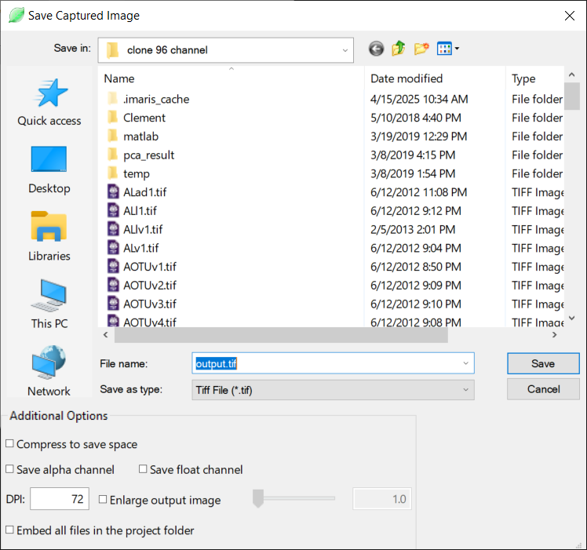

Figure ‑. Save the captured image.

In the pop-up dialog (Figure 7‑3), input the desired file name for the captured image. There are three additional options that you can check before saving the image.

**Compress.** The captured image is compressed for TIFF. For JPEG, a low-quality setting is used. PNG is always compressed.

**Save alpha channel.** An alpha channel is saved in addition to the RGB channels. The alpha channel allows overlaying the rendered data on a different background.

**Save float channel.** When this option is checked, each channel (RGBA) of the output image will be stored with 32-bit floating point numbers. FluoRender renders everything using floating-point frame buffers. Therefore, saving a captured image using floating-point numbers maximizes the precision. You can use an image editing tool, such as Adobe Photoshop to make further adjustments to the captured image without losing the dynamic range. Saving floating-point number images when the HDR (high dynamic range) mode is one way to present the results on non-HDR displays. See Chapter 23 for more information on the HDR mode.

**DPI.** DPI value of the output image. The default value is 72. If a higher value is set, image enlargement is automatically turned on to match the image size in terms of physical length in inches. The enlargement option (see below) can be turned off if it is undesirable.

**Enlarge output image.** Check this option and the enlargement factor becomes available. The render view will be rendered at an enlarged size and saved. Both the width and height of the render view are enlarged by the factor.

|  |  |
| --- | --- |
|  | For example, when you set the enlargement factor to 4, it renders the data as if it were connected to a display 4x4=16 times larger. Make sure your graphics card can support an output image this large. If the program stops responding, set a small number and capture again. |

**Embed all files in the project folder.** If you choose to save a project along with the captured image, check this option so that all original data files are preserved in the project.

## Full-Screen Mode (Microsoft Windows Only)

You can enter a full-screen mode so that the user interface of FluoRender occupies the entire display area. Use the menu Windows ->Full screen to enter or leave the full-screen mode.

 **Full Screen.** Enter full-screen mode. The window title and borders are hidden.

 **Full Screen.** Leave full-screen mode.

# Volume Properties

When a visible volume channel is selected in the “Workspace” panel, its properties are shown as a tab in the “Property” panel (Figure 8‑1). The title of each tab is the name of the channel. Click on the title to show the properties of the channel. Drag the tab title to reorganize the panel by changing the order or showing tabs side-by-side.

|  |  |
| --- | --- |
|  | When the visibility of a volume channel is disabled, its properties will not be loaded into the “Property” panel even if it is selected. |

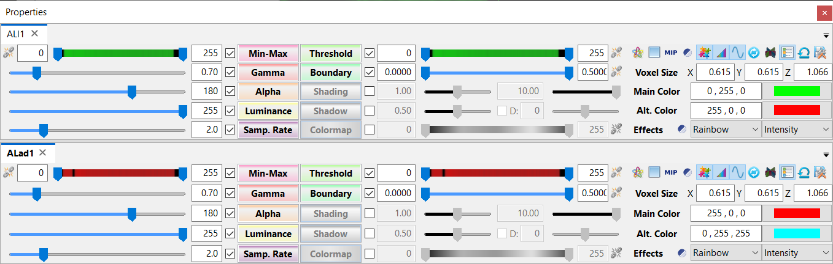

Figure ‑. Volume properties.

## Transfer Function Settings

A transfer function determines how intensity values from the original volume are mapped (or transferred) to colors that can be viewed on-screen with the help of rendering techniques.

A valued parameter of the transfer function is controlled by a slider, a value input box, a check box, and a multifunction button. The multifunction button also shows the name of the parameter. Some parameters can set a range between low and high values. They are controlled by a slider with two thumbs, two value input boxes, and a link button in addition to the check box and multifunction button. The check box always enables or disables the parameter settings. The purpose of the multifunction button can be configured in the main settings of FluoRender (Chapter 23). The available options of a multifunction button in the volume property panel include synchronizing the value through channels in a group, allowing scrolling the mouse wheel to change the value in the render view, applying the default setting for the value, applying machine-learning predicted setting for the value, undoing one step of changes to the value, and enabling or disabling the setting of the value.

**Min-Max.** It sets a range of intensity values mapped to the minimum and maximum output intensities. All intensity values out of the range are clipped. This value is automatically adjusted to match the intensity range of the data when the bit depth is greater than 8. The slider of the Min-Max adjustment shows the intensity distribution of the volume, which is a contrast-enhanced version of the histogram of the data. The computation of the histogram and subsequent intensity distribution display may be disabled for large data. Automatic histogram computation can be configured in the Configuration window (see Chapter 23).

**Gamma.** It adjusts a nonlinear intensity and transparency mapping of the channel values, using a “Gamma curve”: $V_{out}=V_{in}^{γ}$. Increasing the Gamma value maps original intensity values to brighter colors; decreasing the Gamma darkens them. Notice that transparency mapping is also influenced by the Gamma value. Therefore, setting a high Gamma value also makes rendering noisier. Or it accentuates the low-intensity values from the original volume, which usually makes the rendering (an integration calculation) darker. Considering such characteristics of Gamma, the direction of the slider is reversed by design.

**Alpha.** A multiplier to transparency mapping. Decreasing this value makes rendering more transparent. Alpha setting can be disabled. When disabled, volume transparency mapping is disabled. All voxels become opaque. It is useful when a thin layer of volume is visualized. For example, the image sections in Figure 7‑1 have Alpha disabled.

**Luminance.** It changes the luminance of the primary color assigned to the volume. This setting is linked to the primary color setting. An HSV color model is used for luminance calculation.

**Sample rate.** It determines the density of slices for rendering one voxel. A higher setting improves rendering quality but slows down interaction speed.

|  |  |
| --- | --- |
|  | Slices are recalculated when the viewing direction is changed. It makes sure that slices are always facing the view for little artifacts. Therefore, users may experience varying rendering speeds for an anisotropic volume. A “Variable sample rate” setting can be enabled to automatically adjust the sample rate for both high quality and interactive speed. See Chapter 23 for more details. |
|  | A value higher than the slider’s range can be set using the numeric input. |

**Threshold.** It sets two thresholding values (low and high). Voxels of intensity values within the range of setting are rendered. Use this setting to exclude noisy signals. When the low and high values are linked by clicking the link button, the distance between the two values will be maintained when dragging the thumbs on the slider. An intensity distribution similar to the Min-Max settings is displayed on the slider. The distribution can be used as a guide for excluding certain intensity values. Use a narrow range for the linked low and high values to explore how the intensity distribution corresponds to different regions of a volume.

|  |  |
| --- | --- |
|  | You can set a soft threshold in the settings. Soft thresholds can make edges soft. See Chapter 22 for more details. |

**Boundary.** The low boundary value sets a threshold to exclude regions with low gradient magnitude, which are homogeneous structures that are less likely to belong to the boundaries. The high boundary values is a factor to enhance regions with high gradient magnitude, which are boundary structures.

## Effect Settings

**Shading.** When enabled, it applies a shading effect to local features. Higher local contrast can be achieved by lowering this value.

|  |  |
| --- | --- |
|  | Rendering can become too bright when this setting is enabled. In such a case, use “output adjustment” to lower the brightness. See Chapter 9 for more details. |

**Light.** It changes the ratio between highlight and shade.

**Shadow.** When enabled, it applies a shadow effect on rendering. The value setting controls the strength of the shadow effect. The direction of the shadow effect can be adjusted by first enabling the direction setting and then adjusting the angle value.

## Color Settings

**Main Color.** It is the base color of the selected volume channel. Color can be set by typing RGB numbers in the text input box, or from the color chooser. Shortcuts to the most used colors are also available. Double-click the text input box to first select all text. Then, type the following letter code for different predefined colors.

r – Red; g – Green; b – Blue; c – Cyan; m – Magenta; y – Yellow; w – White, k – Black.

|  |  |
| --- | --- |
|  | A dark color, such as black, can be used for a bright background. |
|  | Alternatively, a random color can be assigned from the “Workspace” panel. See Chapter 6 for more details. |
|  | If excitation wavelength information is read from metadata, colors can be automatically assigned. See Chapter 22 and Appendices for more details. |

**Alt. Color.** It is the color to highlight selected structures within a volume. By default, the highlight color is calculated as the inverse of the primary color and changes with it. Once you choose a secondary color, it is fixed to your choice.

**Colormap.** When enabled, it maps original intensity values to a color map. The range of the color map can be adjusted using the low and high values. Additionally, you can choose a color map type and mapping mode. When the low and high values are linked by clicking the link button, the distance between the two values will be maintained when dragging the thumbs on the slider.

**Invert colormap.** Reverse the direction of the colormap. For example, the rainbow colormap is blue to red; the reversed rainbow colormap is red to blue.



|  |  |  |
| --- | --- | --- |
| Colormap Type | | Note |
| Rainbow |  |  |
| Main-Alt |  | Low: Main color, High: Alt. color |
| Hot |  |  |
| Cool | E:\OneDrive\FluoRender\cm04_cool.png |  |
| Diverging | E:\OneDrive\FluoRender\cm05_div.png |  |
| Monochrome |  |  |
| High-key |  | Low: White, High: Main color |
| Low-key |  | Low: Main color, High: Black |
| High Transparency |  | Low: Black, High: Main color |

|  |  |
| --- | --- |
| Mapping Mode | Note |
| Intensity | Maps intensity values to colors |
| Z value | Maps depth to colors |
| Y value | Maps vertical direction to colors |
| X value | Maps horizontal direction to colors |
| T value | Maps timepoint of a time sequence to colors |
| Gradient | Maps gradient magnitude to colors |
| Normals | Maps normal directions to colors |
| Intensity delta | Maps intensity difference between two timepoints of a time sequence to colors |
| Speed | Maps speed of movement of a time sequence to colors |

## Voxel Size

Use the numeric inputs to set the spacings between two sample points in original data, or voxel size, in the X, Y, and Z directions. It uses the unit in scale bar settings. If the metadata are correctly read from a scan, this setting is automatically determined. Otherwise, default values are used.

## Other Settings

 **Apply Machine Learning.** Click this button to automatically set volume properties based on machine learning results. A table for volume properties needs to be loaded in the Machine Learning Manager for this to work. Since Version 2.31, a deep neural network solver has been added to generate the volume properties based on the volume’s characteristics.

 **High transparency.** The high transparency mode is an alternative to MIP that allows you to see high-intensity structures inside of a volume channel more clearly. When the high transparency mode is on, low-intensity signals are assigned with a higher degree of transparency to reveal the underlying structures.

|  |  |
| --- | --- |
|  | The high transparency colormap is recommended to be used together with the high transparency mode. Otherwise, 3D structures may look flat. Additionally, shading and shadow effects help bring out the details. |

 **MIP.** The maximum intensity projection mode can be enabled to visualize concentrations of high-intensity values.

|  |  |
| --- | --- |
|  | MIP cannot be enabled in the Depth channel intermixing mode. Effect settings are available in MIP mode for shape and detail enhancement. |

 **Invert.** It inverts original intensity values so that high becomes low, and vice versa.

|  |  |
| --- | --- |
|  | Use inversion when a thick sample is mostly occupied with high-intensity signals. Threshold setting can be used in conjunction with inversion to visualize deep structures. |

 **Component display.** Enable component display to visualize segmented components in distinctive colors. Previously, the component display was linked to the script running. Since version 2.27, the status of the script running is no longer linked to the component display. Component display is automatically disabled when colormap is enabled.

 **Interpolation.** When enabled, it uses trilinear interpolation for smooth rendering results. Otherwise, the nearest neighbor interpolation is used.

|  |  |
| --- | --- |
|  | It is usually desirable to disable interpolation when a single image section is visualized, and exact intensity values are examined. See Chapter 10 for more details on rendering image sections. |

/ **Filter.** When enabled, a Lanczos-Bicubic filter is applied to rendered images to suppress high-frequency noise. Systems equipped with older or legacy GPUs may experience significantly reduce performance when filtering is enabled.

|  |  |
| --- | --- |
|  | The filter window size changes with the zoom level. At high zoom ratios, the bicubic filter is dominant to remove high-frequency artifacts. This can be useful when settings such as boundary and MIP are applied. At low zoom ratios, the Lanczos filter is dominant to remove the moire effect. See the examples below. |

 **Synchronize group.** Once enabled, the settings of the current selection are propagated to other channels within the same group. Subsequent setting changes of any channel in the group are also automatically applied to other channels. Group channels of similar scans into one group and set up an initial setting with this function. Disable synchronization for finer adjustment of each channel.

** Depth mode in group.** It forces depth channel intermixing mode within a group, disregarding render view’s settings. Usually, a group in the depth mode is layered on top of other channels and visualized without occlusion.

 **Show legend.** When enabled, it includes the current selection in the render view legend. Legend of the render view needs to be enabled in order to see it. Exclude channels of low importance from the legend to save render view space.

 **Save settings.** It saves all volume property settings into a file. The settings are restored to the saved values when FluoRender is launched. When learning is enabled in the Machine Learning Manager, it saves the settings as a record to the currently loaded table.

|  |  |
| --- | --- |
|  | Settings such as color and luminance are determined when a volume is added to render view. Spacing settings can be read from a scan’s metadata. If correct spacing settings are read from metadata, the saved values are not used. |

## Synchronize Settings

You may use the synchronize group button  to synchronize all settings within a group, or you can synchronize settings with a slider adjustment individually. Configure the multi-function button for synchronization and then use the multi-function button to just synchronize the select value.

|  |  |
| --- | --- |
|  | Use group synchronization for quick overall adjustment. Use individual synchronization for fine tuning. |

## Mode Combinations

This table lists different setting combinations for a volume. (0 = Mode OFF, 1 = Mode ON)

| High Transp | Alpha | MIP | Color Map | XYZ Mapping | Shading | Depth Attn | Availability | Note |
| --- | --- | --- | --- | --- | --- | --- | --- | --- |
| 0 | 0 | 0 | 0 | 0 | 0 | 0 | ✓ | Use clipping |
| 0 | 0 | 0 | 0 | 0 | 0 | 1 | ✓ | Not recommended |
| 0 | 0 | 0 | 0 | 0 | 1 | 0 | ✓ | Not recommended |
| 0 | 0 | 0 | 0 | 0 | 1 | 1 | ✓ | Not recommended |
| 0 | 0 | 0 | 0 | 1 | 0 | 0 | ✗ | XYZ mapping needs colormap |
| 0 | 0 | 0 | 0 | 1 | 0 | 1 | ✗ | XYZ mapping needs colormap |
| 0 | 0 | 0 | 0 | 1 | 1 | 0 | ✗ | XYZ mapping needs colormap |
| 0 | 0 | 0 | 0 | 1 | 1 | 1 | ✗ | XYZ mapping needs colormap |
| 0 | 0 | 0 | 1 | 0 | 0 | 0 | ✓ | Use clipping |
| 0 | 0 | 0 | 1 | 0 | 0 | 1 | ✓ | Not recommended |
| 0 | 0 | 0 | 1 | 0 | 1 | 0 | ✓ | Not recommended |
| 0 | 0 | 0 | 1 | 0 | 1 | 1 | ✓ | Not recommended |
| 0 | 0 | 0 | 1 | 1 | 0 | 0 | ✓ | Not recommended |
| 0 | 0 | 0 | 1 | 1 | 0 | 1 | ✓ | Not recommended |
| 0 | 0 | 0 | 1 | 1 | 1 | 0 | ✓ | Not recommended |
| 0 | 0 | 0 | 1 | 1 | 1 | 1 | ✓ | Not recommended |
| 0 | 0 | 1 | 0 | 0 | 0 | 0 | ✓ |  |
| 0 | 0 | 1 | 0 | 0 | 0 | 1 | ✓ |  |
| 0 | 0 | 1 | 0 | 0 | 1 | 0 | ✓ |  |
| 0 | 0 | 1 | 0 | 0 | 1 | 1 | ✓ |  |
| 0 | 0 | 1 | 0 | 1 | 0 | 0 | ✗ | XYZ mapping needs colormap |
| 0 | 0 | 1 | 0 | 1 | 0 | 1 | ✗ | XYZ mapping needs colormap |
| 0 | 0 | 1 | 0 | 1 | 1 | 0 | ✗ | XYZ mapping needs colormap |
| 0 | 0 | 1 | 0 | 1 | 1 | 1 | ✗ | XYZ mapping needs colormap |
| 0 | 0 | 1 | 1 | 0 | 0 | 0 | ✓ |  |
| 0 | 0 | 1 | 1 | 0 | 0 | 1 | ✗ | Colormap not attenuated |
| 0 | 0 | 1 | 1 | 0 | 1 | 0 | ✓ |  |
| 0 | 0 | 1 | 1 | 0 | 1 | 1 | ✓ | Shading attenuated |
| 0 | 0 | 1 | 1 | 1 | 0 | 0 | ✓ |  |
| 0 | 0 | 1 | 1 | 1 | 0 | 1 | ✗ | Colormap not attenuated |
| 0 | 0 | 1 | 1 | 1 | 1 | 0 | ✓ |  |
| 0 | 0 | 1 | 1 | 1 | 1 | 1 | ✓ | Shading attenuated |
| 0 | 1 | 0 | 0 | 0 | 0 | 0 | ✓ | Typical volume rendering |
| 0 | 1 | 0 | 0 | 0 | 0 | 1 | ✓ |  |
| 0 | 1 | 0 | 0 | 0 | 1 | 0 | ✓ |  |
| 0 | 1 | 0 | 0 | 0 | 1 | 1 | ✓ |  |
| 0 | 1 | 0 | 0 | 1 | 0 | 0 | ✗ | XYZ mapping needs colormap |
| 0 | 1 | 0 | 0 | 1 | 0 | 1 | ✗ | XYZ mapping needs colormap |
| 0 | 1 | 0 | 0 | 1 | 1 | 0 | ✗ | XYZ mapping needs colormap |
| 0 | 1 | 0 | 0 | 1 | 1 | 1 | ✗ | XYZ mapping needs colormap |
| 0 | 1 | 0 | 1 | 0 | 0 | 0 | ✓ |  |
| 0 | 1 | 0 | 1 | 0 | 0 | 1 | ✓ |  |
| 0 | 1 | 0 | 1 | 0 | 1 | 0 | ✓ |  |
| 0 | 1 | 0 | 1 | 0 | 1 | 1 | ✓ |  |
| 0 | 1 | 0 | 1 | 1 | 0 | 0 | ✓ |  |
| 0 | 1 | 0 | 1 | 1 | 0 | 1 | ✓ |  |
| 0 | 1 | 0 | 1 | 1 | 1 | 0 | ✓ |  |
| 0 | 1 | 0 | 1 | 1 | 1 | 1 | ✓ |  |
| 0 | 1 | 1 | 0 | 0 | 0 | 0 | ✓ | Typical MIP |
| 0 | 1 | 1 | 0 | 0 | 0 | 1 | ✓ |  |
| 0 | 1 | 1 | 0 | 0 | 1 | 0 | ✓ |  |
| 0 | 1 | 1 | 0 | 0 | 1 | 1 | ✓ |  |
| 0 | 1 | 1 | 0 | 1 | 0 | 0 | ✗ | XYZ mapping needs colormap |
| 0 | 1 | 1 | 0 | 1 | 0 | 1 | ✗ | XYZ mapping needs colormap |
| 0 | 1 | 1 | 0 | 1 | 1 | 0 | ✗ | XYZ mapping needs colormap |
| 0 | 1 | 1 | 0 | 1 | 1 | 1 | ✗ | XYZ mapping needs colormap |
| 0 | 1 | 1 | 1 | 0 | 0 | 0 | ✓ | Typical color-mapped MIP |
| 0 | 1 | 1 | 1 | 0 | 0 | 1 | ✗ | Colormap not attenuated |
| 0 | 1 | 1 | 1 | 0 | 1 | 0 | ✓ |  |
| 0 | 1 | 1 | 1 | 0 | 1 | 1 | ✓ | Shading attenuated |
| 0 | 1 | 1 | 1 | 1 | 0 | 0 | ✓ |  |
| 0 | 1 | 1 | 1 | 1 | 0 | 1 | ✗ | Colormap not attenuated |
| 0 | 1 | 1 | 1 | 1 | 1 | 0 | ✓ |  |
| 0 | 1 | 1 | 1 | 1 | 1 | 1 | ✓ | Shading attenuated |
| 1 | 0 | 0 | 0 | 0 | 0 | 0 | ✗ | No effect |
| 1 | 0 | 0 | 0 | 0 | 0 | 1 | ✗ | No effect |
| 1 | 0 | 0 | 0 | 0 | 1 | 0 | ✗ | No effect |
| 1 | 0 | 0 | 0 | 0 | 1 | 1 | ✗ | No effect |
| 1 | 0 | 0 | 0 | 1 | 0 | 0 | ✗ | No effect |
| 1 | 0 | 0 | 0 | 1 | 0 | 1 | ✗ | No effect |
| 1 | 0 | 0 | 0 | 1 | 1 | 0 | ✗ | No effect |
| 1 | 0 | 0 | 0 | 1 | 1 | 1 | ✗ | No effect |
| 1 | 0 | 0 | 1 | 0 | 0 | 0 | ✗ | No effect |
| 1 | 0 | 0 | 1 | 0 | 0 | 1 | ✗ | No effect |
| 1 | 0 | 0 | 1 | 0 | 1 | 0 | ✗ | No effect |
| 1 | 0 | 0 | 1 | 0 | 1 | 1 | ✗ | No effect |
| 1 | 0 | 0 | 1 | 1 | 0 | 0 | ✗ | No effect |
| 1 | 0 | 0 | 1 | 1 | 0 | 1 | ✗ | No effect |
| 1 | 0 | 0 | 1 | 1 | 1 | 0 | ✗ | No effect |
| 1 | 0 | 0 | 1 | 1 | 1 | 1 | ✗ | No effect |
| 1 | 0 | 1 | 0 | 0 | 0 | 0 | ✗ | No effect |
| 1 | 0 | 1 | 0 | 0 | 0 | 1 | ✗ | No effect |
| 1 | 0 | 1 | 0 | 0 | 1 | 0 | ✗ | No effect |
| 1 | 0 | 1 | 0 | 0 | 1 | 1 | ✗ | No effect |
| 1 | 0 | 1 | 0 | 1 | 0 | 0 | ✗ | No effect |
| 1 | 0 | 1 | 0 | 1 | 0 | 1 | ✗ | No effect |
| 1 | 0 | 1 | 0 | 1 | 1 | 0 | ✗ | No effect |
| 1 | 0 | 1 | 0 | 1 | 1 | 1 | ✗ | No effect |
| 1 | 0 | 1 | 1 | 0 | 0 | 0 | ✗ | No effect |
| 1 | 0 | 1 | 1 | 0 | 0 | 1 | ✗ | No effect |
| 1 | 0 | 1 | 1 | 0 | 1 | 0 | ✗ | No effect |
| 1 | 0 | 1 | 1 | 0 | 1 | 1 | ✗ | No effect |
| 1 | 0 | 1 | 1 | 1 | 0 | 0 | ✗ | No effect |
| 1 | 0 | 1 | 1 | 1 | 0 | 1 | ✗ | No effect |
| 1 | 0 | 1 | 1 | 1 | 1 | 0 | ✗ | No effect |
| 1 | 0 | 1 | 1 | 1 | 1 | 1 | ✗ | No effect |
| 1 | 1 | 0 | 0 | 0 | 0 | 0 | ✓ | Flat result |
| 1 | 1 | 0 | 0 | 0 | 0 | 1 | ✓ |  |
| 1 | 1 | 0 | 0 | 0 | 1 | 0 | ✓ |  |
| 1 | 1 | 0 | 0 | 0 | 1 | 1 | ✓ |  |
| 1 | 1 | 0 | 0 | 1 | 0 | 0 | ✗ | XYZ mapping needs colormap |
| 1 | 1 | 0 | 0 | 1 | 0 | 1 | ✗ | XYZ mapping needs colormap |
| 1 | 1 | 0 | 0 | 1 | 1 | 0 | ✗ | XYZ mapping needs colormap |
| 1 | 1 | 0 | 0 | 1 | 1 | 1 | ✗ | XYZ mapping needs colormap |
| 1 | 1 | 0 | 1 | 0 | 0 | 0 | ✓ |  |
| 1 | 1 | 0 | 1 | 0 | 0 | 1 | ✓ |  |
| 1 | 1 | 0 | 1 | 0 | 1 | 0 | ✓ |  |
| 1 | 1 | 0 | 1 | 0 | 1 | 1 | ✓ |  |
| 1 | 1 | 0 | 1 | 1 | 0 | 0 | ✓ |  |
| 1 | 1 | 0 | 1 | 1 | 0 | 1 | ✓ |  |
| 1 | 1 | 0 | 1 | 1 | 1 | 0 | ✓ |  |
| 1 | 1 | 0 | 1 | 1 | 1 | 1 | ✓ |  |
| 1 | 1 | 1 | 0 | 0 | 0 | 0 | ✓ | MIP increased transparency |
| 1 | 1 | 1 | 0 | 0 | 0 | 1 | ✓ |  |
| 1 | 1 | 1 | 0 | 0 | 1 | 0 | ✓ |  |
| 1 | 1 | 1 | 0 | 0 | 1 | 1 | ✓ |  |
| 1 | 1 | 1 | 0 | 1 | 0 | 0 | ✗ | XYZ mapping needs colormap |
| 1 | 1 | 1 | 0 | 1 | 0 | 1 | ✗ | XYZ mapping needs colormap |
| 1 | 1 | 1 | 0 | 1 | 1 | 0 | ✗ | XYZ mapping needs colormap |
| 1 | 1 | 1 | 0 | 1 | 1 | 1 | ✗ | XYZ mapping needs colormap |
| 1 | 1 | 1 | 1 | 0 | 0 | 0 | ✗ | No effect |
| 1 | 1 | 1 | 1 | 0 | 0 | 1 | ✗ | Colormap not attenuated |
| 1 | 1 | 1 | 1 | 0 | 1 | 0 | ✗ | No effect |
| 1 | 1 | 1 | 1 | 0 | 1 | 1 | ✗ | No effect |
| 1 | 1 | 1 | 1 | 1 | 0 | 0 | ✗ | No effect |
| 1 | 1 | 1 | 1 | 1 | 0 | 1 | ✗ | Colormap not attenuated |
| 1 | 1 | 1 | 1 | 1 | 1 | 0 | ✗ | No effect |
| 1 | 1 | 1 | 1 | 1 | 1 | 1 | ✗ | No effect |

# Output Adjustments

Most volume property settings are applied in 3D space before rendering and channel intermixing. To make finer adjustments to rendered and intermixed results in 2D image space, FluoRender provides a set of output adjustments (Figure 9‑1). There are three tabs for the red, green, and blue channels of the output image. By default, the tabs are shown side-by-side. The tabs can be dragged to stack together so that only the selected tab is shown.

Disregarding the number of volume channels to be visualized, the final output has three fixed color channels: red, green, and blue. For each color channel, there are three adjustment settings: Gamma, luminance, and equalization.

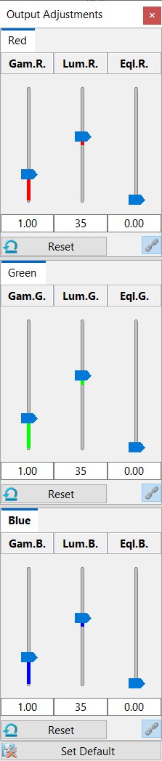

Figure ‑. Output adjustment panel.

**Gamma.** It uses a Gamma curve to remap the color intensities. Increasing Gamma brightens the overall result in nonlinear fashion.

**Luminance.** It is a multiplier that modulates the color intensities. Increasing luminance brightens the result linearly.

**Equalization.** It enhances low color intensities and increases local contrast at the same time. It also equalizes high and low-intensity signals.

Settings for red, green, and blue channels can be linked. Use the **link** button  to synchronize the settings of any combination of red, green, and blue channels.

Settings of each channel can be reset independently using “**Reset**” .

|  |  |
| --- | --- |
|  | Under certain circumstances, the color channel settings are automatically synchronized to maintain the hue of the output color. For example, when a volume channel’s color is set to white, the settings are synchronized. It is still possible to “unlink” the color channels and adjust them individually. |

The scope of the application of the settings can vary when different items are selected from the “workspace” panel. When a volume channel is selected in the “Workspace” panel, the output adjustment settings are applied to the group of selection. When a render view is selected in the “Workspace” panel, the output adjustment settings are applied to the selected render view.

|  |  |
| --- | --- |
|  | Equalization settings behave differently based on selections. When a render view is selected, equalization does not enhance local contrast. It suppresses high color intensities only, which can be used to recover details at colocalized regions in the composite channel intermixing mode. |

# Clipping Planes

When volume property settings become inadequate to reveal occluded structures of thick scans, clipping planes provide an easy solution. For each volume channel, a group of six clipping planes can be adjusted independently. They are +X, -X, +Y, -Y, +Z, and -Z, which are also color-coded as red, magenta, green, yellow, blue, and cyan, for visual distinction.

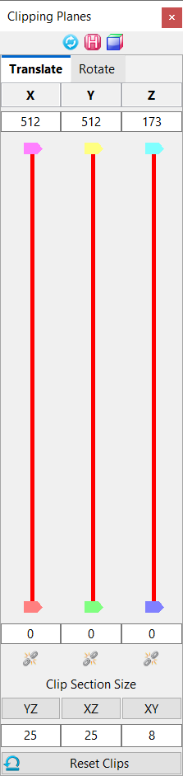

Figure ‑. Clipping plane translations.

## Clipping Plane Display Controls

The top three buttons control how clipping planes are displayed.

 **Synchronize all channels.** Enable clipping plane synchronization so that all channels use the same clipping plane settings.

 **Display hold.** Enable the clipping plane display to remain so that clipping planes are displayed even when the mouse cursor is moved outside of the panel.

 **Display mode.** There are five display modes for clipping planes. Click this button to cycle through all modes.

|  |  |
| --- | --- |
| E:\DESIGNS\FluoRender Arts\list_icons\convert\clip_normal.png | **Normal.** Color-coded planes with high opacity. |
|  | **Wireframe – all planes.** Only the borders of clipping planes are shown. |
| E:\DESIGNS\FluoRender Arts\list_icons\convert\clip_frame.png | **Wireframe – front planes.** Only the borders of front clipping planes are shown. |
| E:\DESIGNS\FluoRender Arts\list_icons\convert\clip_low.png | **Low opacity.** No colors are assigned to planes, which are shown with low opacity. |
| E:\DESIGNS\FluoRender Arts\list_icons\convert\clip_low_back.png | **Back plane, low opacity.** Only the back planes are shown with low opacity. |
| E:\DESIGNS\FluoRender Arts\list_icons\convert\clip_normal_back.png | **Back plane, normal.** Only the back planes are shown in normal mode. |

There are two tabs in the clipping-plane panel for translations and rotations. By default, the two tabs are stacked and only the selected one is shown. Drag a tab to show them side-by-side.

## Clipping Plane Translations

When the mouse cursor is moved into the clipping plane panel (Figure 10‑1. Clipping plane ), the clipping planes of selected volume channels are also visualized in the render view. To adjust one clipping plane, first find its color coding from the render view, and then change its position using the corresponding slider. Data outside of the space between two opposite clipping planes is excluded.

The movement of two opposite clipping planes can be linked so that moving one will also move the other. To link the movement, click the link button . When the space between two opposite clipping planes is reduced to one (the value difference between two clipping planes becomes one), it becomes a visualization of an image section. The section views in Figure 7‑1 are generated using this method. The space between two opposite clipping planes is also called a clip section, whose width can be set using the controls under link buttons. To set the size of a clip section, input a number into the numeric box, and then click the button above the numeric box. For example, we want to look at an XY image section. An XY image section moves along the Z axis. So, in Figure 10‑1, we look at the numeric box with the value “4” under the “XY” button, which is also under the “Z” axis. We change its value to “1”, and then click the “XY” button. +Z and -Z clipping planes are moved and linked. When we change any of the +Z and -Z clipping planes, we are browsing through the XY image sections.

|  |  |
| --- | --- |
|  | Alternatively, you can right-click a slider handle to quickly set the clip section width to one. |
|  | You can use keyboard shortcuts to move a clip section. See Appendices for more details. |

Use the reset button  to reset all clipping plane translations.

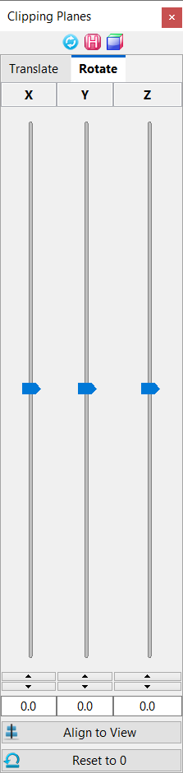

Figure ‑. Clipping plane rotations.

Clipping plane translations of all channels in one render view can be synchronized. To synchronize the settings, enable “Synch Channels”.

## Clipping Plane Rotations

The group of six clipping planes can be rotated independently of the selected volume channel. There are two methods for clipping plane rotations.

To directly adjust clipping plane rotations, change the rotation values using sliders or numeric boxes.

To rotate clipping planes using render view rotation controls, first rotate the view to an angle, so that the user is looking straight at a desired XY plane. Then, click “Align to View” to rotate clipping planes to align with the intended XY plane. This feature is useful when a scan is tilted with an angle.

Use the reset button  to reset all clipping plane rotations.

|  |  |
| --- | --- |
|  | You can save a sub-volume defined by the clipping planes using the bake feature. See Chapter 5 for more details. |

# Mesh Properties

## Basic Mesh Properties

Mesh objects provide clear boundary information. When a mesh object is selected from the “Workspace” panel, its properties are loaded into the property panel (Figure 11‑1). Change the following properties.

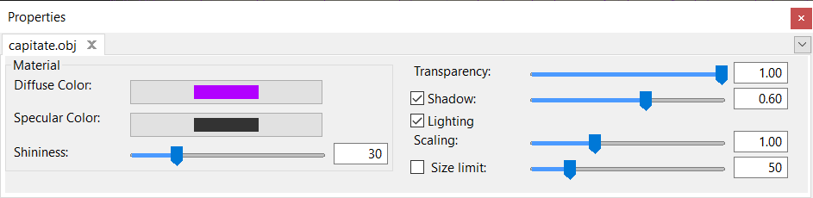

Figure ‑. Mesh properties.

### Material properties

**Diffuse color.** The base color of the object.

**Specular color.** The color of the object’s highlight.

**Shininess.** The size of the highlight.

### Other properties

**Transparency.** Lower is more transparent. 1 means opaque.

|  |  |
| --- | --- |
|  | Depth peeling is used for rendering transparent mesh objects, as well as rendering with volumes. For higher transparency quality, increase the number of peeling layers in the settings dialog. See Chapter 23 for more details. |

**Shadow.** When enabled, it adds a shadow effect, whose strength can be adjusted with the slider.

**Lighting.** It enables/disables lighting effects. When both shadow and lighting effects are disabled, mesh objects look flat.

**Scaling.** It is a multiplier to the overall scale of a mesh object. Use it to enlarge or shrink a mesh object.

## Mesh Manipulations

Mesh manipulations are enabled from the “Workspace” panel, through the context menu. When enabled, the settings are loaded into the “Property” panel (Figure 11‑2).

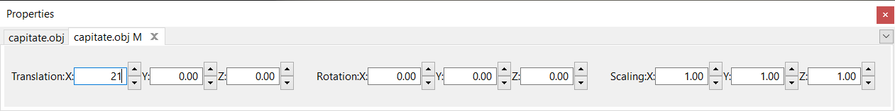

Figure ‑. Mesh manipulations.

Mesh manipulations allow translation, rotation, and scaling of a mesh object within render view. These settings are changed through numeric input boxes in the user interface.

|  |  |
| --- | --- |
|  | When a mesh object is saved, these manipulation settings are lost. Save a project to save these settings. |

# Making Movies

This panel enables a user to animate certain aspects of a volume within the rendering view and is located at the bottom left of the program by default. The top part of the panel contains several tabs for settings to make the animated movie. The bottom part of the panel contains the controls for movie playback.

## Movie Clip Playback Controls

FluoRender supports movie clip playback. A clip is a portion of the entire range of a movie, which can be set and played using these controls. By default, a clip has the same length as the entire movie. Setting up a clip allows focusing on the important part of a long movie.

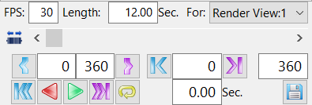

Figure ‑. Movie playback controls.

**FPS.** The frames per second text box allows a user to determine how many frames will be exported per second to either a movie file or a sequence of TIF files. For example, a movie that is 5 seconds long with 30 FPS will have a total of 150 frames in the movie, or 150 TIF files created. A higher FPS increases the quality and “smoothness” of a movie but also contributes to a larger file.

**Length.** The playback length is in seconds of the current movie clip.

**Render View.** This drop-down selection box enables a user to choose which rendering frame to playback on and record to export to a file. Having multiple rendering frames is not common but sometimes useful for side-by-side comparisons. In most cases, there is only 1 frame to render, and subsequently, only 1 option in this drop-down menu.

/ **Time slider style.** There are two styles of the time slider. The direct mode changes the time point to the position indicated by the slider thumb. The jog mode allows continuous playback at different speeds when the thumb is held by the mouse.

**Time Slider.** This slider indicates the progress for playing back a movie. You can move the slider to any point to visualize a frame at that point of time.

 **Set Clip Range.** The buttons set the start and end frames of a movie clip. Use the time slider or step buttons to change the current frame. The start frame of a movie clip is set to the current frame when the clip start button is clicked. The same method is used for the end frame.



**Clip Range.** Set the start and end frames of the clip directly by typing in the frame numbers in the text boxes between the buttons for setting the clip range.

 **Step Playback.** Click the step playback button once to step forward or backward one frame of the movie clip. When the start or end of the clip is reached, it will wrap around to the other end of the clip.



**Current Frame.** Set the current frame of a movie clip by directly typing the frame number in the input box between the buttons for step playback.

**Movie End Frame.** The last input box of the row shows the end frame of the entire movie (instead of a clip). Typing a number in the input box changes the length of the movie.

 **Rewind and Move to End.** Click the rewind button to set the current frame to the start of a movie clip. Click the move to end button to set the current frame to the end of a movie clip.

 **Play Backward and Forward.** Click the play backward button to play a movie clip continuously in reverse order. Click the play forward button to play a movie clip continuously.



 **Pause.** The playback buttons are shown as the pause button during movie playback. Click the pause button to pause the playback.

 **Play with a script.** When a 4D script is enabled, the playback buttons change to indicate the script will be executed along with the movie playback. See Chapter 13 for more details about scripting.



 **Loop.** Click the loop button to enable or disable movie playback in a loop. When one end of a movie clip is reached, it wraps around the other end of the clip.

**Time.** The input box of this row shows the current time in seconds of a movie clip. The time is computed from the FPS and clip range.

**Save / Export.** This button allows you to export a final movie once you feel the preview playback is adequate.



Once you click save, you will see several options to export. You can select a location to save the file, as well as a name for the file. If you export TIF files, your filename will be appended with the frame number for each TIF frame. There are two types of saving a file. The default is “MOV”, which is a QuickTime format of movie files. The other option is for a TIF file sequence.

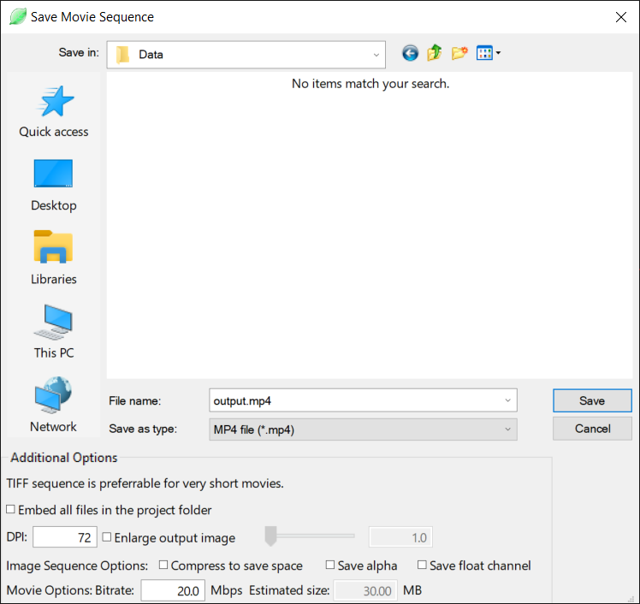

Figure ‑. Save or export a movie or time sequence.

These additional options are available to check before you save the captured image sequence.

**Embed all files in the project folder.** If you choose to save a project along with the movie export, you can check this option to save all original data in the project.

**DPI.** Using a default value of 72 DPI, a scaling factor is computed to enlarge or shrink the saved movie frames. Type the desired DPI number in the input box to change the scaling of the output movie.

**Enlarge output image.** Check this option and the enlargement factor becomes available. The render view will be rendered at an enlarged size and saved. Both the width and height of the render view are enlarged by the factor.

|  |  |
| --- | --- |
|  | For example, when you set the enlargement factor to 4, it renders the data as if it were connected to a display 4x4=16 times larger. Make sure your graphics card can support an output image this large. If the program stops responding, set a small number and capture again. |

**Compress.** If you choose to export the movie as an image sequence of TIFF files, check this option to compress with the LZW method. LZW is a lossless compression method, which reduces file size based on useful information in an image. For a JPEG sequence, a lower quality compression method is used to save space. This option has no effect when saving a PNG sequence.

**Save alpha.** If you choose to export the movie as an image sequence of TIFF files, check this option to save an alpha channel in addition to the RGB channels for each image. You can use the alpha channel to overlay the rendered data on a different background using a compositing software package.

**Save float.** When this option is checked, each channel (RGBA) of the output image will be stored with 32-bit floating point numbers. FluoRender renders everything using floating-point frame buffers. Therefore, saving a captured image using floating-point numbers maximizes the precision. You can use an image editing tool, such as Adobe Photoshop to make further adjustments to the captured image without losing the dynamic range. Saving floating-point number images when the HDR (high dynamic range) mode is one way to present the results on non-HDR displays. See Chapter 22 for more information on the HDR mode. Notice that a movie sequence saved in the floating-point format significantly increases its size on disk.

**Bitrate.** You can set the bitrate to adjust the quality of a QuickTime movie file. The estimated size, based on the Mb/s is on the right. As movies get larger and longer, this estimation becomes less accurate. One Mb/s would approximately be 8 Mb (megabit) in size if the movie is 8 seconds long. This would be only about 1 MB (megabyte).

|  |  |
| --- | --- |
|  | A TIFF sequence is preferred for a very short movie (less than 30 frames) because of the constraints for inter-frame compression of MPEG4. |

## Basic Movie Making

Most of the parameters in FluoRender can be mapped to the frame numbers of a movie, resulting in an animated movie showing the changes in the parameters. The basic tab of the movie-making panel provides easy animations of three commonly used parameters, including rotations around the X, Y, or Z axes, time sequence visualization, and batch files, which are files contained within the same file folder on the system. Depending on the types of data loaded into FluoRender, either the rotation or time-sequence animation is selected by default. However, batch mode is enabled by the user only. Among the three basic movie-making modes, time sequence and batch are mutually exclusive; rotations can be enabled manually in either the time sequence or batch mode.

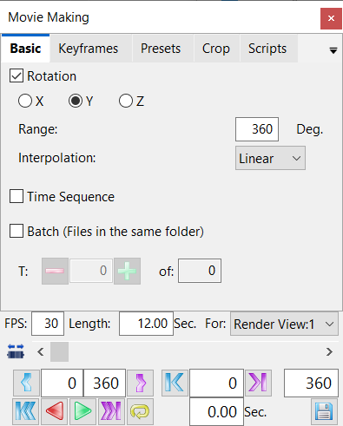

Figure ‑. Basic movie-making settings.

**Rotation.** When a non-time-sequence data set is loaded in FluoRender, the rotation mode is enabled by default. It maps the rotation angle around a specific axis to the movie frames. By default, the rotation axis is Y, and the total degrees are 360 with one degree of rotation per frame, resulting in a typical turn-table animation. Change the rotation settings to customize the animation.

* **Axis.** Select an axis for the rotation animation.
* **Rotation Angles.** The number of degrees of rotation. The start angle of the rotation is the current state of the render view.
* **Interpolation Method.** The relationship between the rotation angle and the movie frame number. Specifically:
  + **Linear.** The rotation speed is constant from the beginning to the end of a movie.
  + **Smooth.** The rotation accelerates and then decelerates through the movie.

**Time sequence.** A time sequence can be a file containing multiple time points or a series of files with their names containing a time sequence identifier. When a valid time sequence is loaded, the time-sequence mode is enabled by default, and the rotation mode is disabled. The default mapping of the time point numbers of the loaded sequence is one-to-one with the movie frame numbers. However, you can enable the rotation animation on top of the time sequence. Adjust both the rotation angles and total movie frame number in the movie playback controls to adjust how the values are mapped. For example, set the total movie frame number to twice the total time point number to play the time sequence at a slower speed, as each time point is visualized in two movie frames. Alternatively, setting the movie frame number smaller than the time point number will result in skipped time points.

**Batch.** Without renaming each file, files within the same file folder on the system can be treated as a time sequence when the batch mode is enabled. You cannot turn on both the batch and time-sequence modes. Otherwise, the batch mode behaves the same as the time-sequence mode.

For some raw formats, such as Leica LIF, multiple series can be saved in one file. These series are independent images like a batch sequence. Turn on the batch sequence and set a series number to load the image. If the image of the series happens to be a time sequence, check the time sequence to enable playback. The time sequence and batch sequence settings are mutually exclusive.

|  |  |
| --- | --- |
|  | The difference between a time sequence and a batch sequence lies in how they are loaded. For a time sequence, the file information is read only from the first file in the sequence. It assumes that all files in the sequence have the same size, channel, and spacing. When a time point is loaded, it simply replaces the existing one. For a batch sequence, everyone in the sequence is considered as an independent file, whose properties can vary. Therefore, memory is released and reallocated for every time point. |

When either the time-sequence or batch mode is enabled, the settings to change the time point number become available:

* + Click the time decrement button load the previous time point of a sequence and update the movie playback parameters accordingly.



* + Click the time increment button to load the next time point of a sequence and update the movie playback parameters accordingly. If the next step is after the total number of frames, the time will wrap around to the beginning.



* + **Current Time Point.** Type in the number of a time point to load it directly.
  + **Total Time Points.** This value is obtained from the sequence loaded into FluoRender and cannot be changed.

## Keyframes

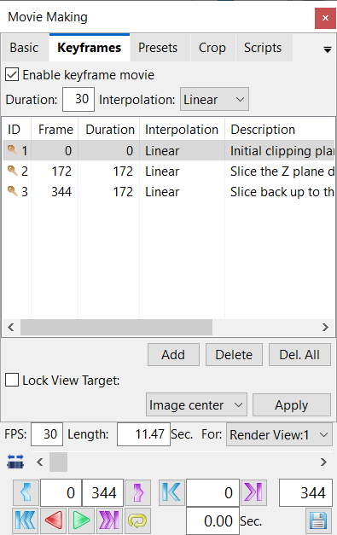

Figure ‑. Advanced movie playback controls.

Keyframe animation allows more parameter settings in FluoRender to be mapped to the movie frame numbers. Add a keyframe to switch from basic movie mode to keyframe animation mode. To enable the basic movie-making settings again, uncheck “Enable keyframe movie” on the panel. Alternatively, enable one of the settings in the basic movie-making settings to also disable the keyframe animation. Once the keyframe animation is enabled, the time control settings, especially the time value, are applied to the keyframe numbers.

These parameters in FluoRender can be mapped to the movie frame numbers for a keyframe animation:

* Rotations in the render view
* Translations in render view
* Scaling transformations, or zoom of render view
* Clipping plane changes
* Showing or hiding a volume channel in the workspace
* Channel intermixing modes (Layered, Depth, and Composite)
* Perspective angle of view (AOV)
* Time point number, changed using the basic movie-making settings
* Properties of a volume channel

|  |  |
| --- | --- |
|  | To make keyframe animations on the time points of a time sequence, the basic and keyframe tabs can be shown side-by-side by dragging the title tabs. |

To make a keyframe animation, set the parameters in FluoRender first, then add a keyframe to record the current state. Keep adding more keyframes to record the changes in parameters. The final animation consists of transitions from one keyframe to the next in the order listed. Use these buttons to add or delete keyframes:

**Add.** Add a keyframe to the list, saving the current parameter settings in FluoRender.

**Delete.** Delete the selected keyframe.

**Delete All.** Delete all the keyframes in the list.

The keyframe list shows all keyframes. Each keyframe contains these information fields:

**ID.** An ID is a unique number to identify a keyframe.

**Frame.** The movie frame number is mapped to the parameter settings recorded by the keyframe.

**Duration.** The number of movie frames for the transition between two keyframes.

**Interpolation.** The relationship between a continuously changing parameter and the movie frame number. Specifically:

* **Linear.** The parameter is mapped linearly to the movie frame number.
* **Smooth.** The changing speed of the parameter accelerates and decelerates for a smooth transition at keyframes.

**Description.** Attach a text description to a keyframe for easy organization.

The duration, interpolation, and description can be changed after a keyframe is added by clicking the row for the keyframe on the list. The default settings for duration and interpolation can be configured before adding keyframes. The default settings are above the list.

Once keyframes are added, their order can be reconfigured by dragging and dropping a row for a keyframe on the list.

Additionally, the orientation of the virtual camera can be locked to an object and override the settings from the keyframes. Once the camera’s target is locked, it always looks at the target object during the playback of the keyframes. For example, make keyframes to pan the view from left to right and then enable target lock. The camera moves from left to right and automatically adjusts its orientation to always point to the target. The auto-orientation adjustments are only effective when the keyframes are played.

**Lock View Target.** Check this option to enable the camera target lock.

**Camera target type.** Select the type of object for the camera lock.

* **Image center.** Choose this option and click Apply to set the camera target to the center of the current render view.
* **Click view.** Choose this option and click Apply. Then, click on a point in the render view to set the camera target.
* **Ruler.** Choose this option and click Apply to set the currently selected ruler in the Measurement window as the camera target.
* **Selection.** Choose this option and click Apply to set the center of the selection mask as the camera target.

**Apply.** Click this button to apply the target for the camera lock.

## Keyframe Presets

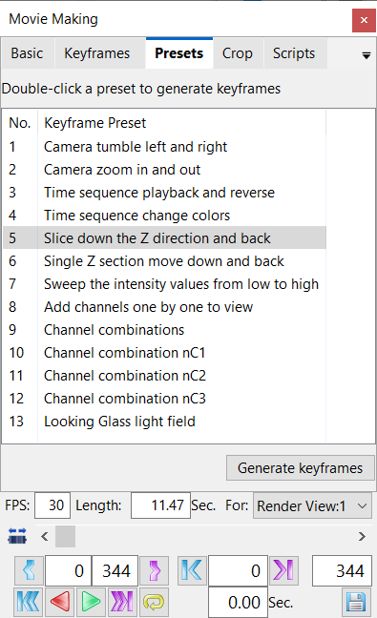

Figure ‑. Keyframe presets.

Create an animation by a preset to simplify the process of making commonly used animations by automatically generating keyframes. Select the name of a preset and click “Generate keyframes” to generate the desired animation. Alternatively, you can double-click on the name of a preset to generate an animation. The keyframe tab is automatically switched and enabled when a preset is used to create keyframe animations.

The built-in templates include:

|  |  |
| --- | --- |
| Template | Description |
| Camera tumble left and right | Rotate the render view left and right. The rotation degree is determined by the duration value in the keyframe movie settings. |
| Camera zoom in and out | Zoom in and out in the render view. |
| Time sequence playback and reverse | Only applies to a time sequence. It plays the time sequence twice, first in sequential order and then backward. |
| Time sequence change colors | Only applies to a time sequence. The color of the data set changes over time. It uses the colormap settings in the volume property settings of the data set. |
| Slice down the Z direction and back | It removes the image sections in the Z direction one by one for all Z image sections. Then, it restores the Z image sections one by one. |
| Single Z section move down and back | It shows only one Z image section. The image section moves down in the Z direction and then back. |
| Sweep the intensity values from low to high | It clips the intensity values using a small range of low and high threshold values. The range is moved from minimum to maximum values. |
| Add channels one by one to view | Only applies to a multichannel data set. It starts with all channels hidden and shows the channels one by one. |
| Channel combinations | Only applies to a multichannel data set. It shows the nC1, nC2, and nC3 combinations one after another. |
| Channel Combination nC1 | It sets a key for each isolated channel within a multi-channel data set. You can browse each channel individually with this setting. |
| Channel Combination nC2 | It sets a key for each two-channel pair within a multi-channel data set. You can use this function to visualize colocalization regions between any two-channel combinations. |
| Channel Combination nC3 | Like nC2, it sets a key for each triple-channel combination. You can use this setting to visualize all colocalization cases of three channels. |
| Looking Glass light field | It makes a camera sweep animation. The resulting images can be exported to be shown on a Looking Glass holographic display. |

## Crop the Movie Frames

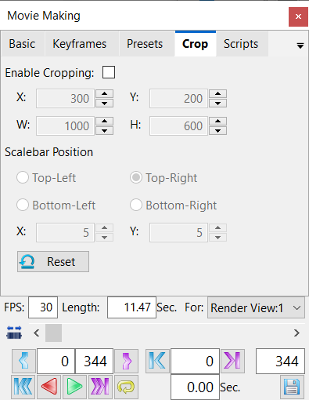

Figure ‑. Frame cropping controls.

This tab allows a user to crop movie frames to a desired size.

**Enable Cropping.** Check this option to enable the movie frame cropping. A frame is shown in the render view to represent the area to be exported in a movie. The frame can be adjusted by dragging its borders and corners in the render view. Alternatively, the values for the cropping frame can be fine-tuned by the settings below.

**X.** The X coordinate value of the lower left corner of the cropping frame.

**Y.** The Y coordinate value of the lower left corner of the cropping frame.

**W.** The width of the cropping frame.

**H.** The height of the cropping frame.

When the cropping frame is enabled and shown in the render view, the scalebar can be positioned at any of the four corners of the frame. Use the buttons to select one corner to avoid overlapping the scalebar with a visualized data set. Additionally, the distance of the scalebar to the cropping frame borders can be set.

**X.** The distance between the scalebar and the cropping frame in the X direction.

**Y.** The distance between the scalebar and the cropping frame in the Y direction.

**Reset.** Click reset to recalculate the cropping frame, whose size and position are based on the extent of the data set visualized in the render view.

# Automated Data Analysis with Scripts

## FluoRender Script

Enable script execution to apply a predefined workflow on a time sequence during playback. A script file contains a series of commands and associated parameters. The execution of the commands in a script can be configured to run before or after the update of a time sequence. Therefore, a fully automated data analysis workflow is accomplished by playing back a time sequence. Using the step function to play a sequence one frame at a time allows manual curations, such as paint selection or segmentation, to be added to a workflow interactively, which maximizes the flexibility for data analysis. The script tab is one part of the movie-making panel (Figure 13‑1).

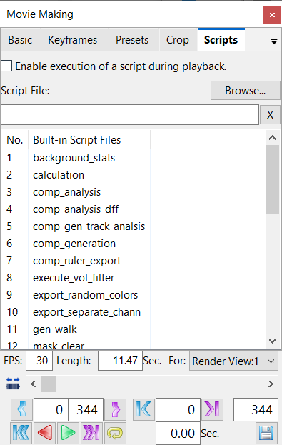

Figure ‑. Script settings.

The script tab has these controls:

**Enable script.** When you check this option, script execution is enabled. The name of the script tab changes to indicate the enabling of the script running. The play button in the movie control also changes to indicate that a script is executed during movie playback or stepping through frames.

|  |  |
| --- | --- |
|  | Data processing scripts only need to execute once are automatically disabled after the last timepoint is reached. Some scripts are for visualization only and need to be manually disabled when they are not needed. |

**Browse…** The script file list shows all built-in script files, which can be found in the Scripts folder of the installation directory. The script files are text files in the Windows configuration file format. You can compose your own script files or modify and resave the built-in files. To select a script file not in the default script file directory, click the Browse button and select the file in the open file dialog window.

**Script File.** It shows the full path to the currently selected script file.

**X.** It clears the script file so that no script will be executed.

**Built-in Script Files.** It lists all built-in script files in the “Scripts” directory where FluoRender is installed. You can click the name of a script file to load it and enable execution.

## Script File Format

A script file is a text file based on the Windows configuration file format to define a sequence of commands, or tasks, each associated with a list of parameters. When the frame number of a time sequence or batch process is changed through movie playback or frame stepping, the commands are sequentially applied to the currently loaded data. Therefore, a fully automated data analysis workflow can be accomplished by simply playing back a time sequence. Alternatively, data curations can be interactively inserted into a predefined workflow by using the frame stepping functions to play the time sequence one frame at a time.

The overall structure of a script file is:

|  |
| --- |
| **[tasks]**  **tasknum=***(user-defined number)*  **[tasks/task***(task sequence number)***]**  **type=***(task name)*  *(task-specific parameter)***=***(user-defined parameter value)*  *(…)*  *(task-specific parameter)***=***(user-defined parameter value)*  **[tasks/task***(task sequence number)***]**  **type=***(task name)*  *(task-specific parameter)***=***(user-defined parameter value)*  *(…)*  *(task-specific parameter)***=***(user-defined parameter value)*  *(…)* |

List ‑. The overall script structure.

A script file starts with **[tasks]**, which is followed by the total number of tasks specified with **tasknum=**. Each task starts with **[tasks/taskn]**, where n is an integer starting from 0. The tasks are usually different predefined operations on data. The same task can be repeated in a script to execute with different parameters. Tasks are executed sequentially based on the task number.

### Common parameters

The common parameters of a task can be applied to most task types. They provide a mechanism to fine-tune the time and object for execution. For example, a task may be executed before or after loading the data at a time point. A task may be only applicable to specific time points instead of all, which can be useful for certain initialization and finalization tasks. Furthermore, a task may be applied only to the currently selected channel in a multichannel data set. The common parameters of a task are used to determine these behaviors.

**time\_mode** -- A bit mask determining the execution time of a task. In general, the bits of a 32-bit integer are grouped in pairs to represent the beginning frames, ending frames, and middle frames. One bit in the pair is used to represent the time before data load (and frame number change), and another for the time after. The detailed design of the bit mask is in the table.

|  |  |  |  |  |  |  |  |  |  |  |  |  |  |  |  |  |
| --- | --- | --- | --- | --- | --- | --- | --- | --- | --- | --- | --- | --- | --- | --- | --- | --- |
| Bits | 15 | 14 | 13 | 12 | 11 | 10 | 9 | 8 | 7 | 6 | 5 | 4 | 3 | 2 | 1 | 0 |
| Use | Re-wind | Pre T7+ | Post T6 | Pre T6 | Post T5 | Pre T5 | Post T4 | Pre T4 | Post T3 | Pre T3 | Post T2 | Pre T2 | Post T1 | Pre T1 | Post T0 | Pre T0 |
| Bits | **16** | **17** | **18** | **19** | **20** | **21** | **22** | **23** | **24** | **25** | **26** | **27** | **28** | **29** | **30** | **31** |
| Use | Post T7+ | Pre TU-6 | Post TU-6 | Pre TU-5 | Post TU-5 | Pre TU-4 | Post TU-4 | Pre TU-3 | Post TU-3 | Pre TU-2 | Post TU-2 | Pre TU-1 | Post TU-1 | Pre TU | Post TU | N/A |

Note: The time sequence starts with T0 and ends with TU. T7+ denotes all frames that are not represented by the bits. Rewind denotes that the frame count resets to T0 after the user clicks the rewind button.

Both decimal and hexadecimal formats of a 32-bit integer can be used to set the bitmask. Alternatively, the most commonly used cases can be set using the names in the table.

|  |  |  |  |
| --- | --- | --- | --- |
| Predefined Name | Bitmask value | Predefined Name | Bitmask value |
| TM\_NONE | 0 | **TM\_LAST\_BOTH** | 0x60000000 |
| TM\_REWIND | 0x8000 | **TM\_ALL\_PRE\_FIRST\_BOTH** | 0x2AAA5557 |
| TM\_ALL\_PRE | 0x2AAA5555 | **TM\_ALL\_POST\_FIRST\_BOTH** | 0x55552AAB |
| TM\_ALL\_POST | 0x55552AAA | **TM\_ALL\_PRE\_LAST\_BOTH** | 0x6AAA5555 |
| TM\_FIRST\_PRE | 1 | **TM\_ALL\_POST\_LAST\_BOTH** | 0x75552AAA |
| TM\_FIRST\_POST | 2 | **TM\_ALL\_PRE\_REWIND** | 0x2AAAD555 |
| TM\_FIRST\_BOTH | 3 | **TM\_ALL\_POST\_REWIND** | 0x5555AAAA |
| TM\_LAST\_PRE | 0x20000000 | **TM\_ALL** | 0x7FFF7FFF |
| TM\_LAST\_POST | 0x40000000 |  |  |

**chan\_mode** – A value determining which channels are used to apply the script task. The valid values are listed in the table below.

|  |  |
| --- | --- |
| Value | Channels selected |
| 0 | Currently highlighted channel in the Workspace panel |
| 1 | All channels in the Workspace panel |
| 2 | Non-hidden channels in the Workspace panel |
| 3 | Hidden channels in the Workspace panel |

Script examples, which can also be used as templates to expand their functions, can be found in the /Scripts folder of FluoRender’s installation directory.

## Script Tasks

The number of 4D script tasks has been increasing for more flexibility in batch processing. Currently supported tasks are as follows.

### Background intensity distribution analysis

Task name (type): **backg\_stat**

Purpose: It extracts the background from a selected channel and performs basic statistics on the intensity distribution on the background. The extraction of the background is based on the local intensity distribution. Basically, low-intensity values within a localized window are considered as background.

Parameters:

**use\_mask** – Set to 1 to perform the calculations within the selected regions by a mask. Otherwise, set it to 0.

**stat\_type** – Set to 0 to compute mean. Set to 1 to compute minimum and maximum. Set to 2 to compute the median and mode.

**stat\_indx** – Set to 0 to retrieve minimum or median. Set to 1 to retrieve maximum or mode.

**kx** – Set the window size in the X dimension for localized intensity distribution.

**ky** – Set the window size in the Y dimension for localized intensity distribution.

**varth** – Set the threshold value for a local variance to include regions of low variance in the background.

**gauth** – Set the threshold to include the low-intensity values in a Gaussian distribution in the background. It is expressed as the multiplier of the variance of a local Gaussian distribution.

Example: Get the mean value of the background of a selected channel. The background is extracted by looking at the relative intensity of a pixel in its local Gaussian distribution. A window size of 100x100 around a pixel is used to compute the Gaussian. Any pixel with a local variance lower than 0.0001 and intensity lower than 1σ from the mean is considered as background.

|  |
| --- |
| [tasks]  tasknum=1  [tasks/task0]  type=backg\_stat  time\_mode=TM\_ALL\_PRE\_LAST\_BOTH  chan\_mode=0  stat\_type=0  stat\_indx=0  kx=100  ky=100  varth=0.0001  gauth=1 |

List ‑. Script for computing the mean value of the background.

### Calculate

Task name (type): **calculate**

Purpose: It loads two channels for calculation and generates a new channel from the calculation result.

Parameters:

**vol\_a** – The first volume channel for the operand A. It is the index value of all shown channels.

**vol\_b** – The second volume channel for operand B. It is the index value of all shown channels.

**operator** – The operator for the calculation. Supported values include “subtract”, “add”, “divide”, “colocate”, “fill”. They correspond to the operators in the Calculation dialog window.

Example: Subtract a membrane channel from a nucleus channel for improved separation. The membranes are in the first channel (index value is 0); the nuclei are in the second channel (index value is 1). The result is saved using the save\_volume script.

|  |
| --- |
| [tasks]  tasknum=2  [tasks/task0]  type=calculate  time\_mode=TM\_ALL\_PRE\_LAST\_BOTH  vol\_a=1  vol\_b=0  operator=subtract  [tasks/task1]  type=save\_volume  time\_mode=TM\_ALL\_PRE\_LAST\_BOTH  source=calculator  format=0  compress=1  delete=1  savepath= |

List ‑. Script for membrane subtraction from the nucleus channel.

### Clear mask

Task name (type): **clear\_mask**

Purpose: It clears both the selection mask and component labels for the selected channel.

Parameters:

**mask** – Set to 1 to clear the selection mask. Otherwise, set it to 0.

**label** – Set to 1 to clear the component labels. Otherwise, set it to 0.

Example: Clear both the selection mask and component labels of the selected channel.

|  |
| --- |
| [tasks]  tasknum=2  [tasks/task0]  type=clear\_mask  time\_mode=TM\_ALL\_PRE\_LAST\_BOTH  chan\_mode=0  mask=1  label=1  [tasks/task1]  type=save\_mask  time\_mode=TM\_ALL\_PRE\_LAST\_BOTH  chan\_mode=0  mask=1  label=1 |

List ‑. Script for clearing masks.

### Component analysis

Task name (type): **comp\_analysis**

Purpose: It analyzes the intensity distributions and morphological properties of components. The results are saved in memory. Use another task “export\_analysis” to show the results in a spreadsheet or infographics.

Parameters:

**consistent** – When there are multiple bricks, set the consistent parameter to 1 to make sure components that fall on brick borders are using the same component IDs.

**selected** – Set the selected parameter to 1 to only analyze the selected components using a brush.

**slimit** – Ignore components with sizes smaller than the size limit.

|  |  |
| --- | --- |
|  | You can use the paintbrush tool to generate a selection mask at the first time point and run a script with this task. All subsequent time points will use the save selection mask from the first time point. You can generate different selection masks for each time point and save the masks. You need to add a second task in the script to fetch mask (fetch\_mask) for each time point. Additionally, you can use the tracking functions to generate the selection mask for each time point. In this case, the task is selection tracking (selection\_tracking). |

Example 1, use the paintbrush tool to define a region of interest at the first time point, and then use it for all subsequent time points for signal intensity analysis:

|  |
| --- |
| [tasks]  tasknum=2  [tasks/task0]  type=comp\_analysis  time\_mode=TM\_ALL\_PRE\_LAST\_BOTH  chan\_mode=0  consistent=1  selected=0  slimit=5  [tasks/task1]  type=export\_analysis  time\_mode=TM\_LAST\_POST  template=table.html  output=  value\_num=13  value\_name0=comp\_center  value\_name1=comp\_size\_ui  value\_name2=comp\_size\_d  value\_name3=comp\_phys\_size\_ui  value\_name4=comp\_phys\_size\_d  value\_name5=comp\_ext\_size\_ui  value\_name6=comp\_ext\_size\_d  value\_name7=comp\_mean  value\_name8=comp\_stdev  value\_name9=comp\_min  value\_name10=comp\_max  value\_name11=comp\_distp  value\_name12=comp\_pca\_lens  js\_value= |

List ‑. Script for component analysis.

Example 2, use saved selection masks at each time point for component analysis:

|  |
| --- |
| [tasks]  tasknum=3  [tasks/task0]  type=comp\_analysis  time\_mode=TM\_ALL\_PRE\_LAST\_BOTH  chan\_mode=0  consistent=1  selected=0  slimit=5  [tasks/task1]  type=fetch\_mask  time\_mode=TM\_ALL\_POST\_REWIND  chan\_mode=0  mask=1  label=1  [tasks/task2]  type=export\_analysis  time\_mode=TM\_LAST\_POST  template=table.html  output=  value\_num=13  value\_name0=comp\_center  value\_name1=comp\_size\_ui  value\_name2=comp\_size\_d  value\_name3=comp\_phys\_size\_ui  value\_name4=comp\_phys\_size\_d  value\_name5=comp\_ext\_size\_ui  value\_name6=comp\_ext\_size\_d  value\_name7=comp\_mean  value\_name8=comp\_stdev  value\_name9=comp\_min  value\_name10=comp\_max  value\_name11=comp\_distp  value\_name12=comp\_pca\_lens  js\_value= |

List ‑. Script for component analysis.

Example 3, use FluoRender’s tracking feature to generate a selection mask at each time point and perform component analysis:

|  |
| --- |
| [tasks]  tasknum=4  [tasks/task0]  type=pre\_tracking  time\_mode=TM\_ALL\_PRE  [tasks/task1]  type=fetch\_mask  time\_mode=TM\_ALL\_POST\_REWIND  chan\_mode=0  mask=0  label=1  [tasks/task2]  type=post\_tracking  time\_mode=TM\_ALL\_POST  [tasks/task3]  type=export\_analysis  time\_mode=TM\_LAST\_POST  template=table.html  output=  value\_num=13  value\_name0=comp\_center  value\_name1=comp\_size\_ui  value\_name2=comp\_size\_d  value\_name3=comp\_phys\_size\_ui  value\_name4=comp\_phys\_size\_d  value\_name5=comp\_ext\_size\_ui  value\_name6=comp\_ext\_size\_d  value\_name7=comp\_mean  value\_name8=comp\_stdev  value\_name9=comp\_min  value\_name10=comp\_max  value\_name11=comp\_distp  value\_name12=comp\_pca\_lens  js\_value= |

List ‑. Script for component analysis.

Example 4, use paintbrush to generate ROIs and compute dF/F for each ROI:

|  |
| --- |
| [tasks]  tasknum=5  [tasks/task0]  type=backg\_stat  time\_mode=TM\_ALL\_PRE\_LAST\_BOTH  chan\_mode=0  stat\_type=0  stat\_indx=0  kx=100  ky=100  varth=0.0001  gauth=1  [tasks/task1]  type=comp\_analysis  time\_mode=TM\_ALL\_PRE\_LAST\_BOTH  chan\_mode=0  consistent=1  selected=1  slimit=500  [tasks/task2]  type=fetch\_mask  time\_mode=TM\_ALL\_POST\_REWIND  chan\_mode=0  mask=1  label=1  [tasks/task3]  type=roi\_dff  time\_mode=TM\_LAST\_POST  value\_name=comp\_mean  bg\_name=bkg\_mean  var\_cut=0.001  output\_mode=1  [tasks/task4]  type=export\_spreadsheet  time\_mode=TM\_LAST\_POST  output=  value\_num=1  value\_name0=roi\_dff |

List ‑. Script for component analysis.

### Disable Script

Task name (type): **disable\_script**

Purpose: Disable further script execution after the last timepoint is reached.

Parameters: None.

### Edit Component IDs

Task name (type): **comp\_edit**

Purpose: Reset component IDs to 0 based on the selection mask.

Parameters:

**edit\_type** – Set to 0 to clean component IDs.

**mode** – Set to 0 to clean component IDs for structures not selected by the mask. Otherwise, set it to 1.

### Select components

Task name (type): **comp\_select**

Purpose: Select structures identified by components for subsequent analysis tasks. The selection of components can be filtered by their size.

Parameters:

**mode** – Set to 0 to select all components. Set to 1 to unselect all components. Set to 2 to select components based on size.

**comp\_min** – Set the lower bound of component size when the selection mode is 2. Set to 0 to ignore the minimum size.

**comp\_max** – Set the upper bound of component size when the selection mode is 2. Set to 0 to ignore the maximum size.

### Export analysis results

Task name (type): **export\_analysis**

Purpose: Show analysis results in an HTML file. It reads an HTML template and replaces the data entries in the HTML file with analysis results. Two HTML templates are provided: table.html for listing analysis results in a spreadsheet and ridgeline.html for showing one specific value of all analyzed components over time in a ridgeline graph. The templates use Javascript and D3 libraries to generate the desired infographics. Users can also modify the templates or use their own templates. See the template HTML files in the Templates folder of the FluoRender installation for more details.

|  |  |
| --- | --- |
|  | Choose a template that uses an online or local version of the D3 library depending on the availability of the Internet connection. If the local version template is used, it refers to the D3 library file supplied with the FluoRender installation. Therefore, moving the resulting HTML file to a different computer without FluoRender will make the result invalid. |

Parameters:

**template** – The file name for the HTML template. Use the full path of a user-defined file. Otherwise, the directory is the Templates folder of the FluoRender installation or the same folder of the script file.

**output** – Specify an output file for the resulting HTML file. Leave it blank and FluoRender will ask for an output file using a save dialog. Use the name DATA\_DIR to save the results in the same folder as the data sets to be analyzed.

**value\_num** – The total number of values to be exported.

**value\_name#** -- The name of a value from data analysis to be exported. Value names are numbered sequentially. Refer to the table below for value names.

|  |  |  |  |
| --- | --- | --- | --- |
| Name | Meaning | Name | Meaning |
| comp\_center | The center coordinates of a component | **comp\_min** | The minimum intensity value of a component |
| comp\_size\_ui | The count of voxels of a component | **comp\_max** | The maximum intensity value of a component |
| comp\_size\_d | The sum of normalized intensity values of a component | **comp\_distp** | The distance of a component from a specific point |
| comp\_phys\_size\_ui | The physical size of a component | **comp\_pca\_lens** | The length of the longest axis of a component from PCA |
| comp\_phys\_size\_d | The physical size of a component weighted by its intensity values | **bkg\_mean** | Mean value of background intensity |
| comp\_ext\_size\_ui | The count of exterior voxels of a component | **bkg\_min** | Minimum value of background intensity |
| comp\_ext\_size\_d | The sum of normalized intensity values of the exterior voxels of a component | **bkg\_max** | Maximum value of background intensity |
| comp\_mean | The mean intensity of a component | **bkg\_median** | Median value of background intensity |
| comp\_stdv | The standard deviation of the intensity values of a component | **bkg\_mode** | Mode value of background intensity |
| max\_int | Maximum intensity sampled along a ruler | **max\_dist** | The distance to the start of a ruler when the maximum intensity is sampled |

**js\_value** – A Javascript snippet to control how the values may be used to draw an infographic.

### Fetch mask

Task name (type): **fetch\_mask**

Purpose: Use this script to let FluoRender load mask files and label files for each time point without engaging actual tracking functions. You may use the UniIDs tool in the Component and Tracking window to process a tracked time sequence so that IDs are consistent through time (see Chapter 20). Then, use this script to play back the newly generated sequence (List 13‑9).

Parameters:

**mask** – fetch the mask data.

**label** – fetch the label data.

Example:

|  |
| --- |
| [tasks]  tasknum=1  [tasks/task0]  type=fetch\_mask  time\_mode=TM\_ALL\_POST\_REWIND  chan\_mode=0  mask=1  label=1 |

List ‑. Script for fetching mask.

Use this task alone to examine the saved selection mask for each time point. This task can also be used together with other tasks, such as component analysis (List 13‑6).

### Generate components

Task name (type): **generate\_comp**

Purpose: This task is the same as the component generation commands in the “Component Analyzer” window. Use this task to generate labeled components for each time point.

Parameters:

**use\_sel –** Only generate components on selected regions with the paintbrush. Otherwise, the component generation is applied to the entire volume.

**th\_factor –** A floating point number factor multiplied by the threshold value in the component generation settings. When use\_sel is set, the fact that the regions are selected by the paintbrush makes component generation easier. Usually, a lower threshold value is desired. Set this parameter to a value less than 1.0 to decrease the threshold value.

**comp\_command** – Specify a file saved from the macro recording in the Component window. The macro commands control how the components are generated. Example command files can be found in the Commands folder of the FluoRender installation. Alternatively, place the command file in the same folder as a user-defined script file. Otherwise, use the full path to the macro command file.

|  |  |
| --- | --- |
|  | To save the generated mask at each time point, use the save mask task. |

Example:

|  |
| --- |
| [tasks]  tasknum=2  [tasks/task0]  type=generate\_comp  time\_mode=TM\_ALL\_PRE\_LAST\_BOTH  chan\_mode=0  use\_sel=0  th\_factor=1  [tasks/task1]  type=save\_mask  time\_mode=TM\_ALL\_PRE\_LAST\_BOTH  chan\_mode=0  mask=1  label=1 |

List ‑. Script for generating components.

This example script generates components for each time point using the parameters set in the “Component Analyzer” window, and then saves the mask.

### Track components

Task name (type): **mask\_tracking**

Purpose: track components over time by comparing it within a window.

Parameters:

**ext\_x, ext\_y, ext\_z** – Extent of the initial search area in pixel number for each X, Y, and Z direction.

**ext\_a, ext\_b, ext\_c** – Extent of initial rotation angle in degree for each X, Y, and Z axis.

**iter –** The number of iterations to optimize the fitting of the match between time points.

**eps –** The error threshold to optimize the fitting of the match between time points.

**fsize –** The filter size to apply a low-pass filter to remove noise.

**compare** – Set to 0 to compare adjacent time points. Set to 1 to compare with the starting time point.

### OpenCL filter

Task name (type): **opencl**

Purpose: Use this script to let FluoRender apply a specific OpenCL filter to each time point.

Parameters:

**clpath** – A path to the filter file. When left blank, the currently selected filter in the Volume Filter window (Chapter 15) is used.

repeat – The number of iterations to execute the filter. When left blank, the current iteration number in the Volume Filter window (Chapter 15) is used.

Example:

|  |
| --- |
| [tasks]  tasknum=2  [tasks/task0]  type=opencl  time\_mode=TM\_ALL\_PRE\_LAST\_BOTH  chan\_mode=0  clpath=gauss.cl  [tasks/task1]  type=save\_volume  time\_mode=TM\_ALL\_PRE\_LAST\_BOTH  source=executor  format=0  compress=1  delete=1  savepath= |

List ‑. Script for applying an OpenCL filter.

This example performs Gaussian filtering at each time point. See Chapter 15 for details on generating and editing OpenCL kernels for image processing.

### Export components as RGB channels

Task name (type): **random\_colors**

Purpose: If component analysis is applied to each time point of a sequence, you can use this script to export components as RGB channels, each component assigned with a color.

Parameters:

**huemode** – Choose one method to compute the hue value of the exported colors.

Example:

|  |
| --- |
| [tasks]  tasknum=3  [tasks/task0]  type=fetch\_mask  time\_mode=TM\_ALL\_POST\_REWIND  chan\_mode=0  mask=0  label=1  [tasks/task1]  type=random\_colors  time\_mode=TM\_ALL\_PRE\_LAST\_BOTH  chan\_mode=0  huemode=0  [tasks/task2]  type=save\_volume  time\_mode=TM\_ALL\_PRE\_LAST\_BOTH  source=selector  format=0  compress=0  delete=1  savepath= |

List ‑. Script for exporting colored components.

### Noise reduction

Task name (type): **noise\_reduction**

Purpose: It applies noise reduction to each time point and saves the result as a new file. The settings correspond to those in the noise reduction window.

Parameters:

**threshold** – The threshold for component analysis;

**voxelsize** – The component size to be removed as noise;

Example:

|  |
| --- |
| [tasks]  tasknum=2  [tasks/task0]  type=noise\_reduction  time\_mode=TM\_ALL\_PRE\_LAST\_BOTH  chan\_mode=0  threshold=0.5  voxelsize=20  [tasks/task1]  type=save\_volume  time\_mode=TM\_ALL\_PRE\_LAST\_BOTH  source=calculator  chan\_mode=0  format=0  compress=0  delete=1  savepath= |

List ‑. Script for noise reduction.

This example script applied noise reduction to each time point.

### Save mask

Task name (type): **save\_mask**

Purpose: Use this script to save the selection mask for each time point.

Parameters:

**mask** – fetch the mask data.

**label** – fetch the label data.

Example:

|  |
| --- |
| [tasks]  tasknum=2  [tasks/task0]  type=fetch\_mask  time\_mode=TM\_ALL\_POST\_REWIND  chan\_mode=0  mask=1  label=1  [tasks/task1]  type=save\_mask  time\_mode=TM\_ALL\_PRE\_REWIND  chan\_mode=0  mask=1  label=1 |

List ‑. Script for saving mask.

This example can be used to manually generate/modify selection masks for a time sequence. Use the paintbrush tool to generate a mask. When you step to the next time point, it automatically saves the mask and gets the mask for the next time point.

### Selection tracking

Task name (type): **pre\_tracking/post\_tracking**

Purpose: To view automatically tracked results, to correct and proofread automatically tracked results, or to manually track a time sequence, use this script to let FluoRender know that label files are present, and IDs need to be linked.

Parameters: None.

Example 1, viewing tracking results:

|  |
| --- |
| [tasks]  tasknum=3  [tasks/task0]  type=pre\_tracking  time\_mode=TM\_ALL\_PRE  [tasks/task1]  type=fetch\_mask  time\_mode=TM\_ALL\_POST\_REWIND  chan\_mode=0  mask=0  label=1  [tasks/task2]  type=post\_tracking  time\_mode=TM\_ALL\_POST |

List ‑. Script for viewing tracking results.

You need to perform manual or automatic tracking using the tools provided in FluoRender before you can use this script. For details on tracking, see Chapter 20.

Example 2, semi-automatic tracking:

|  |
| --- |
| [tasks]  tasknum=8  [tasks/task0]  type=generate\_comp  time\_mode=TM\_ALL\_PRE  chan\_mode=0  use\_sel=1  th\_factor=0.35  [tasks/task1]  type=pre\_tracking  time\_mode=TM\_ALL\_PRE  [tasks/task2]  type=unlink\_cells  time\_mode=TM\_ALL\_PRE  chan\_mode=0  [tasks/task3]  type=save\_mask  time\_mode=TM\_ALL\_PRE\_LAST\_BOTH  chan\_mode=0  mask=1  label=1  [tasks/task4]  type=pre\_tracking  time\_mode=TM\_ALL\_PRE  [tasks/task5]  type=add\_cells  time\_mode=TM\_ALL\_PRE  chan\_mode=0  [tasks/task6]  type=link\_cells  time\_mode=TM\_ALL\_PRE  chan\_mode=0  [tasks/task7]  type=fetch\_mask  time\_mode=TM\_ALL\_POST\_REWIND  mask=1  label=1 |

List ‑. Script for semi-automatic tracking.

### Save volume data

Task name (type): **save\_volume**

Purpose: Save a volume channel from a designated source.

Parameters:

**source** – The source of the volume channel to be saved.

|  |  |
| --- | --- |
| Values | Meanings |
| channels | Channels already loaded |
| calculator | Calculated results |
| selector | Selected results |
| executor | OpenCL filter results |
| registrator | Image registration results |

**bake** – Whether volume properties are applied when saving (It can be used to apply volume properties to non-RGB volumes as well);

**format** – The file format to be saved;

**compress** – Whether the file is to be compressed;

**savepath** – Specify an output file for the resulting volume. Leave it blank and FluoRender will ask for an output file using a save dialog. Use the name DATA\_DIR to save the results in the same folder as the data sets to be analyzed.

**smooth** – The number of frames to be smoothed for motion vector when the results come from image registration.

Example: It separates multiple channels and saves them as individual files.

|  |
| --- |
| [tasks]  tasknum=1  [tasks/task0]  type=save\_volume  time\_mode=TM\_ALL\_PRE\_LAST\_BOTH  source=  chan\_mode=0  format=0  compress=0  delete=0  savepath= |

List ‑. Script for RGB channel separation.

### Export ruler profiles

Task name (type): **ruler\_profile**

Purpose: Create rulers for time sequence data and use this script to export the ruler profile for each time point. If you use non-transient rulers, it samples the same locations through time. See Chapter 17 for more details about rulers.

Parameters:

**fsize –** The window size of pixels to sample around a point on a ruler;

**sample\_type –** The method to get one sample value: 0 – nearest neighbor; 1 – bilinear interpolation;

**step\_len –** The distance between two sample points along a ruler.

Example: Run this script to generate a ridgeline graph of intensity changes at sample points over time.

|  |
| --- |
| [tasks]  tasknum=2  [tasks/task0]  type=ruler\_profile  time\_mode=TM\_ALL\_PRE\_LAST\_BOTH  chan\_mode=0  fsize=0  sample\_type=1  step\_len=1  [tasks/task1]  type=export\_analysis  time\_mode=TM\_LAST\_POST  template=ridgeline.html  output=  value\_num=1  value\_name0=max\_int  js\_value=(+d.max\_int) |

List ‑. Script for exporting ruler profiles.

### Analyze ruler point locations

Task name (type): **ruler\_info**

Purpose: Create rulers and animate them over time. The 3D locations of a ruler at different time points are analyzed using this script task. See Chapter 17 for more details about rulers.

Parameters:none.

Example: Run this script to export point locations of animated rulers.

|  |
| --- |
| [tasks]  tasknum=2  [tasks/task0]  type=ruler\_info  time\_mode=TM\_ALL\_PRE  [tasks/task1]  type=export\_info  time\_mode=TM\_LAST\_POST  output=  type\_num=1  type\_name0=ruler\_info |

List ‑. Script for exporting ruler point locations.

### Analyze fluorescence intensity change within ROIs

Task name (type): **roi**

Purpose: Compute the mean intensity values for each ROI and volume channel (depending on the channel mode).

Parameters:none.

Task name (type): **roi\_dff**

Purpose: Collect the values computed from the roi task and compute the change rate over time. A resting-state intensity is estimated from the background intensity. The difference between the ROI intensity and its resting state is used to compute a ratio: ΔF/F, where F is the resting state and ΔF the difference.

Parameter:

**value\_name –** Usually “roi\_mean”, the mean intensity values from the task roi.

**bg\_name –** Usually “bkg\_mean”, the mean intensity values from the task bkg\_stat.

**var\_cut –** A threshold for the variance to compute the resting state.

**output\_mode –** 0: output for inforgraphs using a template; 1: output to a spreadsheet.

Example: First create ROIs using the ruler tools. Then, run this script to get the ΔF/F over time for each ROI.

|  |
| --- |
| [tasks]  tasknum=4  [tasks/task0]  type=backg\_stat  time\_mode=TM\_ALL\_PRE\_LAST\_BOTH  chan\_mode=0  stat\_type=0  stat\_indx=0  kx=100  ky=100  varth=0.0001  gauth=1  [tasks/task1]  type=roi  time\_mode=TM\_ALL\_PRE\_LAST\_BOTH  chan\_mode=0  [tasks/task2]  type=roi\_dff  time\_mode=TM\_LAST\_POST  value\_name=roi\_mean  bg\_name=bkg\_mean  var\_cut=0.001  output\_mode=1  [tasks/task3]  type=export\_spreadsheet  time\_mode=TM\_LAST\_POST  output=  value\_num=1  value\_name0=roi\_dff |

List ‑. Script for analyzing fluorescence intensity change over time.

### Export analyzed information

Task name (type): **export\_info**

Purpose: Export information from previously saved analysis results to a spreadsheet file in CSV format. The CSV file is opened by the default spreadsheet editor of the operating system, e.g., Microsoft Excel.

Parameters:

**output –** The file name to save the information;

**type\_num –** The total number of tasks for export;

**type\_name# –** A task used to generate the analysis results.

Example: See **ruler\_info**.

### Image Registration

Task name (type): **registration**

Purpose: Perform rigid-body registration to align structures over time in a time sequence.

Parameters:

**use\_mask** – 0 – perform registration on the entire data set; 1 – perform registration only within the paint mask region;

**ext\_x, ext\_y, ext\_z** – Extent of the initial search area in pixel number for each X, Y, and Z direction;

**ext\_a, ext\_b, ext\_c** – Extent of initial rotation angle in degree for each X, Y, and Z axis;

**iter** – The maximum iteration number that the registration algorithm is allowed to run;

**plevel –** The precision level that the registration can reach;

**eps –** The margin of error of the registration;

**fsize –** The window size of a low-pass filter that is applied to the images before registration;

**compare –** The compare method: 0 – compare with previous time point; 1 – compare with first time point;

**sim –** The error term: 0 – dot product; 1 – Euclidean distance squared.

Example 1: Run this script to perform registration of a time sequence. If more than one channel is present, the highlighted channel is used for registration, and the same transformation is applied to other channels. The result is shown in the render view as the sequence plays and is saved in a different folder as specified in the save\_volume task. When the smooth parameter for saving volume files is set, the number of frames is smoothed for the motion vectors generated from image registration. It is helpful to correct the drift movement during imaging.

|  |
| --- |
| [tasks]  tasknum=2  [tasks/task0]  type=registration  time\_mode=TM\_ALL\_POST\_REWIND  ext\_x=10  ext\_y=10  ext\_z=10  ext\_a=0  ext\_b=0  ext\_c=3  iter=50  plevel=4  eps=1e-3  fsize=5  compare=1  sim=1  [tasks/task1]  type=save\_volume  time\_mode=TM\_ALL\_PRE\_LAST\_BOTH  source=registrator  chan\_mode=1  format=0  filter=2  compress=0  delete=0  smooth=5  savepath= |

List ‑. Perform image registration and resave.

Example 2: Run this script to make intensity measurements on a moving structure. The movement is stabilized by the registration task. Create ruler tools on the structure to measure in the first time point. The ruler tool will stay still relative to the structure. The export\_analysis task generates an HTML file containing the measurement results.

|  |
| --- |
| [tasks]  tasknum=3  [tasks/task0]  type=registration  time\_mode=TM\_ALL\_POST\_REWIND  ext\_x=10  ext\_y=10  ext\_z=10  ext\_a=10  ext\_b=10  ext\_c=10  iter=100  plevel=4  eps=1e-3  fsize=5  compare=1  sim=1  [tasks/task1]  type=ruler\_profile  time\_mode=TM\_ALL\_PRE\_LAST\_BOTH  chan\_mode=0  fsize=0  sample\_type=1  step\_len=1  [tasks/task2]  type=export\_analysis  time\_mode=TM\_LAST\_POST  template=ridgeline.html  output=  value\_num=1  value\_name0=max\_int  js\_value=(+d.max\_int) |

List ‑. Perform image registration and resave.

### Create a DeepLabCut configuration file

Task name (type): **create\_va\_config**

Purpose: Create the configuration file for model training with DeepLabCut.

Parameters:

**config** – The path and file name of the configuration file. If left blank, it will prompt the user to select a configuration file from a dialog window.

### Create labeled frames for DeepLabCut training

Task name (type): **create\_va\_label**

Purpose: Create an image for each video frame where tracking points are set. When the last frame of the video is reached, it launches DeepLabCut to start generating the model.

Parameters:

**maxiters** – The maximum iteration number that can be used for model training. The unit is 1K (1000).

Example 1: Run this script to train models. The user needs to create rulers for tracking points before running the script. A subset of video frames can have modified ruler point positions to reflect the movements of an animal in the video. Only the frames with modified ruler points are exported for training.

|  |
| --- |
| [tasks]  tasknum=2  [tasks/task0]  type=create\_va\_config  time\_mode=TM\_FIRST\_PRE  conifg=""  [tasks/task1]  type=create\_va\_label  time\_mode=TM\_ALL\_POST  maxiters=300 |

List ‑. Perform model training for video analysis.

### Analyze a video file for animal postures

Task name (type): **video\_analysis**

Purpose: Launch DeepLabCut and start video analysis to generate tracked points as skeletons of an animal in a video file.

Parameters:

**config** – The path and file name to a DeepLabCut configuration file, which should already be generated, and model trained. If left blank, it will ask the user to select a configuration file from a dialog window.

### Generate rulers from video analysis results

Task name (type): **get\_rulers**

Purpose: It gets the coordinates of the tracked points from DeepLabCut and converts them to ruler points. The result will be shown immediately upon the accomplishment of video analysis. Otherwise, the video playback will restart after reaching the end.

Parameters:

**time\_offset** – DeepLabCut may throw errors in decoding several frames of the video file, resulting in an inconsistency of video frame numbers. Set an offset value to pad several frames if that happens.

Example 1: Run this script to analyze a video file for animal postures. A trained model from DeepLabCut is needed for the analysis. Depending on the computing power of a system, the analysis may not finish when the entire video file finishes playing. It will loop the playback until the analysis results are generated. Then, the results will be shown as rulers.

|  |
| --- |
| [tasks]  tasknum=2  [tasks/task0]  type=create\_va\_config  time\_mode=TM\_FIRST\_PRE  conifg=""  [tasks/task1]  type=create\_va\_label  time\_mode=TM\_ALL\_POST  maxiters=300 |

List ‑. Perform model training for video analysis.

### Switch volume

Task name (type): **change\_data**

Purpose: Load a different volume data set.

Parameters:

**clear** – Remove all existing data sets;

**input** – File name of the volume data to be loaded;

**imagej** – Use the ImageJ extension function to load the data.

### Switch script

Task name (type): **change\_script**

Purpose: Load a different script for data processing. The task is usually performed after finishing an existing script. For example, use one script for preprocessing and another for analysis.

Parameters:

**run\_script** – Controls if the script can be run again;

**script\_file** – The name of the script file;

### Load project

Task name (type): **load\_project**

Purpose: Load a project.

Parameters:

**project\_file** – The name to the project file.

### Fully automated analysis workflow

Here is an example to implement a fully automated analysis workflow. A user can load a time sequence, click the channel to be analyzed and run the script. The script generates components for the starting time point, filters the components based on size, cleans the components with small sizes, tracks the components over time, analyzes the intensity distribution of the components for each time point, and displays the analysis results in an HTML file. Additionally, the background intensity value of each time point is also extracted, which is then subtracted from the component intensity for a normalized result.

|  |
| --- |
| [tasks]  tasknum=10  [tasks/task0]  type=generate\_comp  time\_mode=TM\_FIRST\_PRE  chan\_mode=0  use\_sel=0  th\_factor=1  comp\_command=cell\_50.txt  [tasks/task1]  type=comp\_select  time\_mode=TM\_FIRST\_PRE  chan\_mode=0  mode=2  comp\_min=300  [tasks/task2]  type=comp\_edit  time\_mode=TM\_FIRST\_PRE  edit\_type=0  mode=0  [tasks/task3]  type=save\_mask  time\_mode=TM\_FIRST\_PRE  chan\_mode=0  mask=1  label=1  [tasks/task4]  type=backg\_stat  time\_mode=TM\_ALL\_PRE\_LAST\_BOTH  chan\_mode=0  stat\_type=2  stat\_indx=0  kx=10  ky=10  varth=0.0001  gauth=1  [tasks/task5]  type=mask\_tracking  time\_mode=TM\_ALL\_POST  ext\_x=0.1  ext\_y=0.1  ext\_z=0.1  iter=50  eps=1e-2  fsize=1  compare=1  [tasks/task6]  type=fetch\_mask  time\_mode=TM\_ALL\_POST\_REWIND  chan\_mode=0  mask=0  label=1  [tasks/task7]  type=comp\_select  time\_mode=TM\_ALL\_POST\_REWIND  chan\_mode=0  mode=0  [tasks/task8]  type=comp\_analysis  time\_mode=TM\_ALL\_PRE\_LAST\_BOTH  chan\_mode=0  consistent=1  selected=0  slimit=5  [tasks/task9]  type=export\_analysis  time\_mode=TM\_LAST\_POST  template=ridgeline.html  output=DATA\_DIR  value\_num=2  value\_name0=comp\_mean  value\_name1=bkg\_median  js\_value=(+d.comp\_mean - +d.bkg\_median) / (+d.bkg\_median) |

List ‑. Script a fully automated analysis workflow.

# Managing Projects

Work in FluoRender can be saved as projects. To save a project, click “Save Project”  in the main toolbar. In the file browser dialog, choose a directory to save a project file (Figure 14‑1).



Figure ‑. Save project dialog.

Two options are available when saving a project.

**Embed all files in the project folder.** When checked, FluoRender copies currently opened files and saves them in a folder with the project file. If you choose this option, make sure you copy the folder with the project file.

|  |  |
| --- | --- |
|  | FluoRender does not save data files (volumes, mesh objects, etc.) within a project file. It saves paths instead. If you moved data files or project files, there might be missing links in a project file. When missing links are detected during project loading, FluoRender first searches within the directories containing the project file and looks for files that match the saved names. If missing links cannot be found, the project may not be loaded correctly. You can manually edit a project file using a text editor if this happens. |
|  | Volumes will be saved in TIFF format, disregarding their original formats. |

**Lempel-Ziv-Welch compression.** When enabled, FluoRender uses LZW compression for saving TIFF formats.

Projects can be automatically saved when capturing a render view or exporting a movie. This setting can be enabled in the setting dialog. See Chapter 23 for more details.

When the incremental project saving is turned on in the Settings, Click Save Project will save the project in a new file. Use the incremental saving to save a series of project files representing the history of changes.

If a project is already saved, clicking Save Project will overwrite the file without showing the dialog window.

If you don’t want to overwrite an existing project or save a project incrementally, use the menu item Save As Project under File in the main menu. A dialog window will always show to allow you to name or rename the project.

To open a saved project, click “Open Project”  in the main toolbar and choose the project file from the file browser dialog.

# Volume Filters

To open the Volume Filter window, click the downward arrowhead on the right side of the analysis tool on the main toolbar, and in the drop-down menu select “Volume Filter” (Figure 15‑1). Alternatively, the window can be opened by a button on the vertical toolbar of the Workspace panel. A list of built-in filters is available in the Volume Filter window. You can choose a filter from the list and process a selected volume channel by executing the filter. The source code of each filter is also displayed in the window. The filters are coded using the OpenCL C language for parallel image processing on the GPU. You can customize existing filter code using the built-int code editor. Additionally, you can write your own filter code and run it from this window.

|  |  |
| --- | --- |
|  | If FluoRender fails to run because of the lack of OpenCL, download and install the latest driver for your graphics card. |

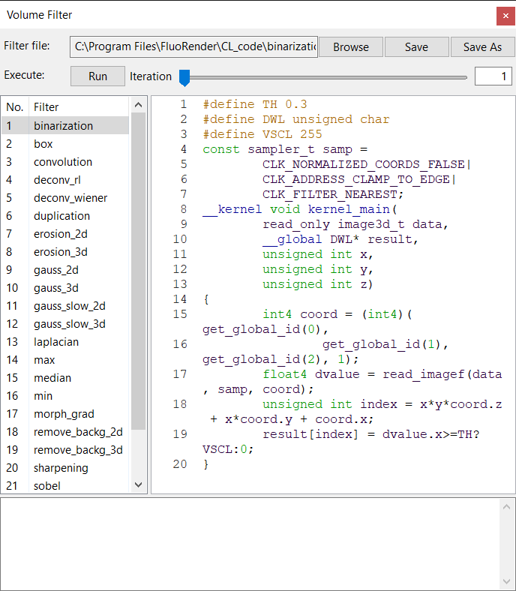

Figure ‑. Volume Filter window.

## Open and save filter files

To open a filter file, click “Browse”, and in the file browser dialog, choose a text file containing the filter code. To save an edited filter file, click “save”, to overwrite the original file. To save a modified filter file with a different name or path, click “save as”, and in the file browser dialog, choose a directory and file name to save it.

## Built-in filter files

Built-in filter files can be found in path CL\_code at where FluoRender is installed. Any file in this folder is listed on the list of filters. To apply a built-in filter, click the filter name. Then, click Execute to apply the filter to a selected volume.

The built-in filters provide commonly used image processing functions. You can change the settings by modifying the code directly.

|  |  |  |
| --- | --- | --- |
| Filter | Use Case | Settings |
| Binarization | Apply threshold on a volume to make it binary | Threshold value (TH) |
| Box | Low-pass filter to compute an average within a window | Window size (KX, KY, KZ) |
| Convolution | Standard image convolution by a template | Window size (KX, KY, KZ)  Template (krn) |
| Deconv\_rl | Deconvolution by the Richardson-Lucy method | Window size (KX, KY, KZ)  Point spread function (psf) |
| Deconv\_wiener | Deconvolution by Wiener filter | Window size (KX, KY, KZ)  Point spread function (psf) |
| Erosion (2D and 3D) | Morphological erosion | Window size (KX, KY, KZ) |
| Gauss (2D and 3D) | Gaussian filter | Window size (KX, KY, KZ)  Template (krn) or Formula (gauss) |
| Laplacian | Laplacian filter for edge enhancement | Window size (KX, KY, KZ)  Formula(Laplacian) |
| Max | Maximum filter | Window size (KX, KY, KZ) |
| Median | Median filter | Window size (KX, KY, KZ) |
| Min | Minimum filter | Window size (KX, KY, KZ) |
| Remove\_backg (2D and 3D) | Remove background noise based on local statistics | Window size (KX, KY, KZ)  Threshold (VTH, GTH) |
| Sharpening | Sharpening filter | Window size (KX, KY, KZ) |
| Sobel | Sobel filter for edge enhancement | Window size (KX, KY, KZ) |
| Thinning | Thinning or skeletonization filter | Threshold (TH) |

## Code panel

Write your own code or modify built-in code for more data processing functions. Coding should strictly follow the OpenCL C standard ([www.khronos.org/opencl/](http://www.khronos.org/opencl/)). In addition, pay attention to the following requirements.

1. The kernel entry point should be named with kernel\_main.
2. Currently selected volume channel is read by the kernel as an OpenGL 3D texture. The first parameter of type image\_3d is used.
3. Preprocessors are used to automatically identify and convert the bit length of a volume. These values need to be included in the code to make it work properly. The actual values are replaced at runtime depending on the bit length of the data.

|  |  |  |  |
| --- | --- | --- | --- |
| Preprocessor definition | Meaning | Values | |
| DWL | Value type | unsigned char | 8-bit data |
| unsigned short | 16-bit data |
| VSCL | Maximum range | 255 | 8-bit data |
| 65535 | 16-bit data |

|  |  |
| --- | --- |
|  | The current design of the OpenCL interface allows one input volume and one output volume of the same resolution. A kernel can have access to all sample points of both volumes. Please contact us for suggestions on more interface types. |

## Execute a kernel

Click “Execute” to execute a kernel on the currently selected volume channel. A new channel from the calculation is created if the kernel is successfully compiled. The new channel is named after the original channel with “\_CL” appended to the end. If you apply a kernel to a channel with a “\_CL” tag in its name, no new channel is created, and the kernel’s processing is directly applied to it. This allows you to repeatedly apply a kernel to a channel.

You can also run a kernel successively for a certain number of iterations. Use the slider to set the number of iterations, and then click “Execute”.

## Output panel

Kernel compiling information is listed in the output panel. If a kernel fails to compile, error messages can be found in the output panel. Correct your kernel code based on the error messages if this happens.

# Paint Brush

FluoRender allows selecting a portion of a volume channel based on underlying structures. Users can directly paint on data in render view and select desired structures. Selected structures become the basis of many subsequent analysis and processing operations. The paint selection settings are in the “Paint Brush” dialog. To open the “Paint Brush” dialog, click  on the main toolbar or the vertical toolbar on the Workspace panel. If the button is not currently showing on the main toolbar, it can be found in a drop-down list by clicking the arrow beside the current tool button.

The Paint Brush dialog controls the behavior of paintbrushes through a series of settings (Figure 16‑1).

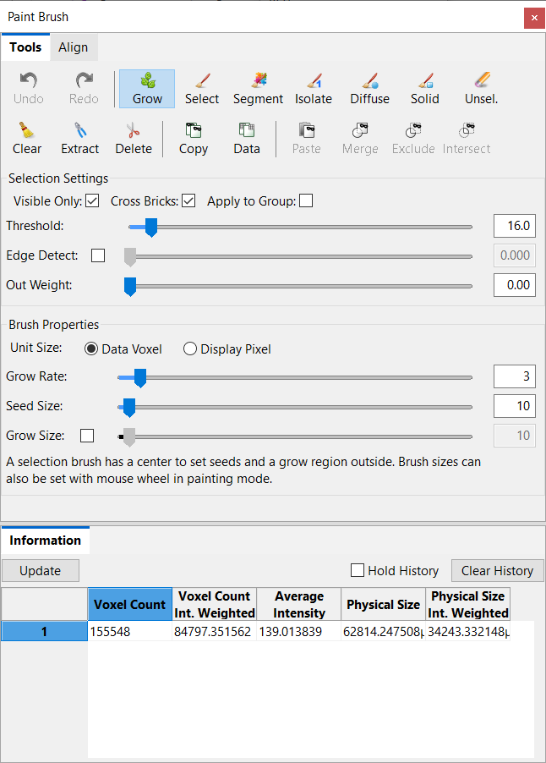

Figure ‑. The Paint Brush window.

## Brush History

You can let FluoRender keep a history of the most recent brush strokes, and undo/redo the operations. By default, the history setting is turned off. You need to first choose the number of strokes to be kept in history in the FluoRender Settings (Chapter 23). Once the brush history is turned on, you can use the  **Undo** and  **Redo** buttons to step through the brush stroke history.

|  |  |
| --- | --- |
|  | It consumes more memory and slows down the operations when the brush history is enabled. Disable this feature if you are not working with brushes. |

## Brush Types

 **Grow.** When enabled, click on a structure to select it. The selection mask grows from a point where the mouse clicks. Hold down the mouse button to continuously grow the selection mask. It can be useful to find all connected structures to a point. When the growth of a structure such as nerves is dominant in one direction, drag the mouse to that direction to constrain the growth selection. The Grow selection tool can be also accessed from the toolbar in the Workspace panel.

|  |  |
| --- | --- |
|  | Divide a large data set into multiple bricks to accelerate the selection speed. Avoid growing to all bricks in one click. Multiple clicks limit the computation to a small region of the entire data set. Interactive speed can then be achieved. |

**Select.** When enabled, the user can paint on visualizations in render view to initialize the selection of desired structures. The brush is typically equipped with two strokes, whose stamps are indicated by two concentric circles. The inner circle, called the center stroke stamp, defines seeds for selection. Seeds are selected based on the “Threshold” value in the “Selection Settings”. The outer circle called the diffuse stroke stamp defines a diffusion region for seeds. Seeds can diffuse or grow within the diffusion region based on a diffusion equation. The Select brush can be activated by the keyboard shortcut Shift (hold) or from the toolbar in the Workspace panel.



 **Segment.** It combines the selection brush and component generation in one operation. After a selection is made with the brush, it uses the settings from the Component window (see Chapter 18) and segment the selected regions into distinct components. The Segment brush tool can be accessed from the toolbar in the Workspace panel.

 **Isolate.** It clears the selection before making a new selection using the brush, isolating the painted regions to the current selection. The isolate brush can be used in tandem with most measurement tools that normally let users click on a volume to create ruler points. When the isolate brush is enabled together with a measurement tool, a ruler point is created by painting instead of clicking. See Chapter 17 for more details about measurement tools. A combination of the Isolate brush and Isolator tool  can be accessed from the toolbar in the Workspace panel.

** Diffuse.** When enabled, the user can paint on visualizations in render view to diffuse or grow existing selected structures. The diffusion brush is exactly a selection brush without the center stamp for seeding. It is used for selecting structures that are three-dimensionally connected to existing selections. It is useful to select complex 3D structures, such as nerves, neuron axons, and dendrites. The Diffuse brush can be activated by the keyboard shortcut Z (hold) or accessed from the toolbar in the Workspace panel.

 **Solid.** When enabled, the user can create masks of fully selected regions disregarding the underlying structures. You can use this brush to create masks even on completely empty regions of the data. It is useful when part or an entire data set needs to be selected and analyzed without missing any information (including empty space).

 **Unselect.** When enabled, the user can paint in render view and remove selected structures. It behaves like an eraser for masks. The Unselect brush can be activated by the keyboard shortcut X (hold) or accessed from the toolbar in the Workspace panel.

Finally,  **Clear** can be used to clear all selections. It can be activated by the keyboard shortcut C (press once) or accessed from the toolbar in the Workspace panel.

|  |  |
| --- | --- |
|  | Selected structures are indicated by a mask with a different color than the original volume channel. The mask color is calculated from the original color and should provide sufficient contrast to be distinguished from the original. For information on assigning IDs and changing mask colors, see the chapter on components and tracking. |
|  | Many settings that change the visualization of a volume channel can influence the paint selected result. Volume properties take part in the calculation of selected results. For example, voxels out of the threshold value range in the volume proper settings are not selected by the paintbrush. One important feature is to use of clipping planes to restrict paint selection. For example, when you set the opposite clipping planes in an axis with a section of one, it essentially allows you to perform paint selection on image sections. |
|  | Enable large data streaming and set a proper brick size for paint selection on a large data set. Only bricks covered by a paint brush stroke are included in the computation to reduce processing time. |

## Creating New Channels from Selection

FluoRender allows the creation of new channels based on selection. When a structure is selected within a volume channel, two operations are available to create new channels. They are in the toolbars of the Analyze window and Workspace panel.

** Extract.** It creates a new channel from the original volume with only the selected structures included. It can be accessed from the toolbar of the Workspace panel.

** Delete.** It creates a new channel from the original volume without the selected structures. It can be accessed from the toolbar in the Workspace panel.

The newly created channels inherit settings from the original channel, including the bit-depths.

|  |  |
| --- | --- |
|  | You can keep creating new channels using the extract operations. However, the delete operation behaves differently. It creates a new channel and appends “\_DELETED” to the end of the channel name. If you select some structures from the newly created channel and use the delete operation again, it will operate directly on that channel, without creating a new one. “\_DELETED” is used to identify a channel so that it will not create a new channel for repetitive detele operations. If you do not want this behavior, make sure you change the channel name to one without “\_DELETED”. Additionally, make sure a file name does not include “\_DELETED” if you do not want to erase directly on the volume channel. |

## Copying and Pasting Masks

Copy an existing mask from one channel to another so that they share the exact same mask. Two masks can be calculated to generate a new mask. The original intensities can also be used as a mask.

Copy. Select a channel from the Workspace panel. It copies the mask of the selected channel to be pasted into another channel.

Data-Mask. It copies the original data of the selected channel, which is used as a mask to be pasted into another channel as the mask.

Paste. Select a channel from the Workspace panel. It pastes the copied mask into the selected channel.

Merge. It merges a copied mask into the selected channel with its existing mask. The result is the union of two masks.

Exclude. It pastes a copied mask into the selected channel and subtracts it from the existing mask.

Intersect. It pastes a copied mask into the selected channel and computes the intersection between the two masks.

## Selection Settings

The behavior of bushes can be further refined using the selection settings.

**Visible only.** When enabled, in the seeding process, seeds occluded in 3D are not selected. It is useful to select densely packed structures, such as cells.

**Cross bricks.** When there are multiple bricks, the diffusion may not go across brick borders. Check this option to allow diffusion to go across brick borders. It may slow down the brush operations significantly.

**Apply to group.** When enabled, brush strokes are applied to structures from different volume channels within the same group of the current selection. It can be used to study colocalized structures within a region defined by brush strokes.

**Threshold.** It is the threshold value for seeding within the center stroke stamp region. It is also used to determine the strength of the diffusion process. The threshold value can be estimated by enabling the auto threshold function. To find a proper threshold value, adjust the setting after painting with a brush tool. The selection result is updated automatically with the change of the threshold if the viewing direction is unchanged.

|  |  |
| --- | --- |
|  | If auto threshold estimation cannot generate a satisfactory result, the user can still change the threshold value manually with the auto threshold option enabled. However, only diffusion brush becomes available for selecting structures. |

**Edge detection.** It incorporates local contrast information into the diffusion process. When high local contrast (usually structure boundaries or edges) is detected, the diffusion stops. You can adjust the strength of edge detection by the slider. A high value of edge strength prevents the diffusion of selecting neighboring structures. When the edge strength value is 0, it is equivalent to turning off edge detection.

**Out Weight.** Adjust the output weight value to enable the settings in the Output Adjustment panel (see Chapter 9) to modulate the weight for brush selection. For example, when the equalization value is increased, originally low intensity values allow the diffusion to grow more easily.

## Brush Properties

Brush diffusion strength and stamp sizes are controlled using the following settings.

**Unit Size.** It determines the unit of the brush size. Two options are available. Choose the data-dependent size to match brush size with a certain structure in the data.

* Data. Brush size uses a voxel as the unit. The brush changes its size to match zooming.
* Screen. Brush size uses screen pixels as the unit. The brush keeps its size when zooming.

**Grow Rate.** It sets the grow rate for the diffusion process, which essentially determines how many iterations are used for evaluating the diffusion equation. Stronger means more iterations. When more iterations are used, diffusion tends to grow further, but it may take more time to calculate. Use strong grow rate for coarse selection of large structures. Use weak grow rate for selecting finely detailed structures.

**Seed size.** It is the center stroke stamp size in screen pixels. It determines the region where the seed can be chosen by the selection brush.

**Grow size.** It is the outer stroke stamp size in screen pixels. It determines the region in which seeds can grow. The growing size can also be disabled. When disabled, the selection brush uses the center stroke stamp only. So, the selection brush is for seeding only. The selection will strictly follow the threshold setting. In addition, both the diffusion brush and un-selection brush use the center size for their stamps.

|  |  |
| --- | --- |
|  | When the brush types are enabled, the user can use the mouse wheel to adjust the stamp sizes. For the selection brush, the mouse wheel adjusts the grow size only. Hold the Ctrl key to adjust the center size. |

## Wacom Tablet and Display Tablet Support

Use a pressure-sensitive stylus for intuitive paint operations. The pressure of the stylus controls these settings:

**Threshold.** Increase the stylus pressure to lower the threshold setting, so that low-intensity structures are selected.

**Edge Detect.** Increase the stylus pressure to lower the edge strength setting, so that dimly connected structures are selected.

**Brush size.** Pressure on the stylus changes the brush size slightly. This is a visual indicator for pressure value. The change in brush size is insignificant to the selected results.

When a Wacom-branded tablet or display tablet is connected, a Wacom Airbrush may be used. The Airbrush is equipped with a wheel on the stylus body, which can be used to adjust the brush size.

## Information

You can get the size information on the select regions from the output. If you are using a fast computer system, you may get real-time information, as it updates with each brush selection operation.

|  |  |
| --- | --- |
|  | When the setting “Compute information on brush selection” is enabled in the Automation section of FluoRender Configuration window, the information for the brush selected regions is computed each time a selection is made. |

**Update.** Use the brush tool to select a region first. Click this button to get the size information on the selected region.

**Hold History.** Check this option to keep a list of size information entries. Each time a new size information entry is generated by either clicking the get selection size button or by brush painting when auto-update is on, the information entry is inserted to the top of the list. You can use this feature to make several size measurements on a single structure, such as a cell, and compute an average value. Or you can select multiple structures individually and get a list representing their size distribution.

**Clear History.** The data entries in the list are cleared.

The detailed information for the selected regions includes:

* **Voxel Count.** The total number of voxels within the selected region. A voxel is counted if its mask value is greater than 0.
* **Voxel Count (Int. Weighted).** The sum of the intensity values of all counted voxels. The intensity value for each voxel is a normalized value within the range [0, 1], where 1 represents the value 255 for 8-bit data and the max intensity for 16-bit data. The intensity-weighted voxel count can be significantly smaller than the voxel counts for low-intensity structures.
* **Average Intensity.** The average intensity is computed as (Intensity weighted voxel count) / (voxel count).
* **Physical Size.** The physical size of the selected region is computed by multiplying the voxel count with the voxel size. The voxel size is retrieved from metadata or set by the user in the volume property panel.
* **Physical Size (Int. Weighted).** Like the voxel count, it is weighted by intensity values.

## Align Render View to Selection Mask

Rotate the render view so that the screen space XYZ axes are aligned to the selection mask. The settings for render view alignment can be found on a separate tab in the Paint Brush window.

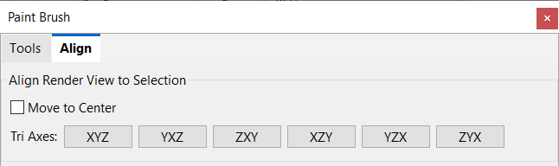

Figure ‑. Align settings.

**Move to center.** When this option is enabled, it also translates the render view when an axis option is selected, so that the center of the selection mask is aligned with the render view center.

**Tri axes.** Three axes are computed from the voxels of the selection mask using the principal component analysis method. Then, the render view is rotated so that the three computed axes are aligned with the screen space XYZ axes.

|  |  |
| --- | --- |
|  | Set the rotation angles after alignment as the zeros in render view, so that they can recover easily. See Chapter 7 for more details. |

# Measurements

Measurement functions allow users to create locators and rulers to get position information and measure length. To use the measurement functions, click “Measurement”  on the main toolbar. If the button is not currently showing, use the drop-down list next to the tool that is currently showing. Alternatively, click the button on the vertical toolbar on the Workspace panel.

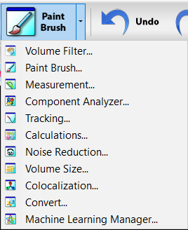

Figure ‑. Launch the Measurement window from the main toolbar.

The Measurement window is shown in Figure 17‑2. Measurement window.

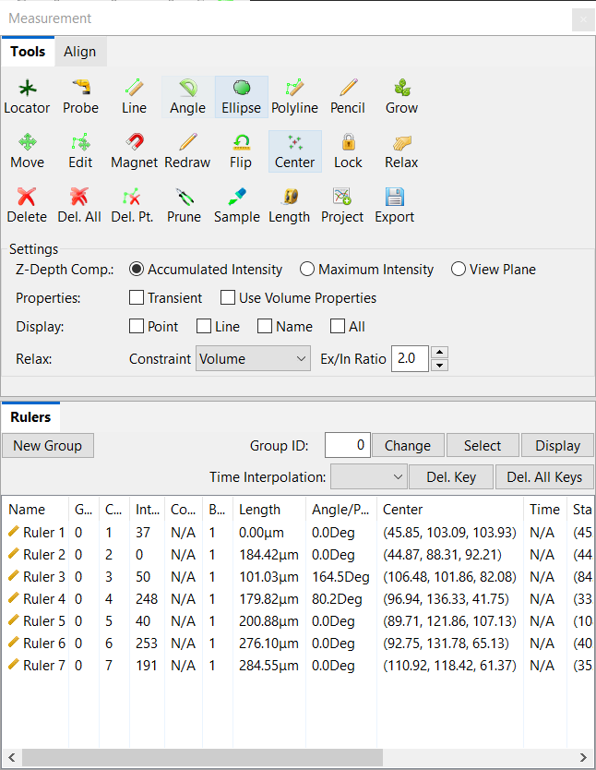

Figure ‑. Measurement window.

## Measurement Tools

Measurement tools are generally referred to as rulers. Most rulers are created by clicking on a volume. Some rulers, like pencil, are created by drawing.

** Locator.** Enable the locator and click on a volume to create a single point. The point in the 3D space measures the position as X, Y, and Z coordinate values. A locator also measures the intensity of the volume at its position. A locator can be simultaneously enabled with the Isolate brush tool. When both are enabled, the locator point is created by painting. The locator’s position is determined by the centroid of the selected region. The average intensity and voxel count are also measured for the selected region. See Chapter 16 for more details about brushes.

 **Probe.** The probe tool allows you to create a two-point ruler that goes through the data from the current viewing direction. Click on a volume to create a two-point ruler for the probe. A probe can be simultaneously enabled with the Isolate brush tool. When both are enabled, the selected region can be sampled to create an intensity profile along the ruler. See Sample tool below for more information.

** Line.** Click on a volume twice to create a ruler with two endpoints. The line ruler is used to measure the length, angle, and start/end points. The larger intensity value between its two endpoints is displayed. It can be simultaneously enabled with the Isolate brush tool. When both are enabled, an endpoint is created by painting. The intensity value is the larger of the average intensity values of the two endpoints. Voxel count for each painted region is also computed. It can be accessed from the toolbar in the Workspace panel.

**Angle.** A contractor allows you to measure the angle between two lines. Click three times in the render view to create an angle measurement. The angle value in degrees is shown in the list of the measurement dialog window. The Angle tool can be used together with the Isolate brush.



**Ellipse.** Click twice to create a circle. Edit the points on the circle to change its shape into an ellipse. An ellipse ruler can be used to define an ROI, within which intensity values from a volume channel can be sampled.



**Polyline.** Click multiple times to create the points for a polyline ruler. End the ruler by right-clicking. Switching to other tools also ends the current polyline ruler. Branches can be created by clicking on an existing ruler point, and it becomes the root of a branch. Continue creating more points to complete the branch; add more branches to create a tree structure. A polyline ruler measures the total length. It also counts the branch number for a multi-branch ruler. It can be used with the Isolate brush for creating ruler points by painting. It can be accessed from the toolbar in the Workspace panel.

**Pencil.** Click and drag the mouse to create a ruler using the pencil tool. Ruler points are added when the mouse cursor is moved away from the previous ruler point. Since the ruler point distance is determined in screen space, zoom in to create a ruler with dense points, and zoom out for coarse ruler points. Branches can be created by starting to draw from an existing ruler point. The projected distance between two ruler points in the screen space can be adjusted in the configuration window (Chapter 23). It can be accessed from the toolbar in the Workspace panel.



**Grow.** The grow ruler is used the same as the grow selection tool in the Paint Brush tools. Click on the starting point of a structure and hold the left mouse button. A selection mask is created and starts to diffuse from the starting point. For each growth step, the newly grown structures are analyzed. Separate ruler points are created for branching structures. When the grow ruler tool is enabled, successive operations add ruler points to the latest ruler. The value [ruler/size thresh] controls how structures are connected when the grow tool is used. The default value is 2, which connects small structures together. If that’s not desired, open the setting file fluorender.ini with a text editor and increase the value.

|  |  |
| --- | --- |
|  | The paint selection brush can be activated when a ruler tool is enabled. It can be used to measure the volume of paint-selected structures. To activate the paintbrush during ruler measurement, you must use the keyboard shortcut. Hold down the “Shift” key and then paint. A new ruler point is created or appended. The volume of the selection is listed under “Volumes” of the measurement list. The coordinates of a locator or ruler point are the centroid of the selected volume structure. |
|  | Measurement tools disable normal render view interactions. To interact with render view with measurement tools enabled, hold down the “Alt” key and use normal render view interactions, including rotation, zooming, and panning. |

## Editing Measurement Tools

You can change the position of locators or ruler points after they have been created. In addition, you can change the settings to set the locations of ruler points more easily in 3D. These settings and tools are available to make changes to measurement tools.

 **Move.** Click on a ruler point and move its position. All ruler points of the ruler are moving together.

 **Edit.** When enabled, you can click on a locator or ruler point and change its position by dragging it in render view. Notice that normal render view interactions are allowed. A locator or ruler point is selected only when you first click within the region indicated by the square box representing the locator or ruler point. Otherwise, you may accidentally rotate the view. An additional mode of editing works the same as the Magnet for editing a single ruler point. Click anywhere in the viewport and the closest ruler point is attracted to the clicked location. It can be accessed from the toolbar in the Workspace panel.

 **Magnet.** Click and draw a stroke like the pencil tool. The closest ruler points are relocated on the newly drawn stroke. The distances between ruler points are preserved.

 **Redraw.** Click and draw a stroke like the pencil tool. Start the stroke from the starting point of an existing multipoint ruler. Ruler points of the ruler are redistributed on the newly drawn stroke. The length of the ruler can be changed by drawing longer or shorter strokes.

 **Flip ruler.** When a ruler has more than 1 point, the order of ruler points can be flipped by clicking this button. In the ruler list, the start and end points are swapped after flipping.

 **Center.** It computes the averaged centers of multiple ruler tools and creates a locator at the location. At least one ruler needs to be created already for the average to work. When multiple ruler tools are created, you can select several among them for the averaging calculation. When no ruler is selected, all rulers will be used for calculating the average.

 **Relax.** Click to perform relaxation on a selected ruler. A ruler can be relaxed as many times as needed to settle down.

 **Lock.** When enabled, click on ruler points to lock them, and thus exclude them from relaxation calculations. Click a locked ruler point once more to unlock it.

|  |  |
| --- | --- |
|  | *Ruler points on a ruler can be automatically reshaped using a spring-mass system. Each pair of adjacent ruler points is connected by a spring, whose rest length is determined when the ruler is created. A multipoint ruler also attempts to straighten itself. A smoother ruler can be generated. Use constraints to further shape the ruler to follow structures in 3D.* |

** Delete.** Delete the currently selected ruler(s) in the measurement list.

** Delete all.** Delete all locators and rulers from the measurement list.

**Delete a ruler point.** When enabled, click a ruler point to delete it. It can be accessed from the toolbar in the Workspace panel.

 **Prune.** Delete very short branches from a selected ruler.

 **Sample.** The sample tool generates an intensity profile within a volume along a selected ruler. The intensity value is shown in the ruler list for each ruler. For a locator, the intensity value is sampled from the exact location. For rulers with certain lengths, the maximum intensity value is shown.

 **Length.** The distance tool computes the distances between a selected ruler tool and analyzed components. You need to first generate and analyze the components and then select a ruler tool to apply this function. The resulting distances are output in a text file that is Excel-compatible.

 **Project.** The project tool projects analyzed the components of a selected ruler. Perform a component analysis first in the Component window (see Chapter 18). Then, select a ruler from the list and compute the projected components. The results are saved in a text file, which can be read by Microsoft Excel. The results contain the ID of each component and the distance of its centroid to the selected ruler.

 **Export.** Export the measurement list to a file. The file is in text format and can be loaded into a spreadsheet editor such as Microsoft Excel. When a ruler tool has more than two ruler points, the coordinates of each point are exported along with other information about the ruler.

## Settings for Measurement Tools

### Choosing a depth calculation method

There are three methods you can choose to determine how the 3D position of a locator or ruler point is calculated from the screen position. Choose the method based on the underlying volume channel’s structures.

**Accumulated intensity.** It places a locator or ruler point at a depth of a voxel that all preceding voxels along the ray have an accumulated intensity adequate to occlude it. It usually finds a point on a well-defined structural surface. Use this method if you want to measure length on a surface. If no such point can be found, it automatically switches to the view plane method.

**Maximum intensity.** It places a locator or ruler point at the depth of a voxel having the maximum intensity along the ray from the viewer. If multiple maximum-intensity voxels exist, the closest one is chosen. Use this method if you want to trace a nerve. However, if the nerve happens to be occluded by other structures at certain locations. The depth may not be calculated as desired. Use the edit tool to correct those points from a different angle of view if necessary.

**View plane.** It places a locator or ruler point on the view plane that is perpendicular to the viewing direction, disregarding the underlying volume channel. The depth is fixed when this method is used. Use this method, for example, if you are measuring lengths on an image section.

### Ruler properties

**Transient.** When enabled, a locator or ruler can only be created and viewed at a specific time point, when a time sequence data set is loaded. The time point that a locator or ruler belongs to can be obtained from the measurement list, under “Time”. The setting is ignored when non-time sequence data are loaded.

|  |  |
| --- | --- |
|  | This feature can be used to manually track the movement of a certain structure. You can disable transient, choose a two-plus-point ruler tool, go to a certain time point of the data, select a structure with the paintbrush activated, and then proceed to the next time point. Since the transient feature is disabled, you can create a multi-point ruler tool across a series of time points, which represents the trajectory of movement of the selected structure. More sophisticated tracking features are discussed in Chapter 20. |

**Use volume properties.** When enabled, the calculation of the depth value is based on the mapped values after volume properties are applied, including Gamma, threshold, saturation, etc. It allows more precise depth calculation but may take more time to calculate.

### Ruler component display

The components of a ruler can be shown or hidden individually by these settings.

**Point.** The points are created by clicking the mouse.

**Line.** The line segment between two ruler points.

**Name.** The name of the ruler is shown at its starting point.

**All.** The points, lines, and name of a ruler are all displayed.

### Ruler relaxation settings

**Constraint.** Use volume, selection mask, or analyzed components to constrain the shape of a ruler, so that t ruler points stay at structural centers.

|  |  |
| --- | --- |
| Constraint type | Effects |
| Free | No constraint is applied. A ruler is smoothed using its internal forces. |
| Volume | Use the selected volume channel to reshape a ruler. Ruler points are attracted by voxels. High-intensity voxels have a stronger attraction force. |
| Selection | Use the selection mask to reshape a ruler. Ruler points are attracted by the voxels of the selection mask. |
| Analyzed components | Use analyzed components to reshape a ruler. Ruler points are attracted by component centers. |

**Ex/In Ratio.** When analyzed components are present, this value determines the ratio of force strength between the attractors (volume, selection mask, or analyzed components) and internal springs. Increasing the ratio makes stronger attraction forces from the components.

|  |  |
| --- | --- |
|  | A ruler can be automatically relaxed after creation. This feature is enabled in the Automation panel in the Configuration window (Chapter 23) |

## Ruler List

### Editable entries

**Hide/Show.** You can double-click on a ruler tool on the list to hide or show it. A hidden ruler tool has a gray background color when it is not highlighted.

**Name.** Click a measurement tool in the list. A text edit box allows you to change the name of the selected tool. When you type in the text edit box, the name of the selected tool is updated in the render viewport at the same time.

**Color.** Click a measurement tool in the list. A color button shows and allows changes to the color of the selected tool. Click the color button. It shows a color selector dialog window. Choose the desired color and close the dialog window. A new color is updated to the selected tool in the render viewport at the same time. Select multiple rulers from the list and change their colors together. Rulers can be selected by dragging a box or using Ctrl or Shift keys.

|  |  |
| --- | --- |
|  | When no color is set for a measurement tool, it uses an automatically calculated color so that it is visible against the current background. |

**Center.** The XYZ coordinates of a locator can be edited on the list. Click a locator tool and its center coordinates become editable. Input the XYZ coordinates, and the locator will change its location. You can also copy and paste the center coordinates from other ruler tools to a locator. Use the keyboard shortcut CTRL+C or CMD+C to copy the coordinates of a ruler center. The copied coordinate format is also Excel-compatible.

### Ruler groups

Use group numbers to manage multiple ruler tools efficiently.

**New Group.** Rulers can be organized under a group ID. The group number starts with 0. Click “New Group” to increase the group number by one. Subsequently created rulers are grouped under the new ID.

**Change.** Type in a group ID in the text box and click the button to change the selected rulers to the group. Subsequently created rulers will be placed in the group too.

**Select.** Type in a group ID in the text box and click the button to select all rulers in the group from the list.

**Display.** Type in a group ID in the text box and click the button to show or hide all rulers in the group. To show or hide the rulers selected from the list, right-click the list and select Toggle Display on the pop-up menu.

### Ruler Editing Over Time

Rulers can be animated over time, creating copies of different shapes at different time points. By default, a ruler is non-transient, which is shown at all time points. A ruler created at a certain time point can be modified at any time point. A copy of the ruler of a modified shape is saved at the time when it is modified. Copies of a ruler at different time points should all have the same topology, i.e., the same number of points and locations of branches. Shape analysis can be performed using this function by tracking the shape of objects over time. Use the script “ruler\_info” to export the results of the ruler animation in a file (Chapter 13).

Just like creating keyframe animations, a key for a ruler point is created when its position is modified at a time point. For time points without modifications, the position of a ruler point is interpolated from the neighboring keys. The interpolation method can be checked by selecting a ruler from the list and its interpolation method is shown as the “Time Interpolation” value above. The method can be modified with three options.

**Step.** If there exists a preceding key, its position is used, Otherwise, the position of a subsequent key is used.

**Linear.** The position of a ruler point is linearly interpolated from its preceding key and subsequent key.

**Smooth.** Like linear interpolation, the change rate of the position over time is smoothed with acceleration and deceleration.

To delete the keys from a ruler, select the ruler first, and then use one of the delete buttons above the list.

**Del. Key.** If a key exists at the current time point, delete the key.

**Del. All Keys.** Delete all keys of a ruler. The positions of ruler points remain at the current time point.

## Align Render View to Rulers

Rotate the render view so that the screen space XYZ axes are aligned to rulers. Use the settings in the Align panel to align the render view to rulers.

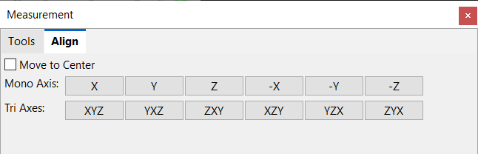

Figure ‑. Align panel in Measurement window.

**Move to the center.** When this option is enabled, it also pans the render view when an axis option is selected, so that the center of the ruler points is aligned with the render view center.

**Mono axis.** Create a 2-point ruler first as the reference for an axis to align with. Then, choose one of the axis options to rotate the render view. For example, click the X-axis so that a 2-point ruler is leveled in the render view. Use the negative axis options to flip the render view.

**Tri axes.** Three axes are computed from ruler points using the principal component analysis method. Then, the render view is rotated so that the three computed axes are aligned with the screen space XYZ axes. At least 3 points not on a straight line are needed to compute the axes correctly.

|  |  |
| --- | --- |
|  | You can select a single ruler or multiple rulers to perform the alignment. Only the ruler points are used for alignment calculations. |
|  | Set the rotation angles after alignment as the zeros in render view, so that they can recover easily. See Chapter 7 for more details. |

# Component Analysis

A volume channel may contain distinct structures separated from each other, such as individual cells or neuronal fibers. These structures are generally referred to as components. Use the Component Analyzer to segment them for detailed examination and quantitative analysis. To use the Component Analyzer, click “Components”  on the main toolbar. If the button is not currently showing, use the drop-down list next to the tool that is currently showing. The Component Analyzer dialog is shown in Figure 18‑1. It contains tabbed panels for different settings and functions. The Generate panel is for generating components from a volume channel; the Analysis panel is for analyzing the components generated from previous pages. ; the Cluster panel is for separating connected components using common clustering methods. The component information is listed in the Information panel.

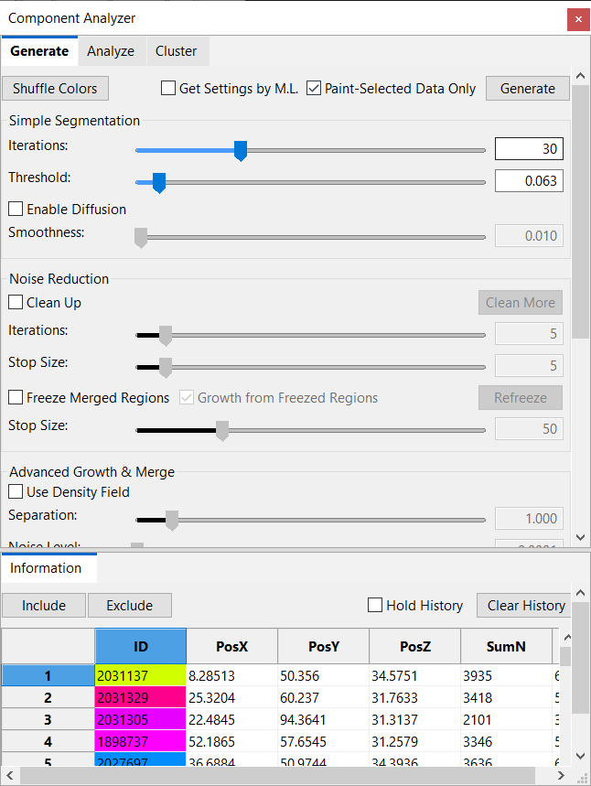

Figure ‑. The basic settings in the component analyzer dialog.

|  |  |
| --- | --- |
|  | You may enable large data streaming and then perform component analysis on a loaded data set. The analysis will apply to each brick of the data set and the resulting bricks are stitched. You may see seams between bricks. However, components belonging to one connected structure will be computed as one stitched entity. |

## Settings for Component Generation

To generate components from a selected volume channel, you may enable and configure a series of settings (Figure 18‑1). The calculations are based on the “Synthetic Brainbows” algorithm (Wan et al., Synthetic Brainbows. *Computer Graphics Forum*, Vol. 32, No. 3, 2013), which is an agglomerative algorithm that starts with a state of all separated voxels and merges them iteratively according to signal strength and structural shapes.

### Component Generation Tools

**Shuffle Colors.** Click the button to shuffle the color palette for components. When it becomes unclear if there exist distinct components mapping to the same or similar colors, use this function to shuffle component colors.

**Get Settings by M.L.**  It automatically determines the settings for component generation based on machine-learning results. A machine-learning table needs to be loaded in the Machine Learning Manager for it to work (Chapter 22).

**Paint-Selected Data Only.** Component generation is only computed within the brush-selected regions.

**Generate.** Set the settings and then click it to generate components. To visualize the components, enable component visualization in the Volume Property panel (Chapter 8).

Auto component generation can be enabled in the Automation panel of the Configuration window. When auto component generation is enabled, components are recomputed after any setting for component generation is changed.

For a time sequence, you can apply settings at different time points and observe the results. When you are satisfied with the results, run a 4D script called “generate\_comp” to apply the settings to all time points. See Chapter 13 for more details on running a 4D script to execute external executables.

### Simple Segmentation

**Iterations.** The number of passes the Synthetic Brainbow algorithm is run. Use enough iterations so that voxels from one component are fully merged. You can observe the merging process by using the “Refine” button, which applies iterations on top of the existing result.

**Threshold.** It sets a threshold for intensity values. Voxels with lower than threshold intensities are excluded from the component generation.

**Enable Diffusion.** When enabled, a falloff setting is available. Diffusion controls component generation speed based on intensity values. Voxels with high-intensity values tend to merge more quickly than low ones.

**Smoothness.** It is the parameter in a Gaussian distribution that controls how fast intensity values lower than the threshold fall out of the component merging process. When diffusion is enabled, different intensity values lower than the threshold are assigned with different merging speeds for component generation. A high falloff value means more low-intensity values are included in the merging process; a low falloff value means that merging becomes stricter for only those intensity values greater than the threshold.

### Noise Reduction

**Clean Up.** Enable this feature to let large components “absorb” small components. However, large components cannot merge with each other.

**Iterations.** The number of passes the cleanup is executed.

**Stop Size.** Components smaller than the size setting can be merged by neighboring large components.

**Clean More.** Apply the clean-up one more time.

**Freeze Merged Regions.** Enable this option so that already separated regions of a certain size will not merge with each other. A data set may contain different structures; a group of settings may only be able to handle a portion of the data set. Use this feature to apply settings to different regions.

**Stop Size.** Already merged structures of larger sizes will be frozen. They cannot merge with each other if the Freeze function is enabled.

**Refreeze.** Reapply the Freeze function after the settings have changed.

**Growth from Frozen Regions.** Allow already frozen regions to grow and expand to unfrozen regions.

### Advanced Growth & Merge

**Use Density Field.** For data with uneven brightness, the density field is generated for equalization. The original data’s intensity field is first filtered to smooth the result. Then, it is divided into a series of cubic regions, where local density distributions are computed. The local density distributions are interpolated for each voxel. The separation of structures is determined by a voxel’s intensity relative to its local density distribution, making low-intensity structures more easily separated from the high-intensity ones. Once the density field is enabled, these settings become available:

**Separation.** It works like a local threshold setting. A higher value allows low-intensity voxels relative to their neighbors to be separated.

**Filter Size.** The smoothing filter’s window size for preprocessing the original data. Increase this value for noisy data; decrease this value when structures of small size need to be distinguished.

**Feature Size.** The size of the cubic region for local distribution calculation. Set it to be about the same size as the structures that need to be distinguished.

**Use Distance Field.** For data with strongly connected components (For example, when a couple of cell nuclei are very close together, there are almost no lower-intensity voxels to separate them), only using their intensity information will not be sufficient to separate them. The distance field is a derived intensity field where a voxel’s intensity value is determined by its distance to a global perimeter. The global perimeter is generated by thresholding the original intensity value. Once the distance field is enabled, these settings become available:

**Strength.** The derived distance field is intermixed with the original data. The strength of the distance field is the factor for intermixing. A 0 value means no distance field is used, and a 1 value means all calculations are based on the distance field.

**Perimeter Value.** The threshold value to generate the perimeter, which is then used to calculate the distances.

**Filter Size.** The smoothing filter’s window size for preprocessing the original data. Increase this value for noisy data; decrease this value when structures of small size need to be distinguished.

**Feature Size.** It determines how far the distance is calculated from the perimeter. Set it to be about the same size as the structures that need to be distinguished.

### Action Recording and Playback

Because components may be generated in a multistep fashion with complex settings, the macro recorder can record the steps to generate a result. A recorded command can be applied to similar data sets.

**Record.** Click once to start recording. Click again to stop recording.

**Play.** Execute a recorded command.

**Reset.** Clear a recorded command.

**Load.** Open a file browser and load a previously saved command.

**Save.** Save the recorded command to a file.

## Cluster

To segment locally selected features with clustering algorithms, click the second tab to show the clustering settings. Select structures with paint brushes (Chapter 15). For example, two cells/nuclei fused together can be separated using a clustering method.

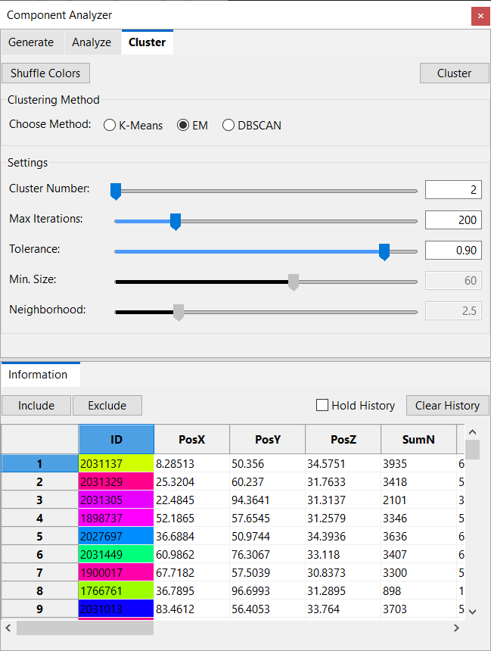

Figure ‑. Clustering tools.

### Clustering Method

**K-means.** It uses the k-means algorithm to cluster structures. You need to provide the number of clusters to separate the selection.

**EM.** It uses the expectation-maximization algorithm on a Gaussian mixture model. You need to provide the number of clusters to separate the selection.

**DBSCAN.** It uses the DBSCAN algorithm to cluster structures based on density. You need to set a minimum size and a neighborhood range for this algorithm.

### Cluster Settings

Depending on the selected algorithm, different settings become available.

**Cluster Number.** The number of expected clusters.

**Max Iterations.** The number of iterations an algorithm can run at most.

**Tolerance.** It controls the quality of the clustering results. A higher tolerance number means stricter conditions.

**Min. Size.** The minimum size for the DBSCAN algorithm.

**Neighborhood.** The range for searching neighbors for the DBSCAN algorithm.

Click the button “Cluster” to run clustering. If you enable the script and the clustering is successful, the separated structures will be rendered with different colors. Use the “Analysis” tab to get detailed information on the clusters.

|  |  |
| --- | --- |
|  | The EM algorithm uses a Gaussian mixture model to detect ellipsoid-shaped objects. When more than 2 clusters need to be separated, use the K-means method first to get an approximate result. Then, you can apply the EM method, which can continue from the K-means result and refine shapes. |

## Component Analysis

Use the component analysis functions for quantitative information on components generated using various methods.

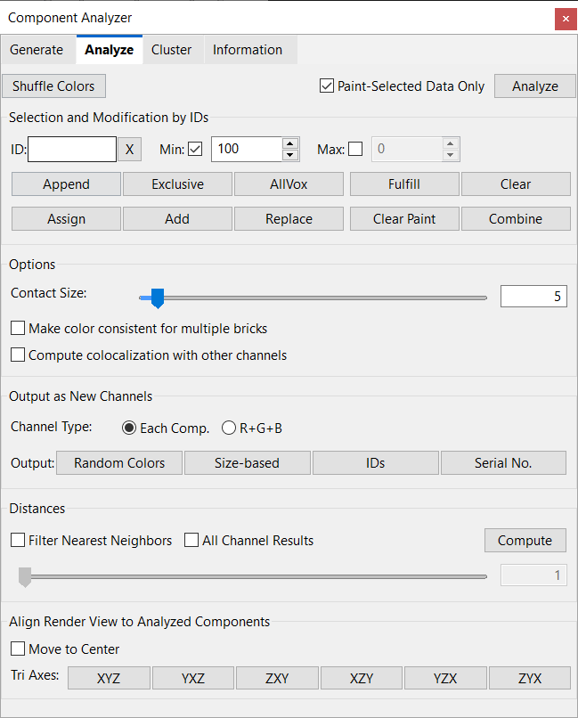

Figure ‑. Component analysis tools.

### Component Analysis Tools

**Shuffle Colors.** Click the button to shuffle the color palette for components. When it becomes unclear if there exist distinct components mapping to the same or similar colors, use this function to shuffle component colors.

**Paint-Selected Data Only.** Only analyze the selected part of a data set. The analysis results are printed in the Output panel. If the results contain many entries, it prompts you to save them in a text file. Choose a text file and click the Save button. The results are Tab-separated, which can be opened using spreadsheet editor software, such as Microsoft Excel.

**Analyze.** Analyze all components of an entire data set. The analysis results are printed in the Output panel. If the results contain many entries, it prompts you to save them in a text file. Choose a text file and click the Save button. The results are Tab-separated, which can be opened using spreadsheet editor software, such as Microsoft Excel.

### Selection and Modification by IDs

You can use the paintbrush tool to select components of interest. It also provides a series of tools to fine-tune the selection.

**ID input box.** You can type in the ID of a component and then select it. It also shows the color of the ID as you type.

|  |  |
| --- | --- |
|  | When a large data set is divided into bricks for either streaming or because a max texture limit is set, a component is uniquely identified by its brick ID and ID, instead of just ID when only one brick is present. This is because the same ID can be reused across multiple bricks. If you only input the ID of a component, all components assigned with the same ID will be selected from all bricks. To select a component within a brick, type its brick ID before the component ID, with a non-digit character to separate them, for example, 1:123456. |

**X.** The X button clears the content of the ID input box.

**Min Size.** Check this option to enable a limiter on minimum voxel size. The input value determines the minimum voxel number of a component to be selected. Use this setting to exclude small-size components to be counted, for example, noise data. Uncheck this option if the minimum size limiter is not needed.

**Max Size.** Check this option to enable a limiter on maximum voxel size. The input value determines the maximum voxel number of a component to be included in the analysis. Use this setting to exclude large-size components from being counted. Uncheck this option if the maximum size limiter is not needed.

**Append.** Add a component with the exact ID in the ID input box to the selection while keeping the currently selected components.

**Exclusive.** Replace currently selected components with a component with the exact ID in the ID input box.

**AllVox.** Select all voxels including the empty background.

**Fulfill.** A selection made with the paintbrush usually does not match exactly with labeled voxels. Click this button after you have selected the paintbrush tool and would like to find out the entire component. Make sure to leave the ID input box empty if selecting the entire component is the desired operation. Otherwise, it is equivalent to the Append button. Pressing the enter key when the ID input box is in focus has similar results.

|  |  |
| --- | --- |
|  | When a large data set is divided into bricks for either streaming or because a max texture limit is set, perform component analysis once to stitch components that span multiple bricks. Component selection after analysis will consider the stitching information and include parts of such components in neighboring bricks, even if all the parts are assigned with different IDs. |

**Clear.** Clear the selection of all components.

**Assign.** Assign the new ID to the current selection. It will automatically resolve any ID conflicts.

**Add.** Only assign the new ID to a selection or selected parts that do not currently have a valid ID.

**Replace.** Replace the current selection with the new ID. No conflicts will be resolved.

**Clean Paint** Reset the IDs of unselected parts to 0.

**Combine.** Combine multiple IDs into a single ID.

### Options

You can set these options before analysis.

**Contact size.** When large data streaming is enabled, a single component spanning multiple bricks is combined. The contact size is the number of overlapping voxels at brick borders. Only components having a contact size larger than this setting are combined into a unified component. Use this setting to exclude noise signals and structures slightly connected.

**Make color consistent for multiple bricks.** When a large data set is divided into bricks for either streaming or because a max texture limit is set, some components may span multiple bricks. Different parts of such components within neighboring bricks may not be assigned with the same ID and color. Check this option and FluoRender will replace IDs within neighboring bricks to make the colors of such components consistent.

**Compute colocalization with other channels.** Check this option and FluoRender will compute the colocalization information for each component of the selected channel with other visible channels in the project. The colocation information is output along with other fields of components.

### Output as New Channels

You can output components as new channels. There are two options to create multiple channels from components.

**Each Comp.** Each component is output as one channel. Use the selection tools to limit the number of components that can be processed.

|  |  |
| --- | --- |
|  | Make sure that you have enough memory if the number of components is high. It may also take a long time to generate many channels. |

**R+G+B.** All components are output as a combination of the three-color channels. Only three channels will be generated, no matter how many components are processed.

Click these two buttons to generate new channels. You can also set the colors of new channels.

**Random Colors.** Each component is assigned a color according to its ID.

**Size-based.** The colors of components are mapped according to their sizes.

**IDs.** Show component IDs as annotations.

**Serial No.** Instead of showing the component ID, it shows the row number in the output table.

|  |  |
| --- | --- |
|  | Save an annotation from the “Dataset” panel. Detailed information includes ID, centroid coordinates, size in voxel, size in physical unit, and averaged intensity. |

### Distances

Calculate the distances between pairs of components. The full result is an adjacency matrix of distances. The matrix is saved in a text file that is Excel-compatible. When there is more than one channel analyzed, the components from all channels are computed and the results are presented in a unified adjacency matrix.

For each component, you can only include the nearest neighbors.

**Neighbors.** Check this option to filter the result and only include the nearest neighbors. Then, you can set a number for neighbors.

|  |  |
| --- | --- |
|  | In the adjacency matrix, the distance from a component to itself is included, which is always zero. When the nearest neighbor filter is enabled, the self-distance is excluded. Therefore, the number of neighbors does not include the component itself. |

### Align render view to components

Rotate the render view so that the screen space XYZ axes are aligned with the analyzed components.

**Move to center.** When this option is enabled, it also pans the render view when an axis option is selected, so that the center of the components is aligned with the render view center.

**Tri axes.** Three axes are computed from the components using the principal component analysis method. Then, the render view is rotated so that the three computed axes are aligned with the screen space XYZ axes.

|  |  |
| --- | --- |
|  | Set the rotation angles after alignment as the zeros in render view, so that they can be recovered easily. See Chapter 7 for more details. |

## Information Panel

The component analysis results are output to the information panel. Select one or multiple components from the list and their corresponding structures are highlighted in the render view. You can also click on the render view to select components.

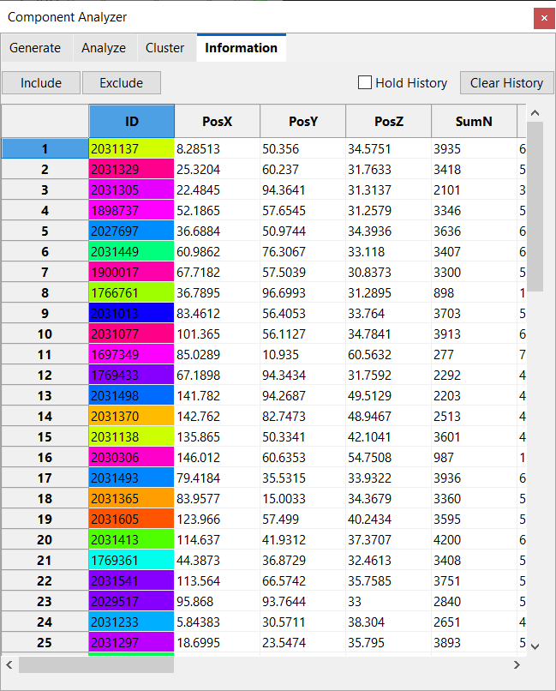

Figure ‑. Component information.

### Select and filter components



Figure ‑. Select components from the output list or in the render view.

Select a component from the output table by clicking its row number. A box is drawn around the component in the render view to indicate its whereabouts (Figure 18‑5). Multiple components can be selected by dragging a box to select multiple rows in the table. Or hold the Ctrl key to select nonconsecutive rows. Components can also be selected directly from the render view by clicking on them. Their corresponding rows in the output table will be highlighted too. To select multiple components from the render view, hold the Ctrl key and click on components. The Ctrl key is also used to unselect a selected component in the render view.

The selected components can be included or excluded from the selection mask (such as that generated by the paintbrush). To only include the selected components in the selection mask, click the Include button. The keyboard shortcut is Enter/Return. To exclude the selected components from the selection mask, click the Exclude button. The keyboard shortcut is /.

### Component Information settings

**Include.** Select components from the list and remove unselected components.

**Exclude.** Select components from the list and remove them from the list.

**Hold History.** Append recently analyzed components to the list without removing previous results.

**Clear History.** Clear the list.

### Component Information entries

**ID.** The integer value to identify a component. The color of a component is computed from its ID. The color is shown as the cell background color.

**PosX.** The x coordinate value of the center of the component.

**PosY.** The y coordinate value of the center of the component.

**PosZ.** The z coordinate value of the center of the component.

**SumN.** The total number of voxels within the component.

**SumI.** The total number of voxels within the component that are weighted by their intensity values.

**PhysN.** The physical size of the component. PhysN = SumN x Voxel size. The voxel size is retrieved from the metadata.

**PhysI.** PhysI = SumI x Voxel size.

**SurfN.** The number of voxels that are on the surface of a component.

**SurfI.** The number of voxels that are on the surface of a component and weighted by their intensity values.

**Mean.** The mean intensity value of all voxels within a component.

**Sigma.** The standard deviation of the voxel intensity values within a component.

**Min.** The minimal intensity value within a component.

**Max.** The maximal intensity value within a component.

**Dist.** The distance of the component to a ruler tool. See “Distance” in Chapter 17 for more details.

**PcaL.** The length of a component is computed as the length of the principal component.

Select one or multiple cells, rows, and columns from the table and copy them into Microsoft Excel using the shortcuts Ctrl+C and Ctrl+V.

# Processing and Analyzing Volumes

The Component Analyzer (Chapter 18) provides a general solution to several specific processing operations. For example, you may set a maximum voxel size limit and then select all components with a relatively small size. Then, you can erase those small components, which are generally noise signals. There are a series of modules in FluoRender that are built on top of the general component analysis module and perform specific processing and analyzing functions. These modules can be found on the drop-down menu of the main toolbar (Figure 19‑1).



Figure ‑. Access the additional processing and analyzing functions from the drop-down menu of the main toolbar.

## Volume Size



Use the “Volume Size” dialog to calculate the sizes of components (Figure 19‑2). To open the “Volume Size” dialog, click the downward arrowhead next to the tool that is currently showing, and choose “Volume Size” (Figure 19‑1).



Figure ‑. Volume size dialog.

These settings are available in the “Volume Size” dialog.

**Selected only.** Only paint-selected structures within a volume channel are analyzed. Otherwise, the entire volume is analyzed. If this option is checked, make sure that you have something selected.

**Min voxel.** The minimum voxel number of a component to be included in the analysis. Use this setting to exclude small-size components to be counted, for example, noise data.

**Max voxel.** The maximum voxel number of a component to be included in the analysis. Use this setting to exclude large-size components from being counted.

**Ignore Max.** When checked, it ignores the setting of “Max voxel”, so that arbitrarily large components are counted.

Two value results are displayed under the component analysis settings after the analysis is finished.

**Components.** It shows the number of components. For example, if you use it to count the number of cells, it is the number of cells.

**Total volume.** It shows the total number of voxels from all components.

|  |  |
| --- | --- |
|  | Some previous functions in the volume size dialog have been replaced by those in the component analyzer dialog. |

## Noise Reduction



The computing of noise reduction is based on the component analysis. Components of small size are considered noise and can be removed. Noise reduction can be performed in the “Noise Reduction” dialog (Figure 19‑3). To open the “Noise Reduction” dialog, click the downward arrowhead next to the tool that is currently showing, and choose “Noise Reduction” (Figure 19‑1).



Figure ‑. Noise reduction dialog.

These settings are available in the noise reduction dialog.

**Threshold.** It sets a threshold value to select components. It is the same value in the “Component Analyzer”.

**Voxel size.** It sets the minimum size for selecting components. It is the same value as “Min voxel” in the “Component Analyzer”.

**Select. Only.** It applies noise reduction only to the selected region.

**Enhance selection.** It highlights the selected noise signals in a color different from the selected volume channel.

Click **“Preview”** to visualize the selected noise. Click **“Erase”** to create a new channel of volume with the selected noise removed.

|  |  |
| --- | --- |
|  | “Preview” functions the same as the “Analyze” button in the component analyzer, and “Erase” functions the same as erase for paint selection. |

## Volume Channel Calculations



Volume channel calculations can be performed in the “Calculations” dialog (Figure 19‑4). To open the “Calculations” dialog, click the downward arrowhead next to the tool that is currently showing, and choose “Calculations” (Figure 19‑1). Since up to two channels can be selected and calculated, the volume channels to be calculated must be loaded into the two slots before calculations.



Figure ‑. Calculation functions in the Analyze window.

**Operand A.** To load volume A, select a volume channel from the “Workspace” panel, and then click the “Load” button on the right side of “Operand A”. The name of the loaded volume is shown in the slot next to the button. You can also load a group as operand A when you use the “Combine Group” operation.

**Operand B.** To load volume B, select a volume channel from the “Workspace” panel, and then click the “Load” button on the right side of “Volume B”. The name of the loaded volume is shown in the slot next to the button.

### Single-valued operations

Single-valued operations only require volume A to be loaded. Only one operation is available.

**Consolidate voxels.** It sets all voxels of the interior of volume A to the maximum intensity (255 for 8-bit data).

|  |  |
| --- | --- |
|  | Consolidating voxels before size calculation may be desired to “fill” holes in the original data. |

**Combine Group.** It combines all channels in a group and generates a new group of red, green, and blue channels. Colors selected for the original channels are summed up in the RGB channels respectively.

### Two-valued operations

Four calculations require both operands A and B.

**Subtract.** It subtracts volume B from A and creates a new volume channel as a result.

**Add.** It adds volumes A and B and creates a new volume channel as a result.

**Divide.** It divides volume A with B and creates a new volume channel as a result.

**Colocalize.** It creates a new volume channel as the common structures of volumes A and B.

## Colocalization Analysis



Colocalization analysis is based on both component analysis and calculations. Colocalization analysis can be performed in the “Colocalization” dialog (Figure 19‑5). To open the “Colocalization” dialog, click the downward arrowhead next to the tool that is currently showing, and choose “Colocalization” (Figure 19‑1).



Figure ‑. Colocalization analysis dialog.

Colocalization analysis computes the overlapping between two volume channels. The result is an adjacency matrix generated for all pair-wise results. For example, the element (1, 2) of the matrix is the overlapping between channels 1 and 2; the element (1, 1) is the size of channel 1 itself. The colocalization analysis is performed for a volume group. To perform the colocalization analysis, select the group or any channel within a group from the Workspace panel. Then, click “Colocalize” to perform the analysis.

There are different methods for computing the overlapping between two channels. This is because the definition of “overlapping” becomes obscure for intensity values with a certain range, instead of being binary.

**Threshold + Logical AND.** The intensity values of a channel are first thresholded and converted to binary data. Then, the overlapping of two binary channels is where both are above the threshold value, i.e., AND(ch1, ch2). The threshold values are set using the volume property panel.

**Min Value.** The overlapping channel of two channels is the minimum intensity for each corresponding voxel, i.e. Min(ch1, ch2).

**Product.** The overlapping channel of two channels is the product of normalized intensities at each voxel, i.e., Norm(ch1) X Norm(ch2). Notice that the normalization maps the intensity values to the range [0, 1]. Therefore, the product is always equal to or smaller than the original intensity values.

The output adjacency matrix can have several formats. When none of the formatting options is checked, the output contains numbers of voxel count for the overlapping.

**Ratio (%).** The ratio in the percentage of an overlapping (non-diagonals) versus the original channel (diagonals). For example, the element (row=1, column=2) of the matrix represents the ratio between the overlapping of channel 1 and 2 versus channel 1, while the element (row=2, column=1) of the matrix represents the ratio between the overlapping of channel 1 and 2 versus channel 2.

**Int. Weighted.** The voxel count is weighted by the normalized intensity values.

**Physical Size.** The voxel count or intensity-weighted voxel count is scaled by the voxel size from metadata.

Additionally, a color map can be applied to the elements of the matrix. When the color map is enabled, it uses the same color map currently set for the selected volume channel.

Click Colocalize to compute the result and show it in the output area. To only compute the colocalization on the freehand-selected region, check “Use Selection”. Check “Auto Update” to instantly show the result when a parameter or selection changes.

Check the Hold History option to keep the component information in the list. Click Clear History to clear the list. Select one or multiple cells, rows, and columns from the table and copy them into Microsoft Excel using the shortcuts Ctrl+C and Ctrl+V.

|  |  |
| --- | --- |
|  | Notice that the time for computing many channels increases quadratically with the number of channels. For example, to generate a 100x100 adjacency matrix of 100 channels, 100C2 = 4950 comparisons are needed. |

# Tracking

In Chapter 18, when a volume channel is analyzed, each component is assigned a unique ID. A time sequence can be labeled similarly for each time point. You can also use the 4D script functions to apply component generation to each time point of a time sequence and generate label/mask files. Once the label files are generated, you can use automatic, manual, or a combination of the two to track the movements of individual structures. The tools are in the Tracking window. The tracking results can then be visualized as trajectories of each linked ID.

Tracking functions are in the “Tracking” window. To open this window, click the downward arrowhead on the right side of the “Analyze” button. The top part of the “Tracking” window organizes several sets of tools into five tabs, which generally represent a workflow from automatic tracking, to visualization, fixing problems manually, and finally to performing analysis. Despite a typical workflow, you don’t have to follow the tabs step by step. You can perform a fully manual tracking using the “Linkage” and “Modify” tabs. Alternatively, you can manually assign IDs and then perform automatic tracking.

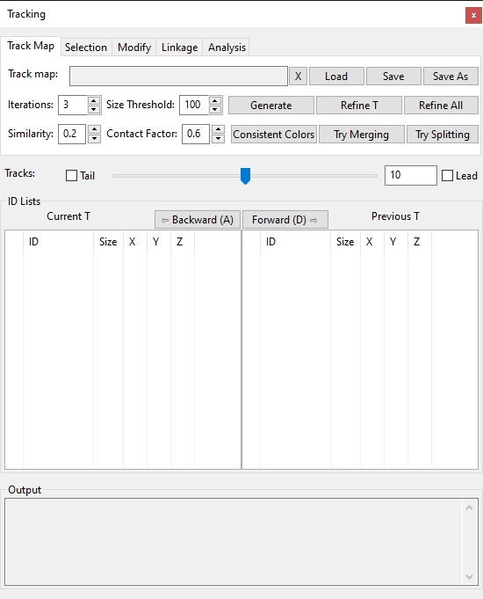

Figure ‑. Components and Tracking window.

|  |  |
| --- | --- |
|  | An ID is a 32-bit unsigned integer to identify a component. In automatic tracking, the same tracked component at different time points may be assigned with different IDs. A tracked structure may be separated into several components at one time point. |

## Track Map Generation and Management

Figure 20‑1 shows the first tab of the “Component and Tracking” window. It is for automatic track map generation and management. A track map describes the linking relationships among components over time. You can generate a track map and then refine it progressively. You can also load a previously generated track map or save the current one to disk.

**Track map file name.** A text box showing the file name of a currently loaded track map or one that has been saved. If a newly generated track map is not saved, it notifies the user that there exists a track map that has not been saved.

**X.** Clear the current track map to redo tracking afresh.

**Load.** Click the load button and browse to a track map file (\*.track) to load it into FluoRender. An unsaved track map generated previously will be replaced.

**Save.** Click the save button to save an existing track map.

**Save As.** Click the save as button to save a modified track map with a different name or directory.

**Generate.** Click the generate button to compute a new track map. It uses the number in the iteration times for the computing. You need a time sequence, and the time sequence must be labeled already. Use a script (comps\_generate) to perform the labeling operations.

|  |  |
| --- | --- |
|  | An unsaved track map will be saved when you save the project. It is loaded when you load the project. |
|  | Since version 2.17, a new format (\*.track) for the tracking results is adopted. The old format (link map, \*.fll) becomes deprecated and unsupported in the new versions. The two formats are also incompatible with each other. Use tracking result files only with the version of FluoRender that generated them. |

**Refine T.** Click the “Refine T” button to refine an existing track map at the current time point. It improves the tracking results for all components of the current time point. It uses the number in the iteration times for the computing.

**Refine All.** Click the “Refine All” button to refine an existing track map for all time points. It uses the number in the iteration times for the computing.

You can adjust these parameters to fine-tune the behavior of the tracking.

**Iteration times.** The number of iterations for the track map generation and refinement. Use more iteration times to refine the track map so the tracking becomes more accurate. However, more iteration times also take more time to compute.

**Size Threshold.** The default value for filtering components by size. Components having voxels less than the threshold value will not be used in the tracking calculations.

**Similarity.** When comparing the sizes of two components to decide which one has a better likelihood of matching to another structure, this value is used to determine how similar the two size values are. If two size values are similar, both are considered with equal likelihood, and more conditions are needed to determine their matching.

**Contact Factor.** A threshold for the overlap between two components so that a large overlap enables the two components to be grouped together in the tracking calculations.

**Consistent Colors.** Tracked components will change their IDs so that one component has a consistent color over time.

**Try Merging.** Check this option to let the tracking algorithm determine if several components can be merged to better match them. The DBSCAN algorithm is used to cluster the components.

**Try Splitting.** Check this option to let the tracking algorithm determine if one component can be split into several components to better match it. The expectation-maximization algorithm is used to cluster the component.

## Semi-Automatic Tracking

The semi-automatic tracking allows you to only select structures from each time point and advance in time. FluoRender will segment your selections from the time points and link them automatically. The semi-automatic tracking is achieved via a 4D script. See Chapter 13 for more details about 4D scripts and the specific tasks for semi-automatic tracking. To enable semi-automatic tracking, enable the script and select the script track\_semi\_auto. Then, make sure the paint brush settings are proper for selecting the desired structures.

## Component Selection Settings



Figure ‑. The Selection tab of the Component and Tracking window.

After loading or generating a track map, components can be selected to show the tracking results. The paintbrush tools are usually used to select components. You can also fine-tune the selection or make precise ID-based selections using these tools. All ID-based selection tools are in the second tab of the Component and Tracking window (Figure 20‑2).

**ID input box.** You can type in an ID and then use one of the following buttons to select it. You can also type “all” in the input box to select all components that have IDs. You can also type and press the enter key on a keyboard to select desired components. Notice that when the enter key is pressed, it is equivalent to clicking the FullCompt button.

**X.** The X button clears the content of the ID input box.

**FullCompt (full component).** A selection made with the paintbrush usually does not match exactly with labeled voxels. Click this button after you have selected the paintbrush tool and would like to find out the entire component. Make sure to leave the ID input box empty if selecting the entire component is the desired operation. Otherwise, it is equivalent to the Append button. Pressing the enter key when the ID input box is in focus has similar results.

**Replace.** Replace currently selected components with a component with the exact ID in the ID input box.

**Append.** Add a component with the exact ID in the ID input box to the selection while keeping the currently selected components.

**Clear.** Clear the selection of all components.

**Shuffle.** Since component colors are assigned according to their IDs, neighboring components may have the same or similar colors. To better distinguish adjacent components, shuffle the colors by clicking this button.

**Component size.** A filter for component selection so that only components of sizes greater than the value are selected.

**Uncertainty filter.** Filter components with a tracking uncertainty range. Components with tracking uncertainty values within the range are selected. When nothing is selected, the uncertainty filter applies to the entire data set. To get a distribution of the tracking uncertainty, use the uncertainty analysis function in the analysis panel.

## Visualizing Tracking Results

You can select any number of components using a combination of the paintbrush and the ID-based selection tools. Once components have been selected, they are added to the ID list of current time in the Component and Tracking window. You can then go through time step by step and watch the tracking results.

|  |  |
| --- | --- |
|  | Internally, a 4D script is executed to find out and highlight tracking results. You need to enable the script and choose the correct script file to use the tracking features. See Chapter 13 and Chapter 22 for more details. |

There are several controls under the tabs in the Component and Tracking window. You can use them to control the display of the tracking results and perform time stepping.

**Tracks.** Tracks are line segments before and after a tracked component to indicate its movement. Tracks indicating the movement ahead of time are called **leads**; Tracks indicating the past movement are called **tails**. You can control the visibility of leads and tails individually by checking their names before and after the track number slider. The track length slider controls the length of tracks, or line segments can be displayed. Although the range of the slider is [0, 20], you can type in an arbitrarily larger number in the numeric input box.

|  |  |
| --- | --- |
|  | You need to select a component and add it to the ID list below to view its tracks. |



**Tail**

**Lead**

Figure ‑. Tracks of a tracked cell.

**ID Lists.** There are two lists for current and previous time points. Timepoint values are shown on top of both lists. When the time point is set forward by one, the current time point value is that of the previous plus one; when the time point is set backward by one, the current time point value is that of the previous minus one. When the time point changes, IDs on the current time point list are copied to the previous time point list, and the current time point list is updated. You can use the Backward and Forward buttons to step through time and watch the tracking results. Additionally, you can select one or multiple components from the ID lists and then perform linking operations.

|  |  |
| --- | --- |
|  | You can copy a selected ID using shortcuts provided by your operating system. |
|  | You can use keyboard shortcuts A and D to go backward and forward in time. |

An entry in the ID list is a component, whose ID value, size in terms of voxels, and center coordinates are shown. It uses colors, which correspond to the visualization in the render view, to visually identify a component. It also uses the following symbols to indicate more detailed tracking information.

|  |  |
| --- | --- |
| ◯ | Selected components. No tracking information. |
| ─ | A tracked component that is also standalone. |
| ┌ | A tracked component that belongs to a group. It indicates the beginning of a group. |
| │ | A tracked component that belongs to a group. It indicates the middle of a group. |
| └ | A tracked component that belongs to a group. It indicates the end of a group. |

**Output.** Information is shown in the output box.

## Assign/Modify IDs

Automatically generated IDs may not match desired components well. You need the manual ID modification tools in the fourth tab of the Component and Tracking window (Figure 20‑4).



Figure ‑. The Modify tab of the Component and Tracking Window.

Like the Linkage tab, it provides several ID-based selection tools as a convenience. However, the ID input box has an additional layer of behavior, depending on the subsequent button to push.

**ID input box.** Selecting a component from its ID works the same as in the Selection and Linkage tabs. It also doubles as an input for the desired ID to be assigned. To notify users about the importance of this ID input box, it uses the same color as an ID should be mapped as a highlight. The following operations will take the value in the ID input box into consideration:

|  |  |  |
| --- | --- | --- |
| **Assign ID** | **Add ID** | **Replace ID** |

|  |  |
| --- | --- |
|  | The value 0 is not used for an ID. If a component is assigned with 0, it means that it is not used for tracking. When 0 is entered in the ID input box, it uses a teal color to remind users. The same color is also used to render a selected component without any ID assigned. |

**Assign ID.** It assigns a non-conflicting ID to currently selected components. If a valid ID value is entered in the ID input box, the value will be used. If 0 is entered in the ID input box, it erases IDs that have already been assigned. If the ID input box is empty, it automatically generates a new ID. It will check whether the ID is conflicting with values that have already been assigned to ensure the uniqueness. If a conflict is detected, the value is increased and checked against existing IDs until a valid number is found. If you manually enter an ID in the ID input box, the resulting ID may be different but keep the same color.

**Add ID.** If there are components already selected and have IDs assigned, you can make more selections, assign IDs, and append the most recently selected components to the ID list, without modifying the existing IDs of the previously selected components. Use this feature to segment a group of components so that the components selected first can be highlighted and used as a reference.

|  |  |
| --- | --- |
|  | Add ID only works on data without ID already assigned. |

**Replace ID.** It replaces the ID of currently selected components with the value entered in the ID input box. You may use this feature to change the color of a selected component.

**Combine.** It combines the components in the current ID list into a single component.

**Separate.** If two or several components are grouped (indicated by the ┌, │, and └ symbols in the ID lists), use divide to separate them into independently trackable entities.

**Segment.** Set the number of components you want and segment a selected structure using the K-means clustering method.

## Manually Linking Components

Manual component linking is useful when automatic track map generation fails to compute the correct results. For a simple tracking task, you can also perform manual component linking for the most accurate result. Tools for component linking are in the third tab “Linkage” of the Component and Tracking window (Figure 20‑5).



Figure ‑. The Linkage tab of the Component and Tracking window.

**ID input box.** You can type in an ID and then use one of the following buttons to select it. You can also type “all” in the input box to select all components that have IDs. You can also type and press the enter key on a keyboard to select desired components. Notice that when the enter key is pressed, it is equivalent to clicking the Append button. The content of the ID input box here is linked to that of the Selection tab so that you don’t need to switch between these two tabs when you are selecting and linking components at the same time.

**X.** The X button clears the content of the ID input box. Since the contents of the ID input boxes of the Selection and Linkage tabs are linked, clearing one will clear both.

**Append.** Add a component with the exact ID in the ID input box to the selection while keeping the currently selected components.

**Clear.** Clear the selection of all components.

|  |  |
| --- | --- |
|  | Notice the duplication of the selection tools in the Linkage tab, which is provided as a convenience. Also notice the slightly different associated operations for the enter key in the ID input boxes, i.e., Full Component vs. Append. |

**Excl. Link (Exclusive Link).** Components from the current and previous ID lists are linked while breaking any links with components that don’t belong to the lists. This is useful for fixing mistakenly tracked components. The operation is equivalent to isolating the components from both the current and previous ID lists and then linking them (see below). The operation is performed on the selected components within the ID lists if anything is selected. Otherwise, it is performed on all components in the lists.

**Link IDs.** Links are added between components in the current and previous ID lists. Notice that existing links will be kept. This is useful to add a missing link to a mitosis event. The operation is performed on the selected components within the ID lists if anything is selected. Otherwise, it is performed on all components in the lists.

**Link New IDs.** Newly assigned IDs from manual modification or segmentation can be linked.

**Isolate.** It breaks all existing links from components in the current ID lists. Therefore, components become isolated without any links. The operation is performed on the selected components within the current ID list if anything is selected. Otherwise, it is performed on all components in the current ID list.

**Unlink IDs.** It breaks existing links only between components in the current and previous ID lists. It is useful to remove mistakenly tracked results. The operation is performed on the selected components within the ID lists if anything is selected. Otherwise, it is performed on all components in the lists.

## Making Analysis

The last tab page of the Component and Tracking window provides several analysis functions (Figure 20‑6).



Figure ‑. The Analysis tab of the Component and Tracking window.

**Rulers.** It converts the trajectories of tracked and currently selected components into rulers. You can view the information on the rulers and export them into a text file in the Measurement window (Chapter 17).

**UniIDs.** Make component color consistent over time.

**Compnts.** It computes the information of currently selected components, including ID, total voxel number, surface voxel number, average intensity value, standard deviation of intensity value, minimum intensity value, and maximum intensity value. The information is printed in the output area at the bottom.

**Links.** It computes the information of the currently loaded track map, including time value, orphan numbers, and multi-link numbers. An orphan is a component that is tracked to no other components in the adjacent time point; a multi-link is a component that is tracked to more than one component in the adjacent time point.

**Uncertainty.** If any components are selected, it prints out the tracking uncertainty value for each selected component. If nothing is selected, it prints out a distribution of the tracking uncertainty values of the entire data set. High values mean the tracking results are unreliable. Filter components based on uncertainty values may help identify and correct tracking issues.

**Save As.** It saves the content in the output area as a text file on disk. Information computed from selected components and track maps can be read by a spreadsheet editor, such as Microsoft Excel.

# Volume-Mesh Conversion

You can extract iso-surfaces from a volume channel or its selected part and create a new mesh object. The settings of volume-mesh conversion are in the “Convert” dialog. To open the convert dialog, click the downward arrowhead on the right side of the analysis tools of the main toolbar, and then in the dropdown menu select “Convert”.



Figure ‑. Convert dialog.

You can select a volume channel and click “Convert” to generate a new object. Additionally, you can first select part of a volume channel using the paintbrush, and then convert only the selected part. Before you click the convert button, several settings are available to adjust the conversion.

**Threshold.** The iso-value for mesh calculation.

|  |  |
| --- | --- |
|  | The marching-cubes algorithm is used to calculate the iso-surface. |

**Downsample XY.** It increases the grid size on the XY plane to the setting value. The generated mesh object becomes coarse as the value increases.

**Downsample Z.** It increases the grid size on the Z axis. The generated mesh object becomes coarse as the value increases.

**Use the transfer function.** When enabled, the iso-surface calculation takes volume properties into consideration. For example, no mesh is generated for voxels with intensity below the threshold setting in the volume properties.

**Selected only.** Only the paint-selected part of a volume channel is used to generate the mesh object. Make sure you have something selected if this option is enabled.

**Weld vertices.** It merges overlapping vertices so that a smooth shading can be applied.

**Output.** When a volume or its selected parts are converted to a mesh object, its surface area is printed out in the output area. You may use this feature to find out the surface area of an object.

# Machine Learning Manager

To open the Machine Learning Manager, click the downward arrowhead on the right side of the analysis tool on the main toolbar, and in the drop-down menu select “Machine Learning Manager” (Figure 22‑1). Use the dialog window to manage the learning and application of machine-learning results to automate certain tasks in FluoRender.

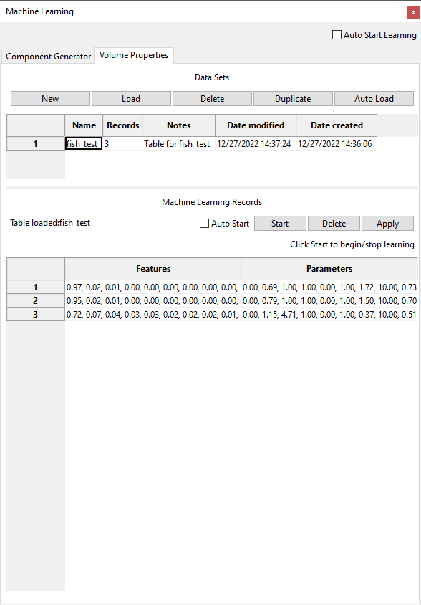

Figure ‑. Machine Learning Manager.

The machine learning in FluoRender associates the features of user data sets with parameters applied by users to visualize or analyze the data. The relationship between data features and parameters is saved in a table file consisting of multiple historical records, which are generated when users use FluoRender. The records can be used to derive parameter settings for new data sets that have similar features to the data that have been analyzed. We organize the machine learning records into different categories based on existing FluoRender functions. Currently, we support the learning and application of the parameters of Component Generator and Volume Properties. New categories will be added for future releases.

## Start Machine Learning Automatically

**Auto Start Learning.** Check this option to start machine learning automatically for all categories when FluoRender starts.

## Choose A Category for Machine Learning Management

### Component Generator

Select the Component Generator tab to view all the settings for managing machine learning for generating components on a volume. Create or load a table that represents the relationship between volume data and settings to obtain satisfactory segmentation results. The actual settings for component generation are still accessed from the Component Analysis window. To add training records to a table, load the table first. Then, start training in the Machine Learning Records section. Go to the Component Analysis window and set the parameters normally. Training is only performed on the paintbrush-selected region of a data set. So, use the paintbrush to select a region and then apply the parameters to generate components. Adjust the parameters until a satisfactory result is obtained. A record of the component generation result is saved when the paint mask is modified. Select a different region or load a different data set and repeat the process to add another record. To apply the result for automated component generation, select the data set from the Workspace panel and click Apply in the Machine Learning Records section. The application of machine learning results can also be accessed from the Component Analysis window.

You can also manage automatically started learning, record deletion, table deletion, and automatic table load on this tab.

## Volume Properties

Select the Volume Properties tab to view all the settings of managing machine learning for automatically setting volume properties. Create or load a table that represents the relationship between volume data and settings to visualize them. The actual settings for volume properties are still accessed from the Volume Property panel. To add training records to a table, load the table first. Then, start training in the Machine Learning Records section. Go to the Volume Property panel to adjust the parameters until a satisfactory visualization is obtained. Click the Save Default button in the Volume Property panel to add a record. Load a different volume data set and repeat the process to add another record. To apply the result for automatically setting volume properties, select the data set from the Workspace panel and click Apply in the Machine Learning Records section. The application of machine learning results can also be accessed from the Volume Property panel.

You can also manage automatically started learning, record deletion, table deletion, and automatic table load on this tab.

## Tables

Organize machine-learning records from similar data sets in one table. For example, data sets used in one project or experiment usually have similar characteristics that can be easily learned by machine learning. Use the Data Sets section to manage tables.

**New.** Create an empty table. After clicking the button, an entry is added to the list below. Input the name and notes for easy identification of the table. A newly created table also loads automatically.

**Load.** Select an entry from the table list and click Load to load it for training or application. The records of the table are also listed in the Machine Learning Records section.

**Delete.** Select an entry from the table list and click Delete to delete it from the computer. Delete a loaded table also unload it.

**Duplicate.** Select an entry from the table list and click Duplicate to make a copy of the selected table.

**Auto Load.** Select an entry from the table list and click Auto Load to let FluoRender the selected table by default on start.

Additionally, click the name of a table to edit its name. Notes to a table can be edited similarly.

## Records

A table contains a series of records, each representing a historical setting in the specific machine-learning category. For example, a record for component generation links the local histogram of a volume data set to the parameters for generating its segmentation as distinct components. The process of training or learning adds historical settings to a table as records.

**Auto Start.** Check this option to let FluoRender start adding records to the loaded table automatically on start.

**Start.** Click Start to allow FluoRender to add records to the loaded table. Otherwise, a table is read-only.

**Delete.** Select an entry from the record list and click Delete to delete it from a table.

**Apply.** Select a data set from the Workspace panel and click Apply to apply machine learning results to the selected data.

**Auto Apply.** Automatically generate volume properties from the current table when a volume data set is loaded.

# Configurations

FluoRender’s settings are found in the “Configurations” dialog. To open the configuration dialog, click “Configurations”  in the main toolbar. The configuration dialog groups settings into six tabs for project, rendering, performance, display, file formats, and ImageJ link.

|  |  |
| --- | --- |
|  | FluoRender’s settings are saved in text format using containers such as XML, INI, or JSON. You can use a text editor to modify settings directly. |

## Project

Project settings are in the project panel. (Figure 23‑1)

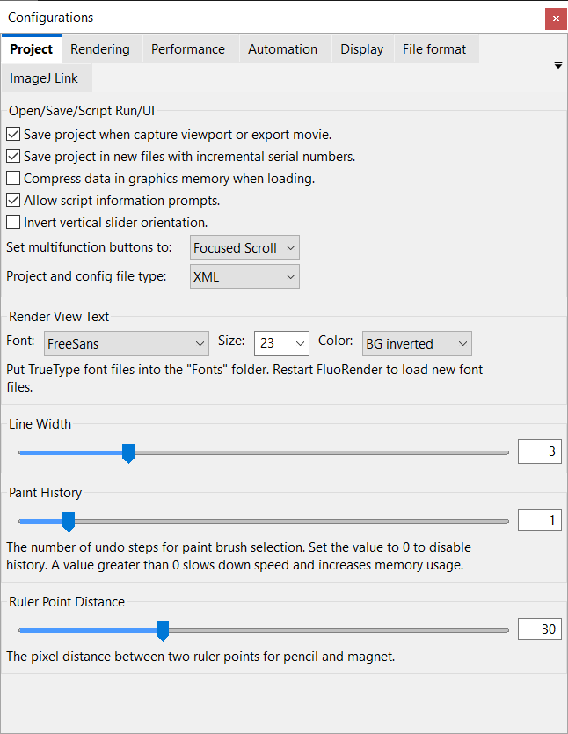

Figure ‑. Project settings.

### Open/Save/Script Run/UI

**Save project when capture viewport or export movie.** When enabled, it automatically saves a project file when you click the “capture” button in render view or export a movie.

**Save project in new files with incremental serial numbers.** When enabled, it automatically adds a serial number after the project file name every time the project is saved by clicking the Save Project button in the main toolbar.

**Compress data in graphics memory when loading.** When enabled, it uses OpenGL texture compression to save graphics memory.

|  |  |
| --- | --- |
|  | Depending on your graphics hardware, textures may not be correctly compressed. Disable this option if this happens. |

**Allow script information prompts.** Some scripts have built-in prompts to expatiate the purpose and requirements for running. Enable this option to show the prompts when running scripts.

**Invert vertical slider orientation.** We changed the orientations of vertical sliders since version 2.30. By default, the low value is at the bottom for a vertical slider. Enable this option to change the orientation to the older versions of FluoRender.

**Set multifunction.** Set the function of a multifunction button, which is the button with the name of some of the settings in the volume property panel, output adjustment panel, and clipping plane panel. A multifunction button is always associated with a slider control for continuous value adjustment. These options are available for the multifunction button:

* Sync Channels. Click the multifunction button and the value associated with the multifunction button is applied to all the channels within the same group.
* Focused Scroll. Click the multifunction button and move the mouse cursor into the render view. Then scroll the mouse wheel to change the value associated with the multifunction button. The focused scroll mode is canceled once the mouse is used to change the render view, such as rotations and zooming.
* Use Default. Click the multifunction button and the value associated with the multifunction button is set to the default.
* Use ML. Click the multifunction button and the value associated with the multifunction button is determined by machine learning.
* Undo. Click the multifunction button and the value associated with the multifunction button is reverted one step in the history of changes.
* Enable/Disable. Click the multifunction button to disable or enable the value associated with the multifunction button.

**Project and config file type.** Set the file format for saving FluoRender configurations and projects. You can still read a file saved in a different format.

### Render View Text

**Font.** FluoRender searches and lists all True-type font files in the Fonts folder within its installation directory. Choose the desired font so that it is used for the render view text.

|  |  |
| --- | --- |
|  | If you want to display Unicode characters in the render viewport, you must copy a True-type font file that supports the character sets into the Fonts folder. Then, restart FluoRender so that the font list can be regenerated. |

**Size.** Change the font size for render view text. You can also type an arbitrary number for the font size.

**Color.** You can choose a scheme for the color of the render view text. The default setting chooses a color that is opposite to the background color of the render view. However, if the render view text is on top of a data set, instead of the background, you may choose a different color than the default. The schemes for render view text color are:

**BG inverted.** It calculates a color opposite to the background color.

**Background.** It uses the same color as the background.

**Vol sec color.** It uses the secondary color of the currently selected volume channel. When nothing is selected, it uses the default color. See Chapter 8 on details of setting the secondary color of a volume channel.

### Line Width

The width of lines for rulers, tracks, clipping plane borders, etc. All line widths are adjusted altogether.

### Paint History

Paint history is the number of paint brush operations that can be remembered by FluoRender. Set a number greater than 0 to use the **Undo** and **Redo** features in the Analyze window. The paint history is kept for each volume independently. Make sure that you choose a reasonable number so that memory consumption remains low.

### Ruler Point Distance

The distance between two ruler points when the pencil tool is used to draw a ruler. The distance is calculated as the pixels between two ruler points on the screen. Therefore, the actual 3D distance depends on the zoom ratio of the view.

## Rendering

Rendering settings are in the rendering panel (Figure 23‑2).

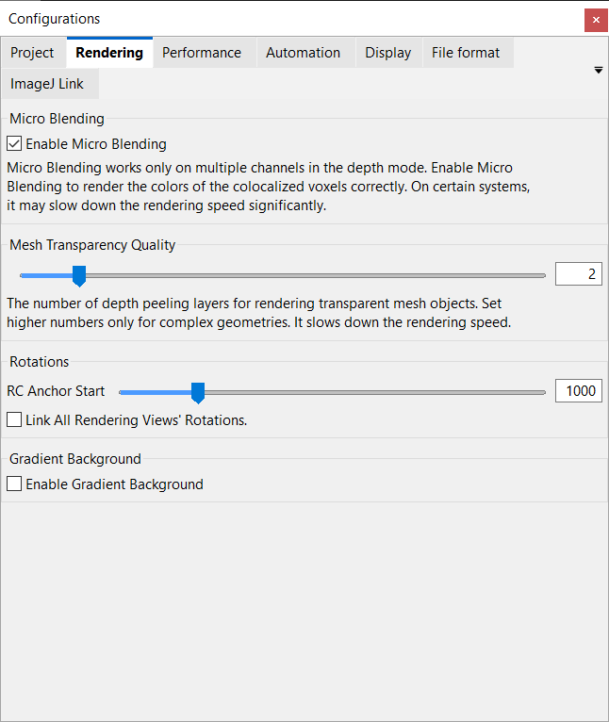

Figure ‑. Rendering settings.

### Micro Blending

**Enable micro blending.** When enabled, channel intermixing in depth mode has more accurate results.

### Mesh transparency quality

It sets the number of depth-peeling layers for rendering semi-transparent mesh objects, and for mixing mesh objects with volumes. A higher number is for better quality when mesh objects have complex shapes.

### Rotations

**Rotation center anchor start.** The zoom ratio above which the rotation center anchoring is turned on automatically. The rotation center anchoring is turned off when the zoom ratio is below this setting. However, users can manually override the anchoring mode. If a user changes the setting manually, the rotation center anchoring will not be enabled/disabled automatically.

**Link all render view rotations.** When enabled, rotations of multiple render views are synchronized. You can view all render views from the same angle.

### Gradient background

**Enable gradient background.** Use a gradient background with a faded horizon, instead of a solid color set in render view. The horizon changes with the viewing direction to help orient.

## Performance

Performance settings are in the performance panel (Figure 23‑3).

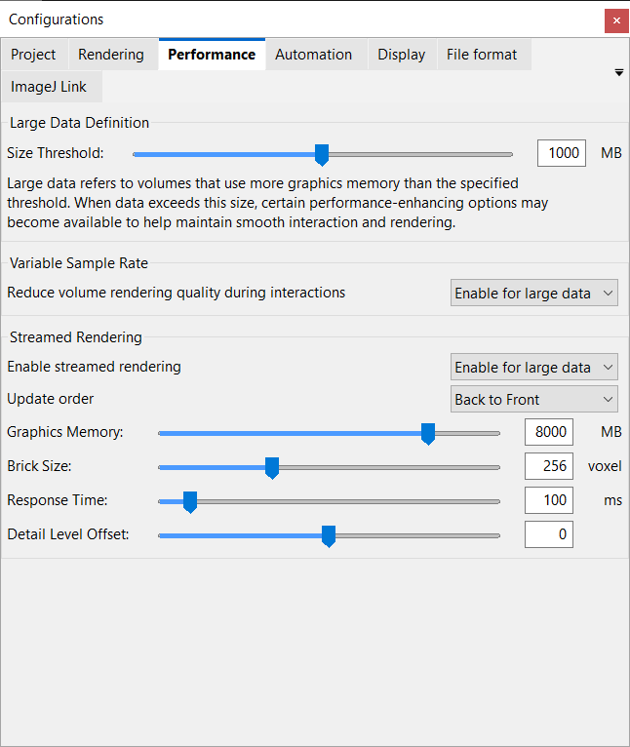

Figure ‑. Performance settings.

### Large data definition

**Size Threshold.** It defines the size threshold in megabytes for a volume to be considered large. Certain functions, such as automation functions can be disabled or enabled based on data size. The streamed rendering also use this size to determine if a volume needs to be preprocessed and divided into smaller bricks for more efficient rendering and analysis.

### Variable sample rate

**Reduce volume sample rate for mouse interactions.** When enabled, a lower sample rate is used during mouse interactions. It allows better interaction speed, but rendering may flicker.

### Large data streaming

**Enable streaming for large data sets.** Enable this option if data sets to be visualized are too large to load into graphics hardware or too slow to render.

**Update order.** You can choose the update order when multiple bricks cannot be rendered within one render loop.

**Graphics memory.** Set this setting to the size of your graphics memory. Check hardware information on graphics cards. Data sets larger than the setting are streamed from system memory to graphics memory.

**Brick size.** When a data set is larger than the limit set by **large data size**, it is broken into bricks with a size of this setting for each of the X, Y, and Z axes.

**Response time.** There is a time limit between two updates during data streaming. Shorter time makes rendering more responsive to user interactions, but less content of a data set may be processed and rendered.

**Detail level offset.** When a multiresolution data set is loaded, use this setting to control the resolution level displayed at a certain zoom ratio. Decrease this setting to show lower resolution levels, which can be useful for low-end or old computers.

|  |  |
| --- | --- |
|  | Large data streaming has been on by default since version 2.22. A volume channel smaller than the large data size setting will not be divided into bricks. |
|  | When you load a data set, the progress dialog shows the current streaming settings. |
|  | Since version 2.26.2, large data streaming applies to brush painting and component analysis. Painting locally on a large data set when only a few data bricks are covered by the paint stroke reduces processing time significantly. Checking “use selection” for component generation and analysis also constrains the computations only within selected bricks to reduce processing time. |
|  | Consider setting different brick sizes for visualization and analysis. Component analysis requires more computational power and thus smaller brick size. |

## Automation

Automation settings are in the Automation panel (Figure 23‑4).

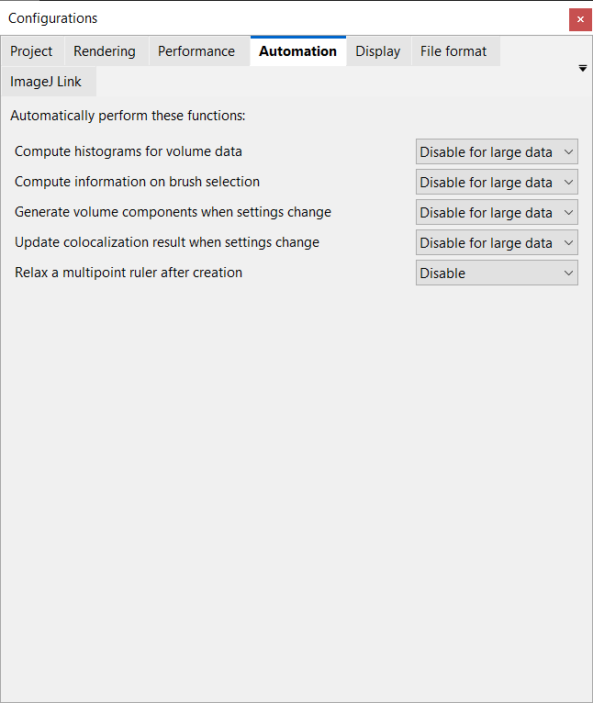

Figure ‑. Automation settings.

Functions listed in the Automation settings are performed automatically when enabled. The options for each function also allow disabling it when the data size exceeds the threshold value in the Performance settings.

* **Compute histograms for volume data.** When enabled, a histogram for a volume is computed when the volume is loaded.
* **Compute information on brush selection.** When enabled, the information in the Paint Brush window is automatically updated after selections are made with various brush tools.
* **Generate volume components when settings change.** When enabled, it runs component generation automatically and updates the results in the render view after changes are made for component generation.
* **Update colocalization result when settings change.** When enabled, it updates the colocalization results in the Colocalization window.
* **Relax a multipoint ruler after creation.** When enabled, it relaxes a polyline ruler after it is created or edited.

## Display

Display settings are in the display panel (Figure 23‑6).

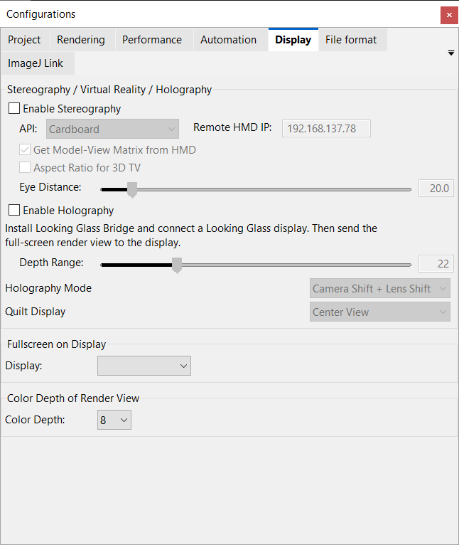

Figure ‑. Display settings.

### Stereography / Virtual Reality

**Enable stereography.** Check this option to render two frames each time for the left and right eyes. The stereography can work with various APIs (Application Programming Interface) to render 3D data on different HMDs (Head-Mounted Display).

**Cardboard.** It uses the same projection settings as the normal rendering mode, which can be changed in the render view settings. Use the plain stereo mode for two situations. 1) Render and capture a video with side-by-side stereo, which can be viewed later using a VR headset, or cellphone-based VR. 2) Connect a cellphone to the computer and use it as a secondary display for the computer. Put the cellphone in a proper cellphone-based VR enclosure and then view the renderings in stereo.

**OpenXR.** OpenXR is an open standard and API for a wide range of VR, AR, and MR devices. A commonly used device is Meta Quest. Connect the headset first using Meta Link with a USB cable or over WiFi. Make sure the Meta Quest Link program is running and the headset is detected. Set the API to OpenXR to show contents on the OpenXR headset. FluoRender may need to be restarted if the contents do not show immediately on the headset.

**OpenVR.** OpenVR is the API for SteamVR devices, such as HTC Vive. Connect a SteamVR headset first to your computer and then set the API to OpenVR. FluoRender may need to be restarted if the contents do not show immediately on the headset.

**Windows Mixed Reality.** Windows Mixed Reality devices, such as HP Reverb, need Direct3D binding with OpenXR. Select the API to Windows Mixed Reality to show contents on a Windows Mixed Reality headset. FluoRender may need to be restarted if the contents do not show immediately on the headset.

**Holographic Remoting.** Holographic Remoting is the API for Microsoft Hololens. To use a Hololens, first connect it to the host computer on WiFi or Ethernet. Install Holographic Remoting Player on the Hololens. Launch Holographic Remoting Player. It will show an IP address. In FluoRender settings, set the API to Holographic Remoting and set the IP address for the remote headset to that shown on the Hololens. FluoRender may need to be restarted if the contents do not show immediately on the headset.

**Get Model-View Matrix from HMD.** Check this option to enable head tracking on the headset. The pose of the head is used to change the viewing directions.

FluoRender’s render view can still be operated using ordinary operations. For a supported headset and accompanying controllers, other options are available to change the viewing of 3D data:

* **Controller thumbsticks.** Use the right-hand thumbstick to rotate the 3D data. Use the left-hand thumbstick to move the data closer or away from the viewer.
* **Controller pose.** Press the grab button on one controller to turn on this function. Then use the controller pose to rotate the data. Press the grab button again to turn off this function.
* **Hand tracking.** For a headset supports hand tracking, show one hand in front of the headset. Extend all fingers to enable this function. The 3D data will follow the rotation of the palm. Clench all fingers to a fist to stop tracking.
* **Voice commands.** For a headset supports speech recognition, use phrases such as “come closer”, “move away”, “rotate left”, and “stop” to operate the 3D data.

**Aspect Ratio for 3D TV.** The aspect ratio of a 3D TV in side-by-side stereo mode is compressed horizontally. Enable this option to show the correct aspect ratio when the stereo rendering is output to a 3D TV.

**Eye distance.** It is the distance between the two rendered frames for the left and right eyes. It doesn’t have to be set to the actual eye distance of the user. Change the value so that the stereo view feels natural.

### Holography

**Enable Holography.** FluoRender supports displaying 3D renderings on a Looking Glass holographic display. Install the display driver first on your computer and then connect the display. Make sure the display works properly with your system. Then, launch FluoRender and enable this option to display the render view on the holographic display.

**Depth Range.** A holographic display shows the renderings of a 3D object from multiple perspectives by moving camera or lens. This value determines the maximum movement of the camera or lens. When it is set to 0, the 3D effect of the hologram diminishes to be similar to a 2D rendering.

**Holography Mode.** A hologram for the Looking Glass display is generated by rendering a scene from different viewing perspectives. The holography mode sets how the camera and lens are moved to generate the perspectives.

* **Camera Shift + Lens Shift.** The camera moves in a straight line. The lens shifts to center the view on the data.
* **Camera Shift + Swing.** The camera moves in a straight line. The camera and lens rotate together around its own center to center the view on the data.
* **Object Rotation.** The camera is static while the object rotates around its own center.

**Quilt Display.** A Looking Glass display can show 3D renderings as a hologram, but the main display is 2D only. The FluoRender view can display the hologram as just one perspective or as a tiled pattern of multiple perspectives.

* **Center View.** Render view shows the perspective that the camera is looking at the data without shift.
* **First View.** Render view shows the perspective that the camera is looking at the data with maximum shift to one side.
* **Last View.** Render view shows the perspective that the camera is looking at the data with maximum shift to the other side.
* **All Views.** Render view shows a tiled pattern of all views comprising the hologram.

### Full Screen on Display

When there are multiple displays connected to the computer, choose the ID of a display for which the full-screen window of the FluoRender render view is placed.

### Color Depth of Render View

When a high color depth display is connected to the computer, choose the color depth for the render view. FluoRender needs to be restarted for the setting to take effect. When an unsupported color depth is set, FluoRender may fail to start. In case a failure happens, edit the setting file (FluoRender.ini) from the installation folder of FluoRender.

## File Format

File format settings are in the file format panel (Figure 23‑6).

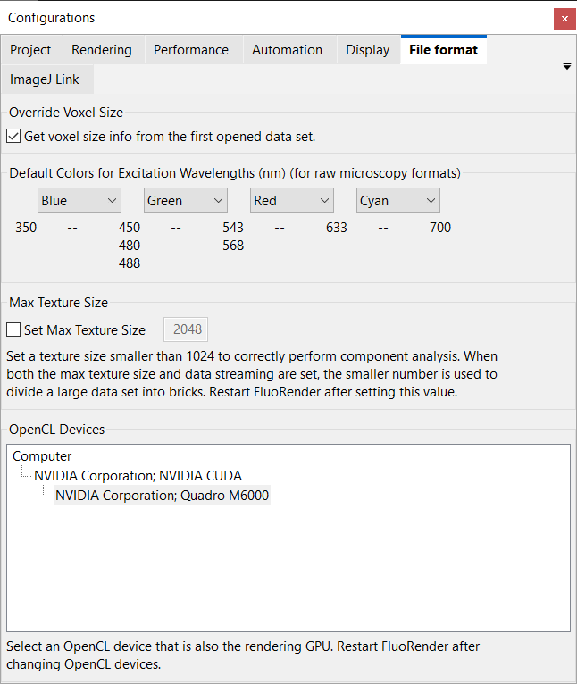

Figure ‑. File-format settings.

### Override voxel size

**Get voxel size info from the first opened data set.** When multiple data sets are opened and they have different voxel sizes, you can enable this option so that all use the voxel size from the first opened file. If this option is not enabled, you can still set all data sets to use the same voxel size by typing voxel spacing values in one data set’s volume property panel (see Chapter 8 for more details).

### Default colors for excitation wavelengths

You can set different default colors for four excitation wavelength intervals. If metadata are read from a microscopy format and its excitation wavelength falls into one of the intervals, a predefined color is used. You can still change the color of a volume channel once it is loaded.

|  |  |
| --- | --- |
|  | For Olympus formats, if a channel is lit by transmitted light, the default color is always set to white. |

### Max texture size

You can force dividing a data set into bricks without using the streaming settings. When this option is unchecked, the value in the input box is the max texture size by the graphics hardware. You can override this size by checking the option and typing in a smaller number. A data set loaded subsequently will be divided into bricks no larger than the setting. It is useful to configure this setting for applying OpenCL kernels on large data that do not require streamed rendering.

### OpenCL devices

A computer may be equipped with more than one GPU. It is common for laptops with both integrated and discrete GPUs, or a Thunderbolt system with externally connected GPUs. In FluoRender, resources including volume textures are shared between OpenGL for rendering and OpenCL for computing. Most drivers require the rendering GPU and computing GPU to be the same when resources are shared. When the default OpenCL GPU is different than the OpenGL GPU, a calculation, such as component generation or filtering, may fail. Use the list as a guide to select the correct GPU. FluoRender needs to be restarted after the OpenCL GPU is changed.

## ImageJ Link

To link FluoRender with ImageJ functions, configure settings on the ImageJ Link panel (Figure 23‑7).

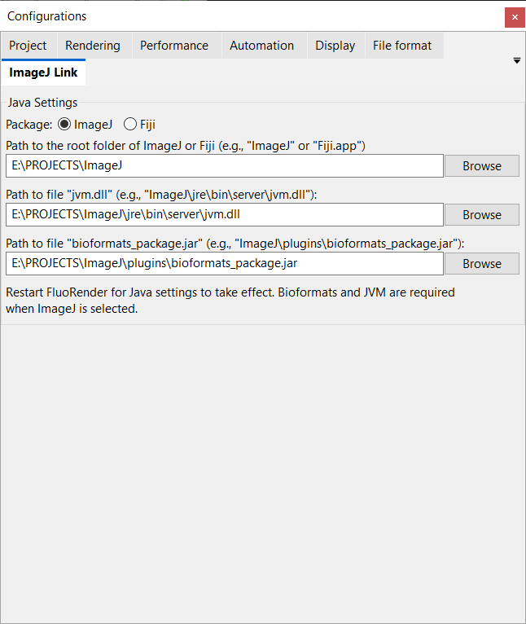

Figure ‑. Settings, ImageJ Link panel.

### Java settings

First, choose which ImageJ package you’d like to use.

**ImageJ**. The barebone ImageJ package includes all the basic functions. Additional plugins, such as Bioformats, need to be downloaded and installed.

**Fiji**. It added plugins and more versatile functions to the original ImageJ package. Bioformats plugin is included.

FluoRender needs to know where to find Java and ImageJ functions. Type in the full path to the required files. Or use the browse button to find the files.

**Path to the root folder of ImageJ or Fiji** is the main folder. This is needed for both ImageJ and Fiji.

**Path to “jvm.dll”** is for the dynamically linked library file of Java Virtual Machine. Use the file that comes with your ImageJ package. This is needed only when ImageJ is selected.

**Path to “bioformats\_package.jar”** is for the BioFormats plugin. It is located inside the plugin folder of the ImageJ package. If it does not exist, download it from the BioFormats website. This is needed only when ImageJ is selected.

## Settings through the configuration File

Some advanced and experimental settings of FluoRender are not exposed in the user interface. You must modify these settings in the configuration file, which is a text file that can be edited by a text file editor, such as WordPad or TextEdit. Depending on the setting, the configuration file can be saved using different containers, such as INI, XML, or JSON. Settings are grouped under groups, and groups can be children under their parent groups. Each setting contains a name and a value. You can only change the value of a setting. We use the INI container to demonstrate the settings. You can locate the settings in XML or JSON formats by their names respectively.

### Pixel format

Change the values under [pixel format] to modify the bit depth of the RGBA channels output to the display devices.

To enable 10-bit output, use these settings:

|  |
| --- |
| [pixel\ format]  red\_bit=10  green\_bit=10  blue\_bit=10  alpha\_bit=2  depth\_bit=24 |

List ‑. Pixel format settings for 10-bit output.

|  |  |
| --- | --- |
|  | You will need the latest professional graphics card (AMD FirePro or Nvidia Quadro) and a 10-bit capable LCD display to use this feature. This feature is also Windows only. Ten-bit signals are not supported by Thunderbolt or HDMI connections. You must use DisplayPort to enable this feature. |

To enable HDR output, use these settings:

|  |
| --- |
| [pixel\ format]  red\_bit=16  green\_bit=16  blue\_bit=16  alpha\_bit=16  depth\_bit=24 |

List ‑. Pixel format settings for 10-bit output.

|  |  |
| --- | --- |
|  | You will need the latest nVidia graphics card and an HDR10 capable display or TV to use this feature. HDR is also Windows 10 only. Enable HDR from Windows display settings before launching FluoRender in HDR mode. To enable HDR, right-click on the empty area of the Windows desktop. From the context menu, choose “Display settings”. If your display hardware supports HDR10, an option to turn on HDR will be available under the “Window HD Color”. Otherwise, considering update Windows 10 or upgrading your hardware components. |

If HDR is set to enable in FluoRender but your system does not support it, launching FluoRender will cause it to close automatically. Then, the pixel format settings will revert to the defaults.

The default settings are:

|  |
| --- |
| [pixel\ format]  red\_bit=8  green\_bit=8  blue\_bit=8  alpha\_bit=8  depth\_bit=24 |

List ‑. Pixel format settings for standard output.

### Antialiasing

Change the value of “samples” under [pixel format] for antialiasing settings. The setting of 0 disables antialiasing. Setting a higher number can smooth jagged edges and lines of the rendering.

|  |
| --- |
| [pixel\ format]  samples=4 |

List ‑. Pixel format settings for antialiasing.

|  |  |
| --- | --- |
|  | The actual supported sample number varies depending on your graphics hardware. Set it to 0 if antialiasing is not supported by your graphics card, or rendering becomes too slow. |

### Selection of OpenGL core profile version and GLSL version

Change the values “gl\_major\_ver” and “gl\_minor\_ver” under [context attrib] to set the OpenGL core profile version and GLSL version. Make sure that a valid version for your system is selected. The default OpenGL version is 4.4. If you experience any problem with using the core profile or creating context on your graphics card, you can set a third parameter “gl\_profile\_mask” to switch to the compatibility profile. For the parameter “gl\_profile\_mask”, setting it to 1 means the core profile, and setting it to 2 means compatibility profile. The default value for the profile mask is 1.

Since the operating system that FluoRender is running on may not honor the OpenGL version settings and select its own, the used OpenGL version numbers are saved back to the setting file after FluoRender has been successfully launched and shut down once. Then, check the setting file to see the exact version that has been used.

|  |
| --- |
| [context\ attrib]  gl\_major\_ver=4  gl\_minor\_ver=5  gl\_profile\_mask=1 |

List ‑. OpenGL version setting.

|  |  |
| --- | --- |
|  | For some graphics cards, anti-aliasing becomes unavailable under certain OpenGL versions. Straight lines become jagged without anti-aliasing. Change the OpenGL version to see if anti-aliasing is enabled. |
|  | You need to set it to the core profile if you are running FluoRender on Mac OS X, or if you are using an Intel CPU-integrated GPU. For the Windows operating systems, if you are using a discrete graphics card with NVidia or AMD GPUs, you can set the profile mask to the core profile or the compatibility profile. However, we found that on certain AMD GPUs, especially the FirePro series, you might need to set it to the compatibility profile for certain functions (such as streaming) to work properly. |

### Soft threshold

Change this value so that threshold settings of a volume use a value range to transit from low to high values. This can give the edges a soft look. This feature is turned off by setting the value to 0.

|  |
| --- |
| [soft\ threshold]  value=0.1 |

List ‑. Soft threshold setting.

### Test mode

Change the values under test mode to enable or disable certain test features. Set a value to 1 to enable; set a value to 0 to disable.

|  |
| --- |
| [test\ mode]  speed=0  param=0  wiref=0 |

List ‑. Test mode settings.

The test modes are:

**Speed.** Continuously refreshing the render view even without user interactions. The FPS reading tells you the speed of your computer hardware.

**Param.** Displaying more parameter information.

**Wiref.** Showing volume bounding boxes and slices in wireframe mode.

# Contributing to FluoRender

You can contribute to FluoRender by adding new functions to its source code.

## Developing and Contributing with Source Code via GitHub

FluoRender is “Open Source” and hosted on GitHub publicly. Anyone can clone or download the repository to access the source code and build it for their own machine. You are expected to learn and understand “git” if you wish to contribute to FluoRender. FluoRender is accessible with the terms of the MIT license agreement.

You may view the GitHub page for FluoRender for full and detailed clone and build instructions:

<https://github.com/SCIInstitute/fluorender>

The build instructions can change frequently, so duplicating them in this document is not feasible.

A simple SSH clone of the repository is done in the command line (assuming you have GIT installed) with the following line:

|  |
| --- |
| git clone https://github.com/SCIInstitute/fluorender.git |

You can then fork your own branch to make changes and improvements.

If you wish to merge your improvements into the master branch, or another branch, please request a “Merge Request” via GitHub, or on the command line.

You may also report bugs and suggest feature requests on GitHub.

# Appendices

## A. Functions of FluoRender

### List of functions of FluoRender on Windows and Mac OS

| Functions | Windows | Mac OS |
| --- | --- | --- |
| **Basic visualization** | **●** | **●** |
| View rotation | **●** | **●** |
| Geared rotation of 45º | **●** | **●** |
| Two styles of rotation slider control | **●** | **●** |
| Zero rotation | **●** | **●** |
| View panning | **●** | **●** |
| Rotation center anchor | **●** | **●** |
| Center data/panning reset | **●** | **●** |
| View zooming | **●** | **●** |
| 1:1 zoom ratio setting | **●** | **●** |
| Data-dependent zoom ratio display | **●** | **●** |
| Pixel-dependent zoom ratio display | **●** | **●** |
| View-dependent zoom ratio display | **●** | **●** |
| Depth attenuation | **●** | **●** |
| Screen capture | **●** | **●** |
| Save alpha channel in screen capture | **●** | **●** |
| Save floating-point numbers in screen capture | **●** | **●** |
| DPI setting for captured image | **●** | **●** |
| Enlarge image when capturing render view | **●** | **●** |
| View center axis | **●** | **●** |
| View information display | **●** | **●** |
| Legend display | **●** | **●** |
| Color map legend | **●** | **●** |
| Scale bar display | **●** | **●** |
| Perspective angle adjustment | **●** | **●** |
| Globe/Flight mode | **●** | **●** |
| Background color setting | **●** | **●** |
| Background color inversion | **●** | **●** |
| Gradient background | **●** | **●** |
| Render view font | **●** | **●** |
| Render view text color settings | **●** | **●** |
| Create new render view | **●** | **●** |
| Link render view rotations | **●** | **●** |
| Render view setting save | **●** | **●** |
| Full screen mode | **●** | **●** |
| Standard orthographic views | **●** | **●** |
| Line thickness setting | **●** | **●** |
| **Touch gesture support** | **●** |  |
| One finger to rotate | **●** |  |
| Two fingers to pan | **●** |  |
| Pinch to zoom | **●** |  |
| **Multi-channel support** | **●** | **●** |
| Layered channel intermixing mode | **●** | **●** |
| Depth channel intermixing mode | **●** | **●** |
| Micro blending in the depth mode | **●** | **●** |
| Composite channel intermixing mode | **●** | **●** |
| Channel grouping | **●** | **●** |
| Synchronize group settings | **●** | **●** |
| Depth mode for group | **●** | **●** |
| Channel streaming | **●** | **●** |
| **Large data streaming** | **●** | **●** |
| Graphics memory setting | **●** | **●** |
| Large data size setting | **●** | **●** |
| Brick size setting | **●** | **●** |
| Response time setting | **●** | **●** |
| **Multiresolution data support** | **●** | **●** |
| VVD | **●** | **●** |
| **Format support** | **●** | **●** |
| TIFF, including Z stack and time sequence | **●** | **●** |
| ImageJ hyperstack (> 4GB) | **●** | **●** |
| Tiled TIFF | **●** | **●** |
| Big TIFF | **●** | **●** |
| Float TIFF | **●** | **●** |
| OIB, Olympus image binary | **●** | **●** |
| OIF, Olympus original imaging | **●** | **●** |
| LSM, Zeiss laser scanning microscope | **●** | **●** |
| XML, Prairie View | **●** | **●** |
| Metadata interpretation for microscopy | **●** | **●** |
| Nrrd, Near raw raster data | **●** | **●** |
| OBJ, Wavefront object | **●** | **●** |
| VRP, FluoRender project | **●** | **●** |
| DFT, FluoRender defaults | **●** | **●** |
| SET, FluoRender settings | **●** | **●** |
| MSK, FluoRender mask, auto-resample | **●** | **●** |
| LBL, FluoRender label, auto-resample | **●** | **●** |
| CL, OpenCL kernel | **●** | **●** |
| S3 texture compression | **●** | **●** |
| TRACK, FluoRender track map | **●** | **●** |
| Zeiss CZI | **●** | **●** |
| Nikon ND2 | **●** | **●** |
| Leica LIF | **●** | **●** |
| Leica LOF | **●** | **●** |
| MPEG, mp4, m4v | **●** | **●** |
| MOV | **●** | **●** |
| AVI, WMV | **●** | **●** |
| JPEG | **●** | **●** |
| PNG | **●** | **●** |
| **ImageJ functions** | **●** | **●** |
| File format import using Bioformats | **●** | **●** |
| Fiji support | **●** | **●** |
| **Volume operations and settings** | **●** | **●** |
| Click selection | **●** | **●** |
| DVR, direct volume rendering | **●** | **●** |
| MIP, maximum intensity projection | **●** | **●** |
| High transparency mode | **●** | **●** |
| Trilinear Interpolation | **●** | **●** |
| Lanczos-Bicubic filtering | **●** | **●** |
| Add to legend | **●** | **●** |
| Voxel spacing | **●** | **●** |
| Main color | **●** | **●** |
| Alt. color | **●** | **●** |
| Gamma | **●** | **●** |
| Boundary | **●** | **●** |
| Min-Max | **●** | **●** |
| Low and high thresholds | **●** | **●** |
| Luminance | **●** | **●** |
| Light | **●** | **●** |
| Shadow | **●** | **●** |
| Directional shadow | **●** | **●** |
| Alpha | **●** | **●** |
| Sample rate | **●** | **●** |
| Shading | **●** | **●** |
| Color map | **●** | **●** |
| Color map type | **●** | **●** |
| Color map inversion | **●** | **●** |
| Color map mapping mode | **●** | **●** |
| 4D color map | **●** | **●** |
| Default setting save/restore | **●** | **●** |
| Apply machine learning | **●** | **●** |
| Synchronizing all settings | **●** | **●** |
| Synchronizing individual settings | **●** | **●** |
| Component display | **●** | **●** |
| **Volume clipping planes** | **●** | **●** |
| Axis-aligned clipping | **●** | **●** |
| Synchronize positive and negative planes | **●** | **●** |
| Clipping plane display hold | **●** | **●** |
| Clipping plane display modes: 6 | **●** | **●** |
| Clipping plane border width | **●** | **●** |
| Clip section size | **●** | **●** |
| Clipping plane rotation | **●** | **●** |
| View-aligned rotation | **●** | **●** |
| Resetting | **●** | **●** |
| Synchronize channels | **●** | **●** |
| Visualizing clipping planes | **●** | **●** |
| **Output adjustment** | **●** | **●** |
| RGB independent adjustment | **●** | **●** |
| Automatic RGB channel synchronization | **●** | **●** |
| Gamma | **●** | **●** |
| Luminance | **●** | **●** |
| Equalization | **●** | **●** |
| Default setting save/restore | **●** | **●** |
| Independent settings for render view | **●** | **●** |
| **Operation history** | **●** | **●** |
| Undo | **●** | **●** |
| Redo | **●** | **●** |
| **Mesh operations and settings** | **●** | **●** |
| Click selection | **●** | **●** |
| Wireframe | **●** | **●** |
| Diffuse color | **●** | **●** |
| Specular color | **●** | **●** |
| Shininess | **●** | **●** |
| Transparency | **●** | **●** |
| Shadow, can be disabled | **●** | **●** |
| Lighting, can be disabled | **●** | **●** |
| Line size limit (for lines only) | **●** | **●** |
| Translation | **●** | **●** |
| Rotation | **●** | **●** |
| Scaling | **●** | **●** |
| Transparency quality (depth peeling) | **●** | **●** |
| **Data set view operations** | **●** | **●** |
| Add selection to view (data duplication) | **●** | **●** |
| Rename selection | **●** | **●** |
| Save selection | **●** | **●** |
| Resample | **●** | **●** |
| Bake (save selection with settings applied) | **●** | **●** |
| Crop (using clipping planes) | **●** | **●** |
| Interpolation/filtering | **●** | **●** |
| Delete selection | **●** | **●** |
| Delete all | **●** | **●** |
| **Workspace operations** | **●** | **●** |
| Visibility toggle | **●** | **●** |
| Create group for volume data | **●** | **●** |
| Create group for mesh data | **●** | **●** |
| Ordering through drag-n-drop | **●** | **●** |
| Delete selection | **●** | **●** |
| Isolation | **●** | **●** |
| Show all | **●** | **●** |
| Randomize color | **●** | **●** |
| **Movie-making operations** | **●** | **●** |
| Axis-aligned rotations | **●** | **●** |
| Smooth interpolation for axis-aligned rotations | **●** | **●** |
| Time sequence playback | **●** | **●** |
| File batch playback | **●** | **●** |
| Forward and backward playback | **●** | **●** |
| Clip definition | **●** | **●** |
| Loop | **●** | **●** |
| View selection | **●** | **●** |
| Key frame animation | **●** | **●** |
| Key frame interpolation (linear/smooth) | **●** | **●** |
| Camera target lock | **●** | **●** |
| Keyframe templates | **●** | **●** |
| View cropping | **●** | **●** |
| Scalebar position | **●** | **●** |
| Script | **●** | **●** |
| Enlargement | **●** | **●** |
| **Movie export formats** | **●** | **●** |
| TIFF, LZW compression selectable | **●** | **●** |
| JPEG | **●** | **●** |
| PNG | **●** | **●** |
| MOV, bit rate selectable | **●** | **●** |
| **Paint selection** | **●** | **●** |
| Grow | **●** | **●** |
| Selection brush | **●** | **●** |
| Segment brush | **●** | **●** |
| Isolate brush | **●** | **●** |
| Diffusion brush | **●** | **●** |
| Solid brush | **●** | **●** |
| Unselecting brush | **●** | **●** |
| Clear selection | **●** | **●** |
| Delete | **●** | **●** |
| Extract | **●** | **●** |
| Threshold setting | **●** | **●** |
| Threshold adjustment after painting | **●** | **●** |
| Auto threshold estimation | **●** | **●** |
| Edge detection | **●** | **●** |
| Edge detection strength setting | **●** | **●** |
| Visible-only selection | **●** | **●** |
| Accurate for bricks | **●** | **●** |
| Select multi-channel volumes in group | **●** | **●** |
| Growth strength | **●** | **●** |
| Brush size adjustment | **●** | **●** |
| Brush size dependency | **●** | **●** |
| Paint history | **●** | **●** |
| Paint in streaming mode | **●** | **●** |
| Wacom tablet support | **●** | **●** |
| Getting selection size | **●** | **●** |
| Copy mask | **●** | **●** |
| Copy data as mask | **●** | **●** |
| Paste mask | **●** | **●** |
| Merge mask | **●** | **●** |
| Exclude mask | **●** | **●** |
| Intersect mask | **●** | **●** |
| Align render view axes to selection mask | **●** | **●** |
| **Measurement** | **●** | **●** |
| Locator | **●** | **●** |
| Probe | **●** | **●** |
| Protractor | **●** | **●** |
| 2 point ruler | **●** | **●** |
| Multipoint ruler | **●** | **●** |
| Branching ruler | **●** | **●** |
| Ellipse | **●** | **●** |
| Grow ruler | **●** | **●** |
| Pencil ruler | **●** | **●** |
| Flip ruler | **●** | **●** |
| Move ruler | **●** | **●** |
| Ruler point editing | **●** | **●** |
| Magnet | **●** | **●** |
| Redraw | **●** | **●** |
| Ruler point distance | **●** | **●** |
| Ruler point deletion | **●** | **●** |
| Ruler prune | **●** | **●** |
| Average | **●** | **●** |
| Distances to components | **●** | **●** |
| Project components to ruler | **●** | **●** |
| Lock ruler point | **●** | **●** |
| Ruler relaxation | **●** | **●** |
| Auto relax | **●** | **●** |
| Ruler relaxation constraint | **●** | **●** |
| Ex/In ratio | **●** | **●** |
| Ruler component display | **●** | **●** |
| Delete selection | **●** | **●** |
| Delete all | **●** | **●** |
| Export ruler information | **●** | **●** |
| Setting ruler point on view plane | **●** | **●** |
| Setting ruler point at maximum intensity | **●** | **●** |
| Setting ruler point at accumulated intensity | **●** | **●** |
| Time-dependent ruler (transient) | **●** | **●** |
| Ruler animation | **●** | **●** |
| Use volume properties for calculation | **●** | **●** |
| Paint brush selection in ruler mode | **●** | **●** |
| Measure location | **●** | **●** |
| Measure length | **●** | **●** |
| Measure angle | **●** | **●** |
| Measure volume (when paint selected) | **●** | **●** |
| Sample intensity | **●** | **●** |
| Configurable text | **●** | **●** |
| Configurable color | **●** | **●** |
| Align render view axis to ruler (mono) | **●** | **●** |
| Align render view axes to ruler (PCA) | **●** | **●** |
| Ruler group | **●** | **●** |
| Interpolation method | **●** | **●** |
| Delete key | **●** | **●** |
| Delete all keys | **●** | **●** |
| **Component Analyzer** | **●** | **●** |
| Component generation | **●** | **●** |
| Auto update | **●** | **●** |
| Apply machine learning | **●** | **●** |
| Synthetic Brainbows | **●** | **●** |
| Diffusion | **●** | **●** |
| Density field | **●** | **●** |
| Distance field | **●** | **●** |
| Fixate grown regions | **●** | **●** |
| Clean up | **●** | **●** |
| Command record and play | **●** | **●** |
| Load command file | **●** | **●** |
| Save command file | **●** | **●** |
| Streaming support | **●** | **●** |
| EM clustering | **●** | **●** |
| DBSCAN clustering | **●** | **●** |
| K-means clustering | **●** | **●** |
| Cluster number setting | **●** | **●** |
| Cluster size setting | **●** | **●** |
| Cluster neighborhood range setting | **●** | **●** |
| Component selection by ID | **●** | **●** |
| Component selection by size | **●** | **●** |
| Component color shuffling | **●** | **●** |
| Component edit | **●** | **●** |
| Make color consistent in streaming mode | **●** | **●** |
| Multichannel colocalization | **●** | **●** |
| Output each component as a channel | **●** | **●** |
| Output all components as RGB | **●** | **●** |
| Random color coding for components | **●** | **●** |
| Size-based color coding for components | **●** | **●** |
| Component annotations | **●** | **●** |
| Component distances | **●** | **●** |
| Component length | **●** | **●** |
| Component output | **●** | **●** |
| Component selection in table | **●** | **●** |
| Component selection in render view | **●** | **●** |
| Include components in mask selection | **●** | **●** |
| Exclude components in mask selection | **●** | **●** |
| Align render view to components | **●** | **●** |
| **Processing and analysis** | **●** | **●** |
| Component counting | **●** | **●** |
| Component size | **●** | **●** |
| Component export | **●** | **●** |
| Component annotation | **●** | **●** |
| Noise removal | **●** | **●** |
| Voxel consolidation | **●** | **●** |
| Combining channels to RGB | **●** | **●** |
| Volume subtraction | **●** | **●** |
| Volume summation | **●** | **●** |
| Volume division | **●** | **●** |
| Volume colocalization | **●** | **●** |
| Volume-mesh conversion | **●** | **●** |
| Mesh surface area computing | **●** | **●** |
| **Colocalization analysis** | **●** | **●** |
| Threshold + AND method | **●** | **●** |
| Min value method | **●** | **●** |
| Product method | **●** | **●** |
| Voxel count output | **●** | **●** |
| Ratio output | **●** | **●** |
| Intensity weighted output | **●** | **●** |
| Physical size output | **●** | **●** |
| Color map | **●** | **●** |
| Freehand selection | **●** | **●** |
| Instant update | **●** | **●** |
| Adjacency matrix output | **●** | **●** |
| **Component tracking** | **●** | **●** |
| Track map generation (automatic tracking) | **●** | **●** |
| Track map clear | **●** | **●** |
| Track map refinement | **●** | **●** |
| Track map refinement at one time point | **●** | **●** |
| Track map computing iteration | **●** | **●** |
| Tracking component size limiter | **●** | **●** |
| Tracking component contact factor | **●** | **●** |
| Tracking component similarity setting | **●** | **●** |
| Merge components during tracking | **●** | **●** |
| Split components during tracking | **●** | **●** |
| Track map loading | **●** | **●** |
| Track map saving | **●** | **●** |
| Track map visualization | **●** | **●** |
| Track length control | **●** | **●** |
| Component listing | **●** | **●** |
| Component selection by ID | **●** | **●** |
| Component filter by uncertainty | **●** | **●** |
| Manual component linking | **●** | **●** |
| Automatic component linking | **●** | **●** |
| Exclusive component linking | **●** | **●** |
| Component isolation | **●** | **●** |
| Component unlinking | **●** | **●** |
| Manual ID assignment | **●** | **●** |
| ID appending | **●** | **●** |
| ID replacement | **●** | **●** |
| Component combining | **●** | **●** |
| Component separation | **●** | **●** |
| Clustering-based segmentation | **●** | **●** |
| Converting trajectory to rulers | **●** | **●** |
| Generating consistent colors over time | **●** | **●** |
| Uncertainty filtering | **●** | **●** |
| Computing component information | **●** | **●** |
| Computing track map information | **●** | **●** |
| Saving tracking information | **●** | **●** |
| **Volume filtering** | **●** | **●** |
| Iterative execution | **●** | **●** |
| 16-bit auto switch | **●** | **●** |
| Binarization | **●** | **●** |
| Box filter | **●** | **●** |
| User-customizable convolution | **●** | **●** |
| Richardson-Lucy deconvolution | **●** | **●** |
| Wiener deconvolution | **●** | **●** |
| Morphological erosion | **●** | **●** |
| Gaussian filter | **●** | **●** |
| Laplacian filter | **●** | **●** |
| Max filter | **●** | **●** |
| Median filter | **●** | **●** |
| Min filter | **●** | **●** |
| Morphological gradient | **●** | **●** |
| Remove background | **●** | **●** |
| Feature sharpening | **●** | **●** |
| Sobel edge detection | **●** | **●** |
| Morphological gradient | **●** | **●** |
| Thinning | **●** | **●** |
| **Machine Learning Manager** | **●** | **●** |
| Auto load tables | **●** | **●** |
| New table | **●** | **●** |
| Delete table | **●** | **●** |
| Duplicate table | **●** | **●** |
| Auto start learning | **●** | **●** |
| Delete record | **●** | **●** |
| Component generator table | **●** | **●** |
| Volume property table | **●** | **●** |
| **Batch processing (script)** | **●** | **●** |
| Enable script | **●** | **●** |
| Load script | **●** | **●** |
| Built-in script list | **●** | **●** |
| Apply to batch process | **●** | **●** |
| Bitmask for fully automated time control | **●** | **●** |
| Calculate | **●** | **●** |
| Component analysis | **●** | **●** |
| Fetch mask | **●** | **●** |
| Generate components | **●** | **●** |
| Executing OpenCL filter | **●** | **●** |
| Export components as RGB channels | **●** | **●** |
| Noise reduction | **●** | **●** |
| Save mask | **●** | **●** |
| Selection tracking | **●** | **●** |
| Save volume | **●** | **●** |
| Sample intensity | **●** | **●** |
| Track labeled masks | **●** | **●** |
| Clear masks | **●** | **●** |
| Background intensity distribution | **●** | **●** |
| Export analysis results | **●** | **●** |
| HTML infographics support | **●** | **●** |
| Image registration | **●** | **●** |
| Ruler point locations | **●** | **●** |
| Point location export | **●** | **●** |
| Switch volume | **●** | **●** |
| Switch project | **●** | **●** |
| Load project | **●** | **●** |
| Analyze ROIs | **●** | **●** |
| Train video | **●** | **●** |
| Analyze video | **●** | **●** |
| **Project** | **●** | **●** |
| Loading project | **●** | **●** |
| Saving project | **●** | **●** |
| Automatic project saving at capture | **●** | **●** |
| **Miscellaneous** | **●** | **○** |
| 10-bit output (requires GPU support) | **●** |  |
| HDR10 support (requires GPU support) | **●** |  |
| Texture size limiter | **●** | **●** |
| Antialiasing (requires GPU support) | **●** | **●** |
| Selection of OpenCL GPU (requires multiple GPUs) | **●** | **●** |
| Selection of OpenGL core profile version | **●** | **●** |
| Feedback of OpenGL core profile version | **●** | **●** |
| Xbox controller support | **●** |  |
| Stereo rendering | **●** | **●** |
| Cardboard VR | **●** | **●** |
| 3D TV | **●** | **●** |
| OpenVR | **●** | **●** |
| OpenXR | **●** |  |
| Microsoft Hololens | **●** |  |
| Looking Glass Holographic display support | **●** | **●** |

## B. File Formats

FluoRender supports a series of file formats to load and save data. This is a list of all natively supported formats. Formats not listed here can still be directly opened through the ImageJ link feature. Configure the ImageJ link in the settings of FluoRender.

### Tagged Image File Format (TIFF)

The implementation of the TIFF format is based on TIFF specification revision 6.0 of June 1992. Features of TIFF format that are supported in FluoRender include:

System-dependent bit order;

Grayscale and RGB data;

Image stacks;

BYTE and SHORT data;

LZW compression;

Data strips;

Tiles;

Big-TIFF.

In addition, 32-bit uncompressed data are converted to 16-bit data at loading. For floating point values, a dialog is displayed for users to enter the range of values to be mapped to 16-bit data.

### ImageJ Hyperstack Format (TIFF)

ImageJ can save multichannel time sequence data with the hyperstack format. FluoRender automatically detects this format and reads channels and time points correctly. ImageJ hyperstack files larger than 4 GB are also supported.

### Joint Photographic Experts Group (JPEG)

JPEG images can be read as the Z-sections of a volume or time points in a time-dependent sequence. They utilize a lossy compression method to save storage space. JPEG images are limited to 3 channels. TIFF is generally a better choice for flexible channel organizations.

### Portable Network Graphics (PNG)

PNG images can be read similarly to JPEG images. They utilize a lossless compression method but still have limitations on channel organizations.

### Near Raw Raster Data (NRRD)

Nrrd reading and writing is based on Teem tools. FluoRender supports reading and writing single channel byte and short nrrd formats.

### Olympus Microscopy (OIB and OIF)

Our implementation is based on OIB/OIF format specification version 1.0.0.0.

### Zeiss Laser Scanning Microscopy (LSM)

Our implementation is based on LSM 5/7 release 6.0 of January 2011. Larger-than-4GB data are supported.

### Prairie View (XML)

Prairie View version 5.1 and older are supported. Our implementation of the Prairie View format is supported by developers from Bruker Corporation.

### VVD (VVD)

A VVD file is a multiresolution format designed by Takashi Kawase. Extremely large data can be downsampled into a series of resolution levels and then converted to the VVD format. When a VVD format is loaded into FluoRender, the resolution loaded and visualized depends on the zoom level. In addition, use the level offset setting in the FluoRender setting dialog to increase or decrease the resolution levels.

### Zeiss ZISRAW (CZI)

Our implementation is based on the ZISRAW file format design specification V 1.2.2, published in July 2016. The assembly of multiple image tiles from scans using a moving stage is supported.

### Nikon ND2 (ND2)

Our implementation is based on the ND2 SDK version 1.1.0.0.

### Leica Image Format (LIF and LOF)

Our implementation is based on the Leica Image File Formats Version 3.2, published in September 2016. A LIF file may contain multiple images from different experiments. Use the new series selection function to select one image at loading. When multiple image tiles are from scans using a moving stage, FluoRender can assemble the images into a full scan as long as the tile position information is provided in the metadata. A LOF file can only contain one image. See **Error! Reference source not found.** for more details.

### Movie Files

FFMPEG is used for movie file support. The following container formats are supported: MP4, M4V, MOV, AVI, and WMV.

## C. Keyboard Shortcuts

|  |  |
| --- | --- |
|  | Make sure the render view is activated when render-view-related shortcuts are used. To activate the render view, click anywhere within it. |

### For render view

**Ctrl + N.** Create a new project.

**Ctrl + S.** Save the current project.

**Ctrl + Z.** Undo one step of operations.

**Ctrl + Shift + Z.** Redo one step of operations.

**Ctrl + O.** Open a volume file.

**F5.** Refresh render view.

**Ctrl + Left.** Pan left for one entire view.

**Ctrl + Right.** Pan right for one entire view.

**Ctrl + Up.** Pan up for one entire view.

**Ctrl + Down.** Pan down for one entire view.

**Esc.** Exit full-screen mode.

### For flight mode

**W.** Move forward.

**S.** Move backward.

**A.** Move left.

**D.** Move right.

### For color input in volume property settings

**B.** Blue (0, 0, 255)

**C.** Cyan (0, 255, 255)

**G.** Green (0, 255, 0)

**K.** Black (0, 0, 0)

**M.** Magenta (255, 0, 255)

**R.** Red (255, 0, 0)

**W**. White (255, 255, 255)

**Y.** Yellow (255, 255, 0)

### For paintbrush tool

**Shift (Hold).** Enable selection brush.

**Z (Hold).** Enable diffusion brush.

**X (Hold).** Enable eraser.

**V (Hold).** Disable highlighting.

**C.** Clear selection.

### For selecting components

**Ctrl (Hold).** Select multiple components; select/unselect components.

**Enter/Return.** Include components.

**/ (Slash).** Exclude components.

### For moving the clipping plane section

**W.** Move up one section size.

**S.** Move down one section size.

### For stepping through a time sequence

**A.** Step backward one time point.

**D.** Step forward one time point.

**Space (Hold).** Continuously play back a time sequence.

### For tracking

**F.** Select full component.

**L.** Link IDs.

**N.** Assign ID.

**M.** Save masks.

## D. Command Line Options

FluoRender supports a series of command line options when launched from the Windows command line tool or macOS Terminal. Browse to the FluoRender executable and open the command line tool or Terminal from the directory. Notice that macOS needs the directory inside of the application contents. You may also add the directory to the system path so that FluoRender can be launched anywhere with the command line tool.

|  |  |  |  |  |
| --- | --- | --- | --- | --- |
| Command Type | Long Command | Short Command | Purpose | Example |
| Switch | --alpha | -a | Turn on the alpha channel for the exported movie, which needs to be in the TIFF format | FluoRender.exe **-a** -m “D:\Example\test\_movie.tif” “D:\Example\test\_data.tif” |
| Switch | --benchmark | -b | Start FluoRender in the benchmark mode. The benchmark mode keeps refreshing the render view even without any interactions. Turn on the render view information to see the frame rate. | FluoRender.exe **-b** “D:\Example\test\_data.tif” |
| Option | --bitrate | -br | Set the bit rate for movie export, which needs to be in the QuickTime format | FluoRender.exe -m “D:\Example\test\_movie.mov” **-br 20** “D:\Example\test\_data.tif” |
| Switch | --fullscreen | -f | Start FluoRender in the full-screen mode. | FluoRender.exe **-f** “D:\Example\test\_data.tif” |
| Option | --height | -h | Set the window height. It only takes effect when the windowed switch is set. | FluoRender.exe -win -w 1920 **-h 1080** |
| Switch | --hidepanels | -hp | Hide all panels in the user interface | FluoRender.exe **-hp** |
| Switch | --imagej | -j | Use ImageJ to load data. ImageJ and Bioformats need to be configured correctly before use. | FluoRender.exe **-j** “D:\Example\test\_data.nd2” |
| Switch | --lzw | -lzw | Use LZW compression for movie export, which needs to be in the TIFF format. | FluoRender.exe -m “D:\Example\test\_movie.tif” **-lzw** “D:\Example\test\_data.tif” |
| Switch | --usage | -u | Print out the command line usage information | FluoRender.exe **-u** |
| Option | --width | -w | Set the window width. It only takes effect when the windowed switch is set. | FluoRender.exe -win **-w 1920** -h 1080 |
| Switch | --windowed | -win | Start FluoRender in windowed mode. | FluoRender.exe **-win** -w 1920 -h 1080 |
| Parameter | NA | NA | Specify data files or a project file to load on startup. Multiple data files are supported. | FluoRender.exe **“D:\Example\Data1.tif” “D:\Example\Data2.tif” “D:\Example\Data3.tif”**  Or:  FluoRender.exe **“D:\Example\test\_project.vrp”** |

## E. Frequently Asked Questions

### 1. What computer hardware is good for running FluoRender?

First of all, FluoRender is built to run on a personal computer with good graphics processing capabilities. Although most newly purchased personal computers can run FluoRender, including Windows desktops, laptops, Apple MacBooks, iMacs, and MacPros, it is best to purchase one with a gaming-level or professional graphics card. Wikipedia provides detailed comparisons of graphics cards from both Nvidia and AMD. Generally speaking, a graphics card with higher “Processing Power TFLOPs” is also better for FluoRender. More recent GPUs having higher base clock frequency are generally faster than older generations at rendering large data. We would recommend a recently released, top-of-the-line gaming graphics card. FluoRender can take advantage of some features of a professional graphics card, such as 10-bit output and better anti-aliasing. However, the difference is subtle in most situations. Second, strong CPU processing power is generally desired. We would recommend the latest CPU with higher clock frequency over more cores. Third, if you have large data sets to process, equip as much system memory as possible. For the year 2025, consumer-level computers can be equipped with as much as 192 GB of system memory, while a professional desktop can have 1 TB or more. Last, if you want to load data quickly or play back large time sequences smoothly, you need high-speed access to hard drives. We would recommend PCI Express-based RAID configurations including onboard or a discrete controller with abundant cache. The speed of hard drives is also important for handling large data sets. We would recommend SSDs that support the NVMe standard for onboard RAID controllers.

### 2. Can I use an external graphics card on a laptop computer?

It depends on the specific hardware and OS combination. If an external graphics card can be successfully recognized by your system, FluoRender can take advantage of the extra processing power. We have tested an external graphics card on Microsoft Windows-based laptops equipped with Thunderbolt 3 technology. A significant improvement in user interaction speed can be achieved. Varying success has also been achieved on Apple computers. However, current macOS only supports a selection of AMD graphics cards (mid-2018).

### 3. Does FluoRender support multi-GPU rendering?

We have tested FluoRender on a limited number of multi-GPU systems. When CrossFire is enabled for AMD GPUs, you need to manually add FluoRender to the application profile settings and set its CrossFire mode to “AFR Friendly”. Rendering speed may scale only in full-screen mode. You are encouraged to try FluoRender on a multi-GPU system. However, speed scaling is not guaranteed.

### 4. Why can’t I start FluoRender?

There are several possibilities for FluoRender to fail. First, check if the graphics driver is installed and updated to the latest version. Some old graphics cards may not support OpenCL, which has been required since version 2.15. If that is the case, you can download and try an earlier version of FluoRender. Since version 2.16, we require the graphics card to support at least OpenGL 3.3. If you have an old graphics card and want to use FluoRender on it, please replace your graphics card or download an old version of FluoRender. Second, make sure that your operating system supports 64-bit applications. Since version 2.15, we have dropped the support of 32-bit applications, which means FluoRender is 64-bit only. For Windows, you need to purchase the x64 version of the operating system; for Mac OSX, you need to update to the recent versions. Finally, FluoRender may not be properly installed, or some required modules have been accidentally uninstalled. Reinstalling FluoRender may solve the issue.

### 5. Why can’t I load a file into FluoRender?

FluoRender can only load supported file formats, which include TIFF and some microscopy manufacturer-specific formats. We write our own readers for these formats to achieve the best performance, especially for large data and time sequence data. So, we can only support “Open” and standard formats. If you have files of unsupported formats, you have to convert the format using a third-party tool. ImageJ can be a good choice in most situations.

### 6. Why can’t I use some of the functions in FluoRender?

If you can use FluoRender for the basic visualizations of volume data, but not some advanced functions, such as paint brushes, it means your system does not support all OpenGL features. This can be that you are using a virtual machine, a remote client, or a system with an integrated graphics card with limited capabilities. You may want to upgrade your system to a standalone desktop computer with the latest graphics hardware to use all features in FluoRender.

### 7. Does FluoRender have a Linux version?

The official FluoRender releases only include a Windows version and a Mac OSX version, both 64-bit. If you want to run FluoRender on systems other than these, you can download the source code of FluoRender and build it on a different operating system. Additionally, you can send us emails and let us know your requirements.

### 8. How can I fix FluoRender crashes when rendering and computing take long time?

You may add a registry value, called “TdrLevel”, on Windows. More information can be found here: <http://nvidia.custhelp.com/app/answers/detail/a_id/3007/~/opengl-message-%E2%80%9Clost-connection%E2%80%9D>

# Index

A

Alpha 44, 47

B

Bake 31, 87

boundary 9, 42, 47, 50, 60, 166

C

Channels 25, 38, 56, 87, 104, 131

Clipping plane 58, 59

clipping planes 20, 31, 32, 58, 59, 104, 167, 168

Colocalization 35

Colocalized 38, 70, 105

colormap 48, 49, 50, 51, 52, 53, 54, 55, 70

Component analysis 117

Composite mode 38

Cropping 67, 70

D

Depth attenuation 41

Depth mode 38, 51

E

Edge detect 106

Equalization 56

F

FPS 62

Full screen 45

G

Gamma 46, 56

I

Install 12

Interpolation 50, 68

Isolate brush 9, 110

L

Layered mode 38, 51

Leads 138

Legend 39, 51

Lempel-Ziv-Welch Compression 44

luminance 47, 51, 56

M

Machine learning 49, 118, 145

Measurement 35, 109

MIP 49

N

Noise 31, 50, 85, 123, 130

Noise reduction 35, 85, 130

O

OpenGL 100, 149, 161

**Output adjustment** 20, 167

P

Paint selection 102

Perspective 39

Probe 110

Profile 112

Project 97

R

relax 170

S

Sample rate 47

Select 43, 102, 103, 105, 122, 129

Sequence 26, 27, 62, 72, 113, 135

Settings 37, 38, 51, 57, 102, 105, 148

Shading 47

Shadow 48, 60

Streaming 28, 152, 153

Surface area 144

Synchronize 51, 56, 58, 151

T

Tails 138

Threshold 47, 85, 105, 118, 130

Tracking 35, 135

Tracks 138

V

Volume Filter 6, 10, 22, 35, 83, 99